MINISTRY OF ENERGY
Nairobi
Republic of Kenya

KENYA OFF-GRID SOLAR ACCESS PROJECT (KOSAP) FOR UNDERSERVED COUNTIES

Component 1: Mini grids for Community Facilities, Enterprises, and Households

Comprehensive Project Report (CPR) FOR THE PROPOSED KOTILE OFF-GRID SOLAR PROJECT

CERTIFICATION
This Comprehensive Project Report (CPR) has been prepared by ESIA /EA Firm of Experts, Centric Africa Ltd, Reg. No.7112 and Norken International Ltd, Reg. No.0181. The report has been written with diligence in accordance with the World Bank Operational Procedures OP, Environmental Safeguards Standards (ESS), the EMCA 1999 (Amended, 2015) and the Environmental and Social Impact Assessment and Audit Regulations, 2003 to bring out the true nature of the intended development. The report was prepared based on the information provided by various stakeholders and village elders at Kotile, Garissa County as well as from primary and secondary sources. It is therefore, issued without any prejudice.
We the undersigned, certify that the particulars in this CPR are correct and righteous to the best of our knowledge.
PROPONENT:
Mr. Rodney I. Sultani
Project Coordinator, KOSAP
Ministry of Energy and Petroleum,
P.O. Box 30582-00100,
Kawi House, Nairobi, Kenya.

Signed: ..........Date: .......

ESIA/EA FIRM OF EXPERTS:

Signature: ________________________ Date: ______________________
Isaiah Kegora
NEMA Expert (Reg. No. 1893).
For Norken (I) Ltd & Centric Africa Ltd

LIST OF ACRONYMS
CBO | Community Based Organization
CDI | County Development Index
CGRC | County Grievance Redress Committees
CoC | Code of Conduct.
Covid 19, | Coronus Virus Diseases 2019
CPR | Comprehensive Project Report
CPS | Country Partnerships Strategy
CRA | Commission on Revenue Allocation
DOSHS | Directorate of Occupational Safety and Health Services
ECD | Early Childhood Development
EHS | Environmental and Health Standards
EMCA | Environment Management Coordination Act
EPRA | Energy and Petroleum Regulatory Authority
EPT: | Energy and Petroleum Tribunal
ESI | Electricity Supply Industry
ESIA | Environmental and Social Impact Assessment
ESM | Environmental and Social Management
ESMP | Environmental and Social Management Plan
FGD | Focus Group Discussions
GBV | Gender Based Violence
GDC | Geothermal Development Company
HIV/STD | Human Immune Deficiency syndromes/Sexually transmitted diseases
IA | Impact Assessment
KETRACO: | The Kenya Electricity Transmission Company
KII | Key Informant Interview
KOSAP | Kenya Off-Grid Solar Access Project
KPLC | Kenya Power and Lighting Company
LEP | Labor & Employment Plan
LGRC | Locational Grievance Redress Committees
MoE | Ministry of Energy
NEMA | National Environmental management Authority
NGOs | Non-Government organizations
NGRC | National Grievances Redress Committee
NLC | National Lands commission
OP | Operation procedures
OP/BP | Operational Procedures/bank policy
PLWDs | People living with disabilities
REREC | Rural Electrification and Renewable Energy Corporation
SA | Social Assessment
SEA/SH | Sexually Exploitation Activity/Sexual Harassment
TSC | Teachers Service Commission
VMGs | Vulnerable and Marginalized Groups
WB | World Bank’s

TABLE OF CONTENTS
CERTIFICATION ii
LIST OF ACRONYMS iii
LIST OF TABLES x
LIST OF FIGURES xi
LIST OF PLATES xii
EXECUTIVE SUMMARY 13
1 INTRODUCTION 1-19
1.1 Context 1-19
1.2 Project Overview 1-20
1.3 Purpose and Scope of Work 1-21
1.4 ESIA Study Team 1-21
1.5 ESIA Methodology 1-21
1.5.1 Screening and Scoping 1-21
1.5.2 Project Description 1-22
1.5.3 Baseline Condition 1-22
1.5.4 Impact Assessment (IA) Prediction 1-22
1.5.5 Environmental and Social Management Plan (ESMP) 1-23
1.6 Limitations 1-24
1.7 Layout of the Report 1-24
2 PROJECT DESCRIPTION 2-26
2.1 Introduction 2-26
2.2 Project Location 2-26
2.2.1 Project site setting 2-28
2.3 Description of Project Facilities, Components and Activities 2-28
2.3.1 Project Components 2-28
2.3.2 Project Phases and Activities 2-29
2.4 Resource Requirement. 2-29
2.4.1 Workforce Requirement 2-29
2.4.2 Water Requirement and Source 2-30
2.4.3 Raw Material Requirement 2-30
2.4.4 Power Requirement 2-30
2.4.5 Fire Safety and Security 2-30
2.5 Pollution Streams during Construction Phase 2-31
2.5.1 Solid Waste Generation 2-31
2.5.2 Air Emissions 2-31
2.5.3 Waste Generation 2-32
2.5.4 Noise Emissions 2-32
2.6 Land Requirement and Procurement Process 2-33
2.6.1 Land Requirement 2-33
2.7 Analysis Of Alternatives And Project Justification 2-34
2.7.1 Site Selection 2-34
2.7.2 Zero or No Project Alternative 2-36
2.7.3 Analysis of Alternative Construction Materials and Technology 2-36
2.7.4 Conclusion 2-36
3 BASELINE SETTINGS- ENVIRONMENT, ECOLOGY AND SOCIAL 3-37
3.1 Study Area 3-37
3.2 Environment Baseline 3-37
3.2.1 Geology and Soil 3-37
3.2.2 Topography 3-37
3.2.3 Hydrogeology and Drainage 3-37
3.2.4 Ground Water Development 3-37
3.3 Ecological Conditions 3-37
3.4 Climatic Conditions 3-38
3.4.1 Land Use 3-38
3.5 Socio-economic Environment 3-38
3.5.1 Community Profile 3-38
3.5.2 Socio-economic status of Study Area 3-39
3.6 Area of Influence 3-41
4 APPLICABLE AND REGULATORY FRAMEWORK 4-43
4.1 Introduction 4-43
4.2 Kenya Policy Provisions 4-43
4.2.1 Kenya Energy Policy, 2014 4-43
4.2.2 Policy paper on Environment and Development (Sessional Paper No. 6 of 1999) 4-44
4.2.3 National Policy on Water Resources Management and Development, 1999 4-44
4.2.4 Sessional Paper No. 10 of 2014 on the National Environmental Policy, 2014 4-44
4.3 National Legal Framework 4-45
4.3.1 Administrative Framework 4-45
4.4 Relevant statutes 4-46
The Employment Act No 11 of 2007 4-55
The Work Injury Benefit Act, 2007 4-56
Air Quality Regulations (2014) 4-56
4.5 National Administrative Requirements 4-57
4.6 International Safeguard Requirements 4-57
5 STAKEHOLDER ENGAGEMENT 5-59
5.1 Stakeholder Consultation and Disclosure Requirement for the Project 5-59
5.2 Stakeholder Characterization and Identification 5-59
5.2.1 Stakeholder Mapping 5-60
5.3 Stakeholder Analysis 5-60
5.4 KEY FEEDBACK RECEIVED DURING STAKEHOLDER CONSULTATION PROCESS 5-61
5.4.1 Positive Comments about the Project from the Participants 5-63
5.4.2 The identified negative impacts of the project 5-63
5.4.3 Consultant’s Response 5-64
5.4.4 Consent 5-64
5.4.5 Community Presentation 5-64
5.4.6 Focused Group Discussions analysis 5-64
6 IMPACT ASSESSMENT AND MITIGATION MEASURES 6-68
6.1 Introduction 6-68
6.1.1 Impact Assessment Methodology 6-68
6.1.2 Assessment of Significance 6-68
6.2 Magnitude of Impact 6-70
6.3 Likelihood 6-71
6.3.1 Sensitivity of Resources and Receptors 6-71
6.4 Definition of mitigation measures 6-72
6.5 Key Environmental Impacts – Pre-Construction phase 6-74
6.5.1 Impact on Waste Generation 6-74
6.6 Key Environmental Impacts – Construction phase 6-75
6.6.1 Land Use 6-75
6.6.2 Impact on Topography 6-76
6.6.3 Impact on Soil Environment 6-77
6.6.4 Impact on Water Environment 6-78
6.6.5 Impact on Air Quality 6-80
6.6.6 Assessment Criteria for Impact on Ambient Noise 6-80
6.6.7 Assessment Criteria for Socio-economic Impacts 6-81
6.6.8 Assessment Criteria for Ecological Impacts 6-82
6.6.9 Visual Intrusions and Changes in Landscape Impact 6-82
6.6.10 Impacts on Waste Generation and Soil Contamination 6-83
6.6.11 Impacts from Hazardous Materials 6-84
6.6.12 Fire Hazards 6-85
6.6.13 Impacts of construction material sourcing (e.g., quarrying) 6-85
6.6.14 Energy Consumption 6-85
6.7 Key Environmental Impacts – Construction phase 6-87
6.7.1 Visual Intrusions and Changes in Landscape Impact 6-87
6.7.2 Land Use 6-88
6.7.3 Impact on Topography 6-88
6.7.4 Impact on Soil Environment 6-89
6.7.5 Impacts on Waste Generation and Soil Contamination 6-89
6.7.6 Impact on Air Quality 6-90
6.7.7 Impact on Ambient Noise 6-91
6.8 Key Environmental impacts – Operation phase 6-92
6.8.1 Impact on Soil Environment 6-92
6.8.2 Waste Generation and Soil Contamination 6-93
6.8.3 Impact on Water Environment 6-93
6.8.4 Impact on Noise and Air Quality 6-94
6.8.5 Landscape and Visual Impacts 6-94
6.9 Key Ecological Impact- Operation Phase 6-95
6.9.1 Collision and Electrical hazards from Transmission Infrastructure 6-95
6.10 Key environmental impacts – Decommissioning Phase 6-98
6.11 Key Social Impacts – Pre-Construction Phase 6-98
6.11.1 Land Acquisition 6-98
6.11.2 Impact on Way leaves 6-99
6.11.3 Impact Related to Stakeholder identification and consultations 6-99
6.12 Key Social Impacts – Construction Phase 6-101
6.12.1 Reduction of Land-holding income 6-101
6.12.2 Impact on local economy and employment 6-102
6.12.3 Community Health and Safety 6-102
6.12.8 Labour Influx 6-106
6.12.9 COVID-19 amongst workers and the community 6-107
6.13 Key Social Impacts – Operations Phase 6-107
6.13.1 Impact on Economy and Employment 6-107
6.14 Key Social Impacts – Decommissioning Phase 6-108
6.14.1 Impact on Economy and Employment 6-108
6.15 Cumulative Impacts 6-108
6.15.1 Cumulative Impact Assessment 6-108
7 Environmental And Social Management And Monitoring Plan 7-109
7.1 Management Plan during Construction Phase 7-151
7.1.1 Construction Management Plan 7-151
7.1.2 Rehabilitation and Site Closure Plan 7-152
7.1.3 Local Recruitment Plan 7-152
7.1.4 Workplace Health and Safety Plan 7-153
7.1.5 Community Health and Safety Plan 7-153
7.1.6 Emergency Preparedness Plan 7-153
7.1.7 SEA/SH Prevention and Response Action Plan 7-153
7.1.8 Stakeholder Engagement Plan 7-154
7.1.9 Labor Influx Management Plan 7-154
7.2 7-156
Grievance Redress Mechanism 7-156
7.2. 1 Introduction 7-156
7.3 Grievance Mechanism 7-156
7.4 National Grievances Redress Committee (NGRC) 7-156
7.5 County Grievance Redress Committees (CGRC) 7-157
7.6 Locational Grievance Redress Committee (LGRC) 7-157
8 IMPACT SUMMARY AND CONCLUSION 8-160
8.1 Introduction 8-160
8.2 Summary of impacts identified and assessed 8-160
8.2.1 Pre-construction Phase Impacts 8-160
8.2.2 Construction Phase Impacts 8-160
8.2.3 Operational Phase Impacts 8-160
8.2.4 Decommissioning Phase Impacts 8-160
8.3 Conclusion and Recommendation. 8-161
9 REFERENCES 9-162
10 9-1
APPENDICES 9-1
Attendance List 9-1
Minutes 9-13
Design 9-18
Land agreement document 9-19
Lead Expert’s License 9-20

LIST OF TABLES
Table 1. Summary of WB policies 15
Plate 1. Water kiosk with broken taps 16
Table 2. Summary of Construction Phase Impacts 17
Table 3. Summary of Operations Phase Impacts 18
Table 4. Summary of Decommissioning Impacts 18
Table 5: Structure of the ESIA Report 1-24
Table 6: Component of the proposed Solar Mini-grid 2-26
Plate 2. Proposed site for the Kotile Solar Mini-grid project 2-27
Table 12: Demographic profile of Kotile 3-39
Plate 3. View of Kotile dispensary 3-40
Plate 4. Presence of Motorcycles used a means of transport in Kotile 3-40
Plate 5. Safaricom Base Transceiver Station at Kotile 3-41
Table 8. Administrative stakeholders and their roles 4-45
Table 9. Policy and Legal Framework 4-47
Table 10: Relevant Enforcement agencies 4-57
Table 11: World Bank safeguards 4-58
Plate 6. View of Kotile dispensary 4-59
Plate 7. Safaricom Base Transceiver Station at Kotile 4-59
Table 13: Identified Stakeholders 5-59
Table 14: Stakeholder Significance and Engagement Requirement 5-60
Table 15: The consultative meeting had a wide representation 5-65
Plat 8. Presence of Motorcycles used a means of transport in Kotile 5-65
Plate 9. Public participation 5-66
Plate 12. Public Meeting 5-67
Table 7-1: Pre-construction Phase ESMMP 7-110
Table 7-2: Construction Phase ESMMP 7-114
Table 7-3: Operations and Maintenance Phase ESMMP 7-129
Table 7-4: Decommissioning Phase ESMMP 7-142

LIST OF FIGURES
Figure 1. Map showing the proposed site 13
Figure 2. Map showing the proposed site 1-19
Figure 3: Summary of Environmental and Social Impact Assessment Methodology 1-23
Figure 3: Project location 2-26
Figure 4: Map showing the KOSAP Counties Lot 4 2-27
Figure 6: Adult/Youth representation 6-53
Figure 7: Gender representation 6-54
Figure 6: School Completion rate 6-59
Figure 9. KOSAP Grievance Redress Mechanism 7-64

LIST OF PLATES
Plate 1. Water kiosk with broken taps 15
Plate 2. Proposed site for the Kotile Solar Mini-grid project 2-26
Plate 3. View of Kotile dispensary 5-48
Plate 4. Safaricom Base Transceiver Station at Kotile 5-49
Plate 5. Presence of Motorcycles used a means of transport in Kotile 6-56
Plate 6. Public participation 6-60
Plate 7. Male FGD 6-61
Plate 8. Female FGD 6-61

EXECUTIVE SUMMARY
E.1 Context Setting

The Ministry of Energy (MOE) hereinafter refer to as proponent is implementing the Kenya Off-Grid Solar Access Project (KOSAP) in 14 underserved counties in Kenya. The aim of the project is to provide clean and modern energy services through off-grid solar solutions. The Proponent is coordinating the implementation of the project through the implementing agencies; Kenya Power (KP) and the Rural Electrification and Renewable Emergency Corporation (REREC). The project is funded by the World Bank Group with $150 million and a $5 million grant from the Carbon Initiative for Development. The goal of the project is to bring electricity to around 250,000 households, 476 community facilities, and 380 boreholes in the target counties, benefiting low-income groups. It also includes the sale and installation of 150,000 efficient cook stoves. The project focuses on marginalized areas based on the County Development Index (CDI) and aims to address infrastructure deficits, lack of access to roads, electricity, water, and social services in these underserved counties. To ensure sustainability, the project relies on public funding, local community participation, and the institutional capacity of KP, REREC, and the MOE.
The KOSAP consists of four main components. The first component focuses on the implementation of mini-grids to provide electricity to community facilities, enterprises, and households in areas where mini-grids are the most cost-effective option. The second component aims to electrify households through standalone solar systems in areas without load clusters where standalone systems are the best technical and financial solution. The third component supports the electrification of public institutions and community facilities using standalone solar systems. It also includes the installation of solar PV-powered water pumps for consumptive purposes. Lastly, the fourth component, provides funding for implementation support, technical assistance, and capacity building activities to ensure the sustainability and impact assessment of the interventions carried out under the other components of KOSAP.
In Garissa County, one of the target counties, the Proponent is proposing to develop 16 mini- grid facilities including Kotile Mini Grid discussed in this report. In order to adhere to both national and donor requirements, the Proponent engaged the services to the consortium of Norken International Limited and Centric Africa Limited to undertake the ESIA. The ESIA has been conducted following the requirements outlined in the Environmental Management and Coordination Act (EMCA) 1999 and its amendments, as well as international environmental and social policies such as the World Bank's OP 4.01 on environmental assessment

E.2 Project Categorization and Justification.
In the World Bank context, there have been several projects supported by the organization that aim to provide electricity to communities located far from the national grid. These projects utilize off-grid approaches, meaning they are independent of a national or regional grid. The experience gained from these projects provides valuable guidance for designing sustainable off-grid electrification initiatives, particularly those targeting dispersed and economically disadvantaged communities. The Kotile proposed site aligns with this category of projects that the World Bank has been involved in.
In the Kenyan context, the Environmental Management and Coordination Act (EMCA) of 1999, as amended in April 2019 through Legal Notice No. 31, classifies solar power farms and plants as medium risk projects. This categorization provides a framework for assessing and managing the potential environmental and social impacts associated with such projects. By categorizing the Kotile site as a solar power facility, it falls within the medium risk project category as per the Kenyan legislative framework.

E.3 Approach and Methodology
The Environmental and Social Impact Assessment (ESIA) for the proposed project followed a structured process, beginning with kick-off meetings and online discussions involving the Proponent, Implementing agencies, and the World Bank Environmental and Social Safeguard Team. These consultations were instrumental in establishing the project's scope, deliverables, timeline, and methodology. Subsequently, screening and scoping exercises were conducted to evaluate potential social and environmental risks. A thorough desk-based review was also undertaken to assess existing project documentation, legal requirements, and relevant plans.
The study employed a comprehensive approach to gather primary and secondary data for the project. Both qualitative and quantitative methods were utilized, with secondary data obtained through literature reviews. Primary data collection involved various techniques, including physical observations, photography, interviews, and stakeholder consultations. This comprehensive approach enabled a comprehensive examination of the project's environmental and social aspects, ensuring a holistic understanding of its potential impacts.
The study further involved the identification and assessment of potential impacts throughout the project's life cycle. Key areas of evaluation included land use, water resources, biodiversity, air quality, noise levels, community health and safety, and socio-economic conditions. To mitigate adverse effects, the study developed environmental and social management and monitoring plan, aiming to address both positive and negative impacts that may arise from the project. These measures aimed to ensure the project's sustainability and enhance its overall environmental and social performance.
E.4 Legislative Regulatory Framework
The evaluation, planning, and implementation of the proposed project is guided by the World Bank's Environmental and Social Framework, the national legislative framework, and the project's safeguard instruments. These measures aim to ensure environmental sustainability, protect the rights and needs of indigenous peoples and marginalized groups, and minimize adverse impacts through effective management and mitigation measures.
The Government of Kenya established the Environmental Management and Coordination Act (EMCA) in 1999, providing a legal framework for environmental management. EMCA takes precedence over other sectoral laws related to the environment. In 2013, the government formulated a national Environmental Policy with the goal of promoting sustainable management and use of the environment.
Collaboration and consultation among government agencies and stakeholders are essential for coordinating environmental management effectively. Key institutions in Kenya responsible for environmental issues include the National Environment Management Authority (NEMA), County Environment Committees, National Environmental Complaints Committee, National Environment Action Plan Committee, Standards and Enforcement Review Committee, National Environment Tribunal, and National Environment Council (NEC).
The project also adheres to the World Bank Safeguard Policies, which aim to improve decision-making processes, promote sustainable project options, and involve affected people in consultations. The applicable operational policies for this project include Environment Assessment, Natural Habitats, Indigenous Peoples, and Involuntary Resettlement. The Environmental and Social Impact Assessment (ESIA) considers these policies and addresses potential environmental and social concerns.
Additionally, the ESIA references other Safeguard Instruments prepared under the Kenya Off-Grid Solar Access Project (KOSAP), including the Environmental and Social Management Framework (ESMF), Resettlement Policy Framework (RPF), and Vulnerable and Marginalized Groups Framework (VMGF). These instruments provide procedures and guidelines for assessing and managing environmental and social aspects specific to the proposed subprojects under KOSAP.
E.5 Environmental Setting
Ijara is the only subcounty in north eastern Kenya with a forest cover. The area is covered by a coastal tropical rainforest covering over 2000 km². 1,339 km² of the forest has been gazetted as Boni National Reserve while 1145 km is classified as trust land. The Boni forest has been intact over the years due to insecurity in the area and the presence of tsetse fly. Currently, the forest is under threat from loggers, farmers and high demand for firewood. The project site is plain with a few dwarfs’ drought tolerant plant species. The area is characterized by sandy loamy soils and is normally dusty during the dry seasons while muddy during the wet seasons. Prevailing strong winds are experienced at the proposed site. The sunshine in the county is 12hours. The annual average temperature is approximately 26°C.
Kotile has drought tolerant flora tree species (Acacia spps and Comephorid Spps, Balanites aegyptiaca, Azadirachta indica (Mwarobaini), Salvadora persica). The Fauna: include the Herola antelope, Columbus monkey, Giraffes, Elephants, Hippos, water bulk, various species such as Moe vera, Baba Kofi Afzelia quansesis, Garaas- Dobena dobrina, Avian Spps (Kite, Heron, Sacred Bird and Marabou Stork). The area’s ecological conditions are influenced by the soil type, altitude, vegetation, rainfall pattern and human activities. As like the rest of the county, Kotile is a semi-arid area falling in the ecological zone V-VI. The county receives an average of rainfall of 275 mm per year. The rainfall is usually erratic and short making it unfavorable for vegetation growth.

E.6 Project Description
The Kotile Mini Grid project aims to provide electricity to approximately 166 residential and 0 nonresidential consumers in Kotile Village, Ijara Sub-location, in Garissa County. The project will utilize solar photovoltaic panels, a Battery Energy Storage System, and a Diesel Generator to generate electricity. A Low Voltage Power Distribution Network will be established to distribute the power to customers. The estimated cost of the project is around USD 367,298, although this amount may change as more detailed plans are developed.
The project will utilize solar photovoltaic panels, a Battery Energy Storage System, and a Diesel Generator to generate electricity. A Low Voltage Power Distribution Network will be established to distribute the power to customers. The project utilizes solar panels with a total capacity of 49 kWp to harness solar energy. Solar power is a clean and renewable energy source that will provide a significant portion of the electricity needed for the project. A 159 kWh Battery Energy Storage System is incorporated to store excess solar energy during the day, ensuring a consistent power supply even during cloudy or nighttime conditions. A 50 kVA diesel generator is included to serve as a backup power source for periods of low solar generation or in case of battery depletion. It provides reliability and backup in the event of extended periods of cloudy weather or high demand. A 2,000-litre fuel tank is provided to store diesel fuel for the generator, ensuring continuous operation during extended periods of low solar or high demand. Additionally, PV Inverter: A 41 kW solar PV inverter is used to convert the direct current (DC) electricity generated by the solar panels into alternating current (AC) electricity suitable for consumer use.

The project consists of two main components: Hybrid Mini-Grids and power line reticulation lines. The Hybrid Mini-Grids will combine solar panels and diesel power generation. These energy sources will be integrated through a centralized photovoltaic plant connected to a 3-phase AC busbar line. The configuration is designed to prioritize direct supply from the solar generator during daylight hours, reducing reliance on battery storage. The battery storage will primarily be used when solar generation is low or demand is high. The construction of power line reticulation lines will ensure the efficient distribution of electricity to residential, commercial, and other consumers, ensuring a reliable and efficient power supply.
To develop the Mini Grid, approximately 1.196 hectares of land will be compulsorily acquired by the Proponent from the community. This land is part of the community's designated public purposes area. The Proponent engaged with the community during the land acquisition process, and there were no objections to transferring 1.196 Ha hectares of land to KPLC for management of the solar mini-grid. In accordance with the World Bank's Operation Procedure 4.12 on Involuntary Resettlement, an abbreviated Resettlement Action Plan (A-RAP) was prepared, outlining the principles and procedures for land acquisition and compensation. This plan is annexed to the project report.

E.7 Project Alternatives
Solar energy is identified as a non-polluting and site-specific option, and the proposed site for Kotile MG is chosen as the most suitable location for the mini-grid based on factors such as sunlight availability and the community's lack of grid connectivity. The use of wind power, thermal power, fossil fuels, and power import from neighboring countries are considered as alternative methods of power generation but are found to have limitations or environmental concerns. Solar energy is favored due to its low production costs, versatility, clean nature, and economic savings. The "No Project" alternative is deemed unfavorable as it would maintain the current lack of electricity access and hinder socio-economic development. The project will be constructed using modern materials and technology, with a focus on public health, safety, security, and environmental requirements. The technology will involve a Battery Energy Storage System.
E.8 Stakeholder Engagement
It is important to highlight that two forms of stakeholder engagement were carried out for the project. The first form as noted earlier, focused on the acquisition of land for the project and involved the Proponent and the implementing agency (KP). The second form of engagement was conducted specifically for the Environmental and Social Impact Assessment (ESIA) study.
For the ESIA study, various methods were employed to engage stakeholders, taking into consideration their different categories. Face-to-face discussions were held with government officials and key stakeholders, while separate focused group discussions were conducted with men, women, and youth. Additionally, a public baraza or meeting was organized to allow community members to participate.
During the ESIA stakeholder engagement public meeting, which took place on 20th of January,2022, a total of 62 stakeholders attended. The meeting provided an opportunity to discuss project details, including the preliminary design, positive and negative impacts, and mitigation measures. Stakeholders were encouraged to share their views and provide feedback on the project.
Some of the concerns raised by stakeholders included the employment opportunities, distribution of the solar power, site’s security, and cases of injury to a worker during construction phase. The study team addressed these concerns by assuring stakeholder that the contractor’s insurance will cater for the bills in case of injuries/accidents and that the project will be inclusive of all vulnerable groups and that the available job opportunities will always be advertised and information provided on basic requirements and qualifications. He informed them that those who will be eligible will be considered, local capacity is encouraged.
E.9 – Impacts and Mitigation Measures
The Environmental and Social Impact Assessment (ESIA) for the proposed Solar Mini-grid project has identified both positive and negative impacts across its different phases: pre-construction, construction, operation, and decommissioning. In the construction phase, positive impacts include local employment opportunities, boosting local businesses, and sourcing materials locally. During the operation phase, positive impacts encompass reliable power supply, economic improvement, education, health benefits, improved living standards, and enhanced security and communication. Similarly, the decommissioning phase offers positive impacts such as local employment and sourcing.
On the negative side, the pre-construction phase involves minor impacts like land acquisition, while the construction phase encompasses various minor to moderate impacts such as vegetation clearance, soil erosion, dust emissions, and occupational health and safety concerns. Challenges related to stakeholder engagement, labor influx, child labor, and exclusion of vulnerable individuals are also anticipated. In the operation phase, negative impacts include waste generation, increased oil consumption, fire outbreaks, occupational health and safety concerns, and inadequate stakeholder engagement. Issues of exclusion, inadequate grievance management, and public health concerns may arise as well.
During the decommissioning phase, negative impacts primarily relate to solid waste generation, noise and vibration, and challenges in stakeholder engagement, labor influx, child labor, gender-based violence, and exclusion of vulnerable individuals and households.
Tables 0-2 to 0-5 below present summaries of anticipated impacts and their corresponding levels of significance, both pre- and post-mitigation.
Table 0-2: Summary of Pre-construction Impacts
Impact | Significance Of Impact (Pre-Mitigation) | Residual Impacts (Post-Mitigation)
Land acquisition | Minor | Negligible
Way leaves | Minor | Negligible
Stakeholder identification and consultations | Major | Minor

Table 0-3: Summary of Construction and Decommissioning Phases Impacts
Impact | Pre-construction | Construction phase | Decommissioning phase
Impacts on Local Economy and Employment | Not Applicable | Positive | Positive
Change in land use | Not Applicable | Moderate | Positive
Site rehabilitation | Not Applicable | Not Applicable | Positive
Topography | Not Applicable | Minor | Not Applicable
Soil environment | Not Applicable | Minor | Minor
Air Quality | Not Applicable | Moderate | Moderate
Ambient noise | Not Applicable | Minor | Minor
Visual intrusion and change in landscape | Not Applicable | Minor | Positive
Waste generation and soil contamination | Not Applicable | Minor | Minor
Impact on water environment | Not Applicable | Minor | Not Applicable
Impacts from hazardous materials | Not Applicable | Minor | Not Applicable
Fire hazards | Not Applicable | Moderate | Minor
Impacts of construction material sourcing | Not Applicable | Moderate | Not Applicable
Energy consumption | Not Applicable | Negligible | Not Applicable
Occupational safety and health | Not Applicable | Moderate | Moderate
Community safety and health | Not Applicable | Moderate | Moderate
Labor influx | Not Applicable | Minor | Minor
Child labor | Not Applicable | Minor | Negligible
Cultural heritage | Not Applicable | Minor | Not Applicable
Gender based violence, SEA and SH | Not Applicable | Minor | Minor
Exclusion of VMGs, Vulnerable individuals and households | Not Applicable | Major | Major
Risk of communicable diseases | Not Applicable | Minor | Minor
Increased water demand |  | Negligible | Negligible
Forced labor |  | Minor | Negligible
Table 0-4: Summary of Operation Phase Impacts
Impact | Significance Of Impact (Pre-Mitigation) | Residual Impacts (Post-Mitigation)
Impact On Economy and Employment | Positive | Positive
Quality, reliable power supply | Positive | Positive
Reduction of pollution associated with thermal power generation, kerosine and wood fuel usage | Positive | Positive
Education | Positive | Positive
Health benefits | Positive | Positive
Improved standard of living | Positive | Positive
Security | Positive | Positive
Communication | Positive | Positive
Soil environment | Minor | Negligible
Waste generation and management | Minor | Negligible
Water environment | Negligible | Negligible
Landscape and visual impacts | Minor | Negligible
Increased oil consumption | Minor | Negligible
Increased storm water flow | Minor | Negligible
Fire outbreaks | Moderate | Minor
Water demand | Negligible | Negligible
Sanitary waste | Negligible | Negligible
Flooding | Negligible | Negligible
Noise and Vibration | Negligible | Negligible
Electric and magnetic fields (EMFs) | Negligible | Negligible
Dust Emission | Negligible | Negligible
Vehicle Exhaust emission | Minor | Negligible
Collision and electrical hazards from distribution infrastructure | Minor | Negligible
Occupational safety and health | Moderate | Minor
Community safety and health | Moderate | Minor
Gender based violence, SEA and SH | Minor | Negligible
Exclusion of VMGs, Vulnerable individuals and households | Major | Minor
Risk of communicable diseases | Minor | Negligible
Shocks and electrocution to the PAPs | Moderate | Minor
Risks related to poor and inadequate stakeholder engagement (conflict) | Minor | Negligible

E.10 Environmental and Social Management and Monitoring Plan
A comprehensive set of mitigation measures in the form of an Environmental and Social Management and Monitoring Plan (ESMMP) have been prepared for the project. The ESMMP serves as a comprehensive framework for the integrated management of all environmental and social impacts throughout the project's lifecycle. It has been prepared to ensure that the social and environmental impacts and risks identified during the Environmental and Social Impact Assessment (ESIA) process are appropriately managed during the construction, operations, and decommissioning phases of the project. It specifies the mitigation and management measures that the project proponent and contractor are committed to implementing and outlines how organizational capacity and resources will be mobilized to achieve these measures. The ESMMP also ensures compliance with the relevant laws, regulations within Kenya, as well as the environmental and social sustainability requirements of the World Bank's Operational Policies (OPs).
These measures emphasize a proactive approach, prioritizing prevention rather than reaction. They encompass various aspects such as proper waste handling and disposal to prevent pollution, engaging stakeholders to address grievances, providing personal protective equipment (PPE) for workers, ensuring adequate supervision, and emphasizing good workmanship from the contractor. Specific plans are also outlined to address specific issues that may arise. The ESMMP also highlights environmental performance indicators that should be regularly monitored. Monitoring serves as a means to detect and draw attention to any changes or problems in environmental quality. It involves continuous or periodic reviews of the ESMMP implementation progress, allowing for adjustments and improvements as necessary.
While accommodating the recommended mitigation measures to the extent practical and economically viable, the project proponent and contractor should ensure that the measures do not compromise the economic viability of the project or have long-lasting adverse impacts on the environment.
For the mitigation measures to be successful, it is imperative that KP allocates sufficient resources for the implementation of the ESMMP. Adequate resources will enable the proper execution of the proposed measures and ensure their effectiveness in minimizing the identified negative impacts.
Following the project's commissioning, it is mandatory to conduct statutory Environmental and Safety Audits in accordance with national legal requirements. These audits serve to evaluate the environmental performance of the site operations and assess their compliance with the recommended mitigation measures.
E.11 Conclusion
Based on the assessment findings, the consultant concludes that there are no substantial reasons to hinder the proposed project from progressing to the next stage of planning and development. However, this progression is conditional upon the implementation of the recommended mitigations and the monitoring of potential environmental and socio-economic impacts as outlined in the ESMMP.
It is in the opinion of the Environmental expert that the anticipated negative impacts can readily and effectively be mitigated and on the whole the proposed project does not pose any significant threat to the Environment and may be licensed to proceed

INTRODUCTION
The Ministry of Energy (MOE) Kenya is coordinating the implementation of the Kenya Off-Grid Solar Access Project (KOSAP) to provide access to clean and modern energy services through off-grid solar to 14 underserved counties. Garissa county was identified as one of the underserved Counties and others include Mandera, Wajir, Narok, Garissa, Tana River, Samburu, Isiolo, Marsabit, West Pokot, Turkana, Taita Taveta, Kwale, Kilifi and Lamu.
Driven by the imperative to provide equal opportunities across the entire Kenyan territory as key to achieving Kenya’s Vision 2030, and the National target of achieving universal access to electricity by 2020, the GoK now seeks to close the access gap by providing electricity services to remote, low density, and traditionally underserved areas of the country. The World Bank’s (WB)Country Partnerships Strategy (CPS) for Kenya (2014-18) also recognizes the access to basic electricity, as a key developmental issue. The Strategy sets at improving core infrastructure as one of the Projects the WB will be engaged in. It also emphasizes the importance of mobilizing concessional funding to expand the sector including electricity generation, transmission, and distribution to meet the Government’s economic growth targets.
K-OSAP directly promotes the achievement of these objectives by supporting the use of solar and clean cooking Solutions to drive electrification of households (including host communities), enterprises, community facilities, and water pumps in Garissa County as one of the counties in Kenya that have been defined as “marginalized areas” based on the County Development Index (CDI) by the Commission on Revenue Allocation (CRA). According to the CRA as the communities in the marginalized areas have been excluded from social and economic life of Kenya for different reasons” (CRA, 2013).
Garissa County and other identified underserved counties, collectively represent 72% of the Country’s total land area and 20% of the Country’s population, including historically nomadic societies that even today continue to rely on pastoralism. Their population is highly dispersed, at a density four times lower than the national average. They present profound infrastructure deficits, including lack of access to roads, electricity, water, and social services. There is also significant insecurity in certain areas, giving rise to substantial numbers of displaced persons and livelihood adaptations that further undermine economic prosperity.

Context
This ESIA report has been prepared based on Site visit baseline survey, desktop survey, documentation review, consultation with stakeholders and in accordance Environmental Management and Coordination (Amendment) Act, 2015 and World Bank’s Environmental and Social Safeguards. The study has also assessed the requirement of the project with respect to the local and national regulations relevant to the project.
Norken International Limited in Joint Venture with Centric Africa Limited were appointed by Ministry of Energy to undertake consultancy services for the Environmental and Social Impact Assessment (ESIA), Social Assessment (SA) and Vulnerable and Marginalized Groups Plan (VMGP) as per the standard TOR and NEMA and WB ESS. As reported, land acquisition has not resulted in any economic or physical displacement and no resettlement is envisaged for the proposed project.
Due to the remoteness and sometimes dispersed nature of the target populations and considering the lifestyles and socio-economic status of those residing in underserved Counties, the Project is designed to address low affordability of the potential users, and sustainability of service provision. Therefore, sustainability of the proposed approach to energy access expansion beyond the Nationally owned power network is predicated on two primary factors - public funding, local community participation: and institutional capacity of Kenya Power and, Rural Electrification and Renewable Energy Corporation (REREC) and the Ministry of Energy (MOE) as the implementing agencies.

The project components are:
- Component 1- US$40M: Mini-grids for Community Facilities, Enterprises, and Households -This component will support electrification of areas where electricity supply through mini-grids represents the least cost option from a country perspective.
- Component 2- US$48M: Stand-alone Solar Systems and Clean Cooking Solutions for Households; This component will support electrification of households using standalone solar systems in areas where load clusters do not exist, and the best technical and financial solution is standalone solar systems.
- Component 3- US$40M: Stand-alone Solar Systems and Solar Water Pumps for Community Facilities; This component will support electrification of public institutions and community facilities using standalone systems. This component will also support the installation of solar PV-powered water pumps for consumptive purposes.
- Component 4- US$22M: Implementation Support and Capacity Building; This component will finance various technical assistance and capacity building activities to ensure the sustainability and measure the impact of the interventions devised and implemented within the other components of K-OSAP.
The MOE provides overall coordination of the project as well as lead in the implementation of components 2 and 4. Components 1 and 3(a&b) will be implemented by the Kenya Power (KP) and the Rural Electrification and Renewable Energy Corporation (REREC), respectively.

Project Overview
The project is located 21km from Ijara town, in Kotile village in Ijara subcounty, Garissa County at coordinates of latitude 1°58'39.4032"S and longitude 40°12'38.304"E. The proposed solar mini grid will be located on a 1.196Ha piece of land.

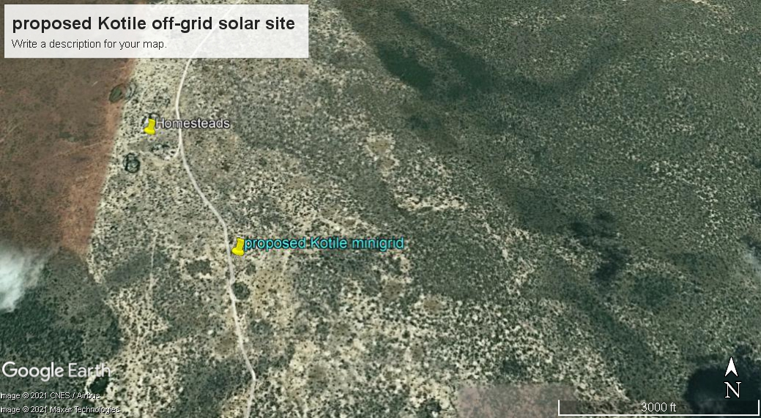
Figure 2. Map showing the proposed site
The solar mini grid will contain Solar panels, batteries, invertors, perimeter fence and length of transmission line to cover a circuit distance of approximately 4.55km.

Purpose and Scope of Work
This report discusses the environmental and social baseline within which the proposed solar power project is commissioned and assesses the potential adverse and beneficial impacts that the project could have, along with suitable mitigation measures and an Environmental and Social Management Plan (ESMP) for the project. The report also evaluates the environmental and social risks associated with the project and implements mitigation measures to avoid adverse impacts for the remainder of the project’s lifecycle. The project must comply with international standards (World Bank Environmental and Social Safeguards) along with applicable national, state, and local regulations.

ESIA Methodology

Screening and Scoping

Screening Methodology
Evaluation of ESIA procedure has been undertaken as a fundamental procedure to implementation of the solar power mini-grid development project which is systematically mainstreamed into the project’s Cycle. World Banks Social safeguards underpin and demonstrate this commitment. The main aim of this is to enhance positive social opportunities and benefits as well as ensure that adverse social and environmental risks and impacts are avoided, minimized, and mitigated.
The below steps were followed.

Kick-off Meeting
Norken and Centric team had a brief kick-off meeting with the Ministry of Energy on 12th July 2021 followed by subsequent online meetings and discussion on various aspects of the project up to 5th August 2021. The meetings addressed varied deliverables and thresholds to be achieved and maintained during this assessment in terms of scope of work, deliverables, timeline, and the methodology. All communication and meetings were done online.

Desk based review and baseline assessment
A comprehensive description of the KOSAP Component 1: project includes a desktop review of all the existing project documentation including the Project Appraisal Document and the four main safeguard framework documents prepared under KOSAP- these are Social Assessment, Vulnerable and Marginalized Group Framework, Resettlement Policy Framework and the Environmental and Social Management Framework.

Project Description
The consultant firm has concisely described the project location including its geographical, ecological and the general layout of associated infrastructure including maps at an appropriate scale where necessary. Location of all projects related development sites, including proximal offsite investments; general layout; flow diagrams/drawings of facilities/operation design basis, size, capacity, flow-through of unit operations, including pollution control technology included if any; pre-construction activities and construction activities; construction schedule; staffing size and support; facilities and services around; commissioning, operation and maintenance activities and plan

Baseline Condition
This entails description and collection of relevant primary data within the project site’s bio-physical, socio-economic, and cultural profile with respect to the biodiversity profile, land use types, cultural heritage and practices, social and economic issues likely to be affected, expected project activities to be involved during the design, construction, and operation of the proposed facility. The information also includes description of the community social structure, employment and labour market, sources and distribution of income, cultural/religious sites and properties, vulnerable groups, and indigenous populations. This also covers description of the sites’ physical environment including their topography, land cover, geology, climate and meteorology, air quality and hydrology. This entails use of secondary data sources and for some specific environmental parameters the deployment of specialized equipment to measure and record the environmental readings as primary data for analysis and inclusion in the ESIA CPR report. The ecological and biophysical environment will focus on describing the flora and fauna resident in the Garissa County at the mini-grid site level. This will be based on ecological surveys, KPIs on local indigenous knowledge on historical and status of rare, endemic, and endangered plant and animal species known to occur in these localities. Vegetation assessment was done to gain an understanding of the mini-grid sites habitat type. This has provided for an in-depth description of existing land use type and their linked socio-economic activities.

Impact Assessment (IA) Prediction
The anticipated impacts generated by the project and subsequent evaluation of their significance is provided by this report. A suite of field data collection methods was deployed including public forums discussions, Focus Group Discussions, Key Informant Interviews incorporating questionnaires for social risks assessment. Based on the outcome of the evaluation, the need for emphasis on critical areas was discussed. To accomplish this task an initial listing of the range of all issues and concerns identified during the study has been undertaken subsequently followed by analysis of the identified potential environmental and social impacts in terms of type (direct, indirect, cumulative, positive, negative), magnitude (local, widespread, random, severity) and duration (temporary, permanent, long term, short term). Consequently, an evaluation system will be used to categorize these impacts and evaluate them. This aided in determining the significance of the identified potential impacts in relation to established criteria or standards, geographic extent of effects, cumulative nature of the impact, community tolerance and preferences, etc. This culminated into generation of a short list of the most critical issues in terms of environmental, ecological, and social impacts both positive and negative associated which the different phases of the project activities that are likely to affect the baseline environmental and social conditions presently occurring at the mini-grid sites.
Socio-cultural risks linked to Component 1 of KOSAP were identified during the assessment. These include, Labour influx, Gender Based Violence, Sexual Exploitation and Abuse, workplace Sexual Harassment, Spread of HIV/AIDS, STDs & other communicable diseases, Gender biases and inequality exclusion of vulnerable and marginalized groups (VMGs) and vulnerable individuals and households from accessing project decision making and governance structures, engagement processes, opportunities, and benefits. The vulnerable individuals and households will include the poor, elderly persons, PWDs, the sick, poor women, poor single mothers, child-headed households. The VMG’s include ethnic minority communities that are present in Kotile area.
The impacts and risks were identified in relation to free, prior, and informed comprehensive stakeholder consultations on land acquisition for construction of mini-grid, contractor’s facilities e.g., yard and workers camp site, way leave acquisition for the powerline distribution network; restricted access to grazing lands, water resources, soils and tree resources, economic/livelihoods displacement etc.

Environmental and Social Management Plan (ESMP)
The ESMP as the implementation instrument of the ESIA has captured all the parameters that need to be monitored on a routine basis. The parameters as indicated in an Environmental and Social Management and Monitoring Plan (ESMMP) matrix, a detailed description of the implementation and monitoring program.
The ESMMP has a detailed arrangement of responsibilities for managing and monitoring the implementation of mitigation measures and the impacts of the project during construction, operation, and decommissioning. This include: a description of monitoring methodology, specific operations, and features to be monitored, monitoring reporting relationships and arrangements to ensure that monitoring is effective. Simple and straightforward monitoring processes established for ease of implementation through the project cycle. This plan follows through a description of the impacts and areas affected, key mitigation measures, monitor-able indicators, timeframe, responsibilities, and budget implications.

The ESMP include an implementation schedule and budget cost estimates for the mitigation measures both capital and recurrent costs estimates and the financing entity. It also describes institutional arrangements regarding the implementation of the ESMP among the implementing agencies, and the mini-grid contractor(s). This has specific responsibilities, procedures and resources required by each institutional actor engaged in implementing the ESMP.
The “Chance Find Procedures” has also been included in the ESMP as part of prevention and mitigation measures that will be implemented in the event physical cultural resources are encountered during subproject implementation.
Additionally, the ESMP has a component on contracting management that will ensure the implementation of the ESMP by all contractors and subcontractors. A contracting mechanism is included in the ESMP to incentivize contractors and their subcontractors to comply with the ESMP or alternatively penalize them for failure to comply with the ESMP. It also includes contractor clauses that will cover worksite health and safety, the environmental and social management of construction sites; labour camps/out of area workers, HIV/AIDS, and other Sexually Transmitted Diseases (STDs), stakeholder engagement plans, grievance redress mechanism, child protection, gender equity and sexual harassment, labor rights and the employment of community members. The ESMP also have a budget to guide the contractor on resources required for the implementation and monitoring of the ESMP.
Figure 2 is a summary of the methodology the firm will adopt in undertaking environmental and social impacts assessment for the proposed KOSAP project
- Preparation and Planning

- Desk Review of available reports and documents

Inception Report

- Stakeholders Consultation and Participation:
  - Key informant interviews
  - Focus Group Discussions (FGDs
Draft ESIA Reports

Incorporation of Review Comments from PCU & IAs

Deliverable 1

Deliverable 2

Final ESIA Reports for the proposed Kotile Mini grid
Deliverable 3
- Baseline data gathering
- Identification of Potential Social Impacts
- Summary of mitigation & Management mmeasures
Figure 3: Summary of Environmental and Social Impact Assessment Methodology

Limitations
The limitation experienced during the study are illustrated below.

- Some data which the consultants sought from the community could not be ascertained e.g., the exact number of the VMG’s, orphans, rate of HIV infections, cases of GBV etc
- Risk of being infected or transmitting COVID-19 during the public meetings and interactions.

Layout of the Report
Table 5: Structure of the ESIA Report
SECTION | TITLE | DESCRIPTION
Section 1 | Introduction | (This section) Introduction to the Project and ESIA scope and methodology adopted.
Section 2 | Project Description | Technical description of the Project & related infrastructure and activities.
Section 3 | Environmental, Ecology and Social Baseline | Outlines Environmental, Ecology and Social Baseline status in the study area of the Project
Section 4 | Applicable Legal and Regulatory Framework | Discusses the applicable environmental and social regulatory framework and its relevance for the Project. (The world bank safeguards and EMCA and environmental regulations)
Section 5 | Stakeholder Engagement | Provides an overview of the stakeholder engagement activities undertaken during the ESIA, stakeholder categorization and profiling Additionally, it details the provision of Grievance Redress Mechanism for the project
Section 6 | Grievance Redress Mechanism | Provides grievance mechanism, the national, county and locational grievance redress committee,
Section 7 | Impact Assessment and Mitigation Measures | This section includes details of identified environmental impacts and associated risks due to Project activities, assessment of significance of impacts and presents mitigation measures for minimizing and /or offsetting adverse impacts identified.
Section 8 | Environmental and Social Management Plan | Outline of the ESMP considering identified impacts and planned mitigation measures and monitoring requirements.
Section 9 | Impact Summary and Conclusion | Summary of impacts identified for the Project and conclusion of the study.

ESIA Study Team

Below is the list of the planning and field team for the study:
NAME | INSTITUTION | POSITION
Isaiah Kegora | Norken International Limited | Project manager
Umulkheir Abdi | Centric Africa Limited | Environmentalist
Allan Owino | Centric Africa Limited | Environmental & Social Expert
Martin Mbabu | Norken International Limited | Environmentalist
Hottensia Kabuki | Norken International Limited | Social & Stakeholder Engagement Expert
CLIENT REPRESENTATIVES
Samuel Olela | KPLC Nairobi | Environmentalist
Salah Abdi | Wajir County Government | CREO

PROJECT DESCRIPTION

Introduction
This section provides a description of the project in terms of location, facilities and associated project infrastructure and activities during the project lifecycle and facilitates and identification of the potential impacts on resources and receptors that could result from project activities during the pre-construction, construction, operation, and decommissioning stages.
The components of the proposed solar mini grid are provided as follows.
Table 6: Component of the proposed Solar Mini-grid
S/NO. | PARTICULARS | DESCRIPTION
1. | Project location | The project is located 39km from Ijara town, in Kotile village, Ijara subcounty in Garissa County. Geographically, the site is located on coordinates of latitude 1°58'39.4032"S and longitude 40°12'38.304"E at altitude of 56 metres above the sea level.  The solar mini grid will contain Solar panels, batteries, invertors, perimeter fence and length of transmission line.
2. | Land Size/Tenure | The proposed solar mini grid will be located on a 1.196 Ha piece of land in Kotile village. The land is unregistered community land set aside for public use
3.
4. | Mini grid Capacity | - PV Capacity of 49kw; 159kWh Battery
 | Energy Demand | Monthly energy demand of 3860 kWh and daily energy demand of 129 kWh
 | Generator & Fuel Tank | The generator capacity of 50kV and the fuel tank for diesel generator of 2000 liters.
6. | Distribution line | Approximately 5km
7. | Target Consumers | 166(158 Residential and 8 Non-residential)
8. | Climatic condition | Given the arid nature of the county, temperatures are generally high throughout the year and range from 20°C to 39°C. The average temperature is however 36°C. The hottest months are September and January to March, while the months of April to August are relatively cooler. The humidity averages 60g/m3 in the morning and 55 g/m3 in the afternoon. An average of 9.5 hours of sunshine is received per day. Strong winds are also experienced between April and August with the rest of the months getting calm winds.
10. | Site Conditions | The side is generally in open area with minimal fauna and flora.
11. | Road Accessibility | Earth road through Masalani to Ijara
12.. | Nearest Airport | Wajir International Airport at about 374.11km
13. | River/canal/nallah/ pond present in project footprint | No rivers are present in the village

Project Location
The project site is in Kotile, Ijara subcounty in Garissa County at coordinates of latitude 1°58'39.4032"S and longitude 40°12'38.304"E. The proposed power plant will be constructed on approximately 1.196Ha.
The project site is approximately 39km from Ijara town. Ijara is strategically positioned between the lower Tana belt on one hand and the vast Boni forest on the other. These two physical features have influenced the types and use of the soils of Ijara. Along the Tana Belt, soils are mostly alluvial while areas close to the Bone Forest consist of sand rich forest soils. Between these two types of soils are the black cotton soils that dominate.

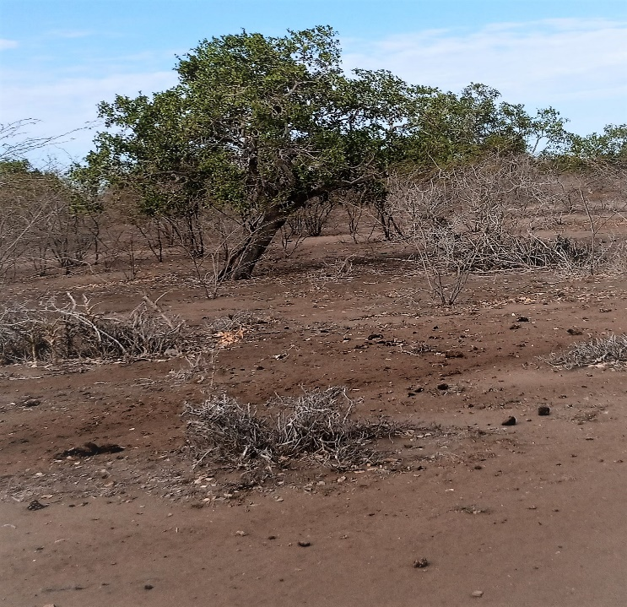

S 1°58'39.4032"
E 40°12'38. 304"

Altitude 56m

22/10/21 11:30

No street

Kotile Site
Plate 2. Proposed site for the Kotile Solar Mini-grid project
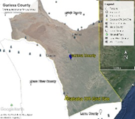
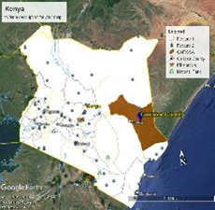
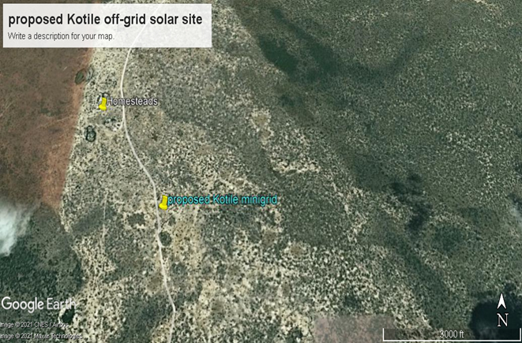
Figure 3: Project location

Project site setting
The proposed Kotile mini grid is in Garissa County. It falls under Lot 1 of clusters 3 which has a total of 47 mini-grids. Geographically, Kotile site falls on latitude 1°58'39.4032"S and longitude 40°12'38.304"E.
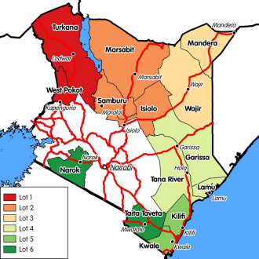
Figure 4: Map showing the KOSAP Counties Lot 4

Description of Project Facilities, Components and Activities

Technical aspects of Solar Mini grid
Kotile is among the beneficiaries of the KOSAP based on an aerial survey done in 2019 and has a potential customer base approximated at 1700 households within the Kotile area, and a 49 kWp solar Mini-grid to supply power to the community will be installed. The Solar PV hybrid system is based on a centralized photovoltaic plant connected to a 3-phase 415V AC busbar line, where the multi-mode battery inverter and the diesel generator are also connected. The noise rating for the inverter and the diesel generator is 85-90dB.

Project Components

Solar PV modules
The project will use PV Array (DC-kW) 50 polycrystalline silicon module with three strings connected in series. Each string will have five sets of panels connected in series, with output converged at the six-way combiners. The life expectancy of the PV modules is estimated at 25-30 years.

Battery Energy Storage System
The Battery Energy Storage System (BESS) will comprise of Lithium-ion Battery pack that conforms to IEC standards with warranty of 10 years, 3,000 cycles minimum. The Lithium-ion Battery Power Packs will be used to cater for required energy capacity, or equivalent as per approved design, minimum 80% DOD for Lithium-Ion. Batteries will be capable of at least C/4 charge and discharge rate. Batteries will be charged by Battery Inverter / Charger. A 159kWh Battery Capacity is incorporated to store excess solar energy during the day, ensuring a consistent power supply even during cloudy or nighttime conditions.

Battery Inverters/ Chargers.
A 28-kW battery inverter charger is employed to manage the energy flow to and from the battery storage system. The Inverters/charges shall be designed for nominal voltage of 415 Vac which will be continuous, reliable power supply as per specification and shall have internal protection arrangement against any sustained fault in the feeder line and against lightning strikes in the feeder line. The inverters shall be capable of complete automatic operation including wake-up, synchronization & shut down independently & automatically. The inverter shall be 3-phase multi-mode (DC to AC and AC to DC), bi-directional, four-quadrant capability.

Distribution lines
The site will have a distribution line circuit of 5 km in total. Supply of concrete poles for the distribution lines will be based on detailed survey and accessories like phase plates, circuit plates, number plates, danger plates, anti-climbing devices as per KPLC requirements/specifications. Erection of the Poles, fixing of insulator strings, stringing of conductor and earth wires along with all necessary line accessories and earthing will be as per KPLC requirements/specifications.
Project Metrics:
Monthly Energy Demand: The project is expected to meet a total monthly energy demand of 3,860 kWh.
Daily Energy Demand: The average daily energy demand is approximately 129 kWh, ensuring a consistent supply for the consumers.
Peak Demand: The peak demand of the system is 16 kW, which is the maximum power requirement during any given moment.
PV Capacity: The solar photovoltaic panels have a total capacity of 49kWp.
Battery Capacity: The Battery Energy Storage System has a capacity of 159kWh, providing energy storage and ensuring a continuous power supply.
Generator Capacity: The diesel generator has a capacity of 50 kVA, serving as a backup power source.
Fuel Tank Capacity: The fuel tank for the diesel generator can hold up to 2,000 liters of diesel fuel.

Estimated Project Cost:
The estimated cost of the Kotile Mini Grid project is approximately USD 367,298. It's important to note that this cost may be subject to change as more detailed plans and implementation phases are developed. The investment is expected to provide long-term benefits to the local community, improving their quality of life, economic opportunities, and access to modern amenities.

    - Project Phases and Activities
The main project activities include site clearance and leveling, civil works and construction of utilities and structures for the facilities, installation, and connection of the power plant.

Construction Procedures
The project will be constructed based on applicable standards of Kenya, environmental guidelines and health and safety measures in line with OSHA Act 2007.
The project inputs will include the following.
- Construction of raw materials will include solar modules, inverter, wires, metals, among others. All these will be obtained from licensed dealers and especially those that have complied with the environmental management guidelines and policies.
- Construction machines will include machinery such as trucks, and other relevant construction equipment. These will be used for the transportation of materials, clearing of resulting construction debris.
- A construction labour force of both skilled and non-skilled workers will be required.
Construction activities will include the following:
- Contractor mobilization.
- Site Preparation.
- Procurement of construction material from approved dealers and transport to the site.
- Storage of PV modules delivery and their installation.
- Laying of internal electrical connections.
- Installation of inverters, Battery Energy storage system and transformers.

Resource Requirement.

Workforce Requirement
Approximately 40 skilled, semi-skilled and unskilled Laborer’s will be required at the construction stage. During the operation phase, the following personnel will be required; one operations and maintenance head, 2 engineers and 5 technicians. The Kenya Power Company will be responsible for conducting the operations and management of the project through the O&M contractors for the first seven years.
Approximately 5 unskilled workers will be involved during operation phase of the project for grass cutting and module cleaning. Also, two trained security guards will be engaged at the operations phase.

Water Requirement and Source

Construction Phase
It has been estimated that approximately 50KL of water will be required per day for civil works during construction stage. Further, water will be required for workers at project site. However, this quantity of water requirement will vary depending upon the mobilization of construction workers at site. The water for the construction phase will be supplied by a water tanker from the area water vendors

Operation Phase
The water required during operation phase of the project will be mainly for washing the face of the solar modules, Minimal water will be used for this purpose. Water requirement during operational phase of the project will be met from the water vendors in the area.
Approximately, 10 employees (direct and contractual) will be working during operation phase. For this workforce, approximately 10,000 Liters of water will be required for domestic consumption.

Raw Material Requirement

Construction Phase
The major raw materials required for the construction phase will be solar modules, fencing materials, construction materials like cement, sand, and aggregate. The fencing materials and the construction materials will be sourced from the local hardware facilities. Solar Modules for the project along with associated structures will be obtained from appropriate sources within or outside the country.

Operation Phase
There will not be major requirement of raw materials during operation phase. Only maintenance spares will be required at this phase.

Power Requirement
Power requirement during the construction phase will be met through Diesel Generators sets. The exact
number of Diesel Generator sets to be used, as well as the quantity of fuel, will be ascertained once the project is in the implementation stage.

Fire Safety and Security

Construction Phase
Appropriate firefighting system and equipment shall be provided throughout the construction period. The fire extinguishers will be well distributed according to the fire risks and will be available in areas such as the site office, security area, storage yard etc. A comprehensive emergency response plan with all the emergency numbers will be well displayed at the site and on the fence. The contractor will make an effort to educate all employees about electrical safety. Increased awareness and communication about the importance of electrical safety will be emphasized throughout the workplace.

Operation Phase
Suitable fire protection and fighting systems that will include portable fire extinguishers, automatic fire detection system and means of fire communication will be made available at the entire PV array area, inverter stations, main control room and switchyard. Installation of short circuit will be done to mitigate against rodents gnawing on the cables or heating up during operation and maintainance. Damaged batteries will be well confined in a non permearble surface awaiting disposal by a NEMA Licenced waste handler. Fire safety measures will be in place.
The mini-grid grid will have a galvanized Chain link fence to keep off the electrical installation away from access by the public. A gate will be constructed at the entrance to the site which will be locked at all times. The Mini Grid will be lit at night, and a photocell will be used to automatically switch on the lights at a set time each evening. The Mini Grid will also be guarded 24/7 by at least two security guard at any given time.

The systems and equipment’s will align to the Kenyan Fire Reduction Rules of 2007. The Fire protection and fighting systems will be maintained and serviced after every 6 months.

Pollution Streams during Construction Phase

Solid Waste Generation

Construction Phase
The key solid waste that is expected to be generated during construction phase include. Broken solar panels and PV Modules, Hazardous waste like waste oil, lubricants, oil contaminated rags and Domestic soil from the temporary site office.
The hazardous wastes will be stored onsite at separate designated covered area provided with impervious flooring and secondary containment. The storage containers/ bins/ drum will be clearly marked, and color coded for their hazards. The waste will then be collected by a NEMA approved waste handler.
Any broken solar panels or PV Modules will be sent back to the vendor as part of buyback arrangement. All the other domestic solid waste will be disposed at the nearest municipality dumpsite.

Operation Phase
During operation phase, waste generated from the project will include domestic waste at site office, scrap materials like scrap tools, damaged PPEs etc.; hazardous waste like waste oil, lubricants, used transformer oil; damaged batteries; electronic waste like damaged PV modules etc.
The hazardous wastes will be stored onsite at separate designated covered area provided with impervious flooring and secondary containment. The storage containers/ bins/ drum will be clearly marked, and color coded for their hazards. The waste will then be collected by a NEMA approved waste handler.
Any broken solar panels or PV Modules will be sent back to the vendor as part of buyback arrangement. All the other domestic solid waste will be disposed at the nearest municipality dumpsite.

Air Emissions

Construction Phase
Air quality will be impacted due to onsite construction activities. The likely emissions from construction activities would include the following:
- Dust emissions from the dusty roads leading to the site.
- Increased vehicular emissions due to the high traffic of vehicles transporting construction materials, PV Modules, and accessories.
- Dust emissions from site clearing, material handling, piling and use of the construction machinery.
- Exhaust emissions from the diesel generator.
The high dust emissions arising from various activities such as piling, transportation of material (loading and unloading), vehicular movement (on unpaved roads) should be minimized through sprinkling of water and maintaining vehicular speed to 10-15 km/hr.
All the vehicles and the Diesel generator should be well maintained and serviced to reduce the rate of exhaust emissions.

Operation Phase
It is expected that the normal operations of the site will produce minimal gaseous emissions from all the operating areas. The minimal gaseous and fugitive dust emissions will be attributed to the in and out movement of the maintenance vehicles. It will be ensured that well maintained vehicles are used for maintenance purposes.

Waste Generation

Construction Phase
The liquid effluents generated during the construction phase will include domestic sewage from temporary site offices, kitchen and washing areas. As part of the site preparation stage, septic tank will be constructed for the camp and site office. Sewage disposal trucks should be used to periodically remove the sludge/sewage from the septic tank.

Operation Phase
The operational phase will have negligible wastewater generation at site office. Septic tank and soak pits will be provided at the site office for disposal of sewage.

Noise Emissions

Construction Phase
Noise emissions will be generated from piling, movement of vehicle and other construction machinery and operation of the Diesel Generator. The main noise receptors will be the neighboring settlements and the construction workers. Noise from Diesel Generators will be minimized through provision of acoustic enclosures and occasional maintenance of the generator. Every single noise generating activity will be restricted to Day time only.

Operation Phase
Under normal operations, none of the activities of solar power plant will generate noise. The only noise that can be generated at this phase is during the maintenance works and it will be restricted to daytime only. However, during cloudy periods and when solar energy is low, the backup generator that will be utilisd will produce noise. Mufflers and silencers will be installed so as to minimize noise pollution from the backeup generator.

Land Requirement and Procurement Process

Land Requirement

Land Tenure
Land ownership in Garissa County is mainly community land and private land. The site for the proposed site is on unregistered community land. The community has since offered the land to the project proponent to establishment the proposed project. The entire county is categorized as Community land.

Compensation Details
Compensation for the proposed project will be in kind; for the offered land by the community, the Proponent will undertake some projects for the community. The area has an existing two- and half-inch pipe that has served the community for 7 years. The community requested for upgrading of the pipe and also renovation of the water distribution kiosk.

Analysis Of Alternatives
This section analyses the project alternatives in terms of site and technology. Solar projects are non -polluting energy generation projects which are site specific and dependent on the availability of solar irradiance resource. The current site selected is a high solar power potential site with high irradiation and consistent sunny days throughout the year.

2.7.1 Site Selection
Solar projects are non-polluting energy generation projects which are site-specific and dependent on the availability of solar irradiance resource.
The proponent identified one location for the proposed solar project. This site selection process considered the following criteria;
1. Geophysical Factors-Proximity to Hills-Shade effect, Soil erosion, Drainage of the area, Flooding etc.
2. Land identified is free from any dispute on ownership or any other encumbrances
3. Proximity to public utilities-Schools, Dispensaries, Places of worship and community settlements
4. No squatters, encroachers or other claims to the land
5. The Size of the Mini-grid to be constructed and the optimal coverage of a Mini-grid in terms of the number of people to be reached.
6. The Land identified should be on spaces set aside for public use within the community centres.

Power Scenario at Kotile
This option involves remaining on the status quo.
The no construct/no project alternative will not achieve the objectives of the project since the listed benefits will not be achieved.
Failure to construct and operate the Mini grid will lead to the failure of achieving one of the Kenya’s national long-term development policies that aims to transform Kenya into a newly industrializing, middle-income country, by providing a high quality of life to all its citizens by 2030 in a clean and secure environment. PAPs will be households, public and community institutions, enterprises and community facilities that cannot access electricity through the national grid and whose use of electricity will replace kerosene and other fuels for lighting and other activities like pumping water.

Present Power Supply Position
According to the Garissa County Integrated Development plan (2018-2022), About 84 per cent of the county’s population use fire wood as a source of energy for cooking purposes while 40 per cent of the population use charcoal thus aggravating Environmental degradation. Electricity is available in Garissa, Ijara, Dadaab, Bura East, Balambala and Modogashe, and their environs with only 1.5 per cent of the population having access to electricity. In Hulugho, the project of installation of power was started and stalled on the way. In addition, the Ministry of Energy has installed solar systems in health facilities, schools and watering points. Other sources of energy such as biogas and solar are used on a limited scale both at 0.3 per cent.
The county government of Garissa needs to invest in solar power which remains a sustainable option for lighting up rural and remote areas of the country and that the sector has the potential to drive economic development in the county. With an arid climate and a vast desert landmass, Garissa is geographically optimal for harnessing the solar power.

Alternate Location for Project Site
In determining the most appropriate site for the establishment of the minigrid, several options were explored. This site selection process considered the following criteria:
- The availability of primary resources required for the operation of the minigrid, such as Sun
- Availability of land to locate the site and associated infrastructure.
- The availability and accessibility of infrastructure for the provision of services, manpower and social structure for the construction and operation of the power plant.
- General environmental acceptability in terms of social impacts, water utilization, general ecology, etc.
Kotile was identified as the most suitable area for the establishment of the proposed minigrid based on the following factors:
Location: The area is in a predominantly pastoral setting. The population density is low, and majority of the surrounding land is de-vegetated grazing lands and tree cover is currently low at 45%. There is enough grazing land for the community and use of the site to construct the mini grid will not significantly impact grazing land.
Grid Connection: A grid connection with enough capacity and material was recommended due to the anticipated increasing demand in solar energy. This eliminates the need to overhaul the grid connection when the population increases in Kotile location.

Alternate Method of Power Generation
The possible alternatives to electrical energy could be solar power, wind power, thermal power, fossil fuel and firewood. Power import from neighboring countries is another option. Wind power is also a source of clean energy.
The problems in operation of wind power are lack of time series data of wind, trained human resources to intricate design of wind power etc. In addition, providing wind power for Kotile residents is technically and financially challenging.
Thermal power plants are associated with serious environmental problems like air pollution, waste pollution, noise pollution, temperature pollution etc. Besides coal and petroleum products, the basic input required for the conventional thermal power plants will have to be imported. Therefore, thermal power option based on coal and petroleum products is not a viable option for Kotile.
The use of firewood and solid waste for electricity generation using thermal technology is another option. But the issue of air pollution and destruction of vegetative cover through firewood harvesting and charcoal burning already are environmental problems of serious concern which will further aggravate the natural environment. For these reasons, the thermal power options evaluated above seem inappropriate for Kotile on environmental as well as economic grounds.
Solar energy was a desirable option because:
- It has low energy-production costs
- Versatile installation
- It is a clean source of energy hence minimal impact on the environment air quality
- Economic savings.

Zero or No Project Alternative
The No Project option in respect to the proposed project implies that the status quo is maintained. This option is the most suitable alternative from an extreme environmental perspective as it ensures non-interference with the existing conditions. This option will, however, involve several losses both to Kotile area and Ijara as a whole. The village and the surrounding area will continue to have no electricity, and this will not help in maximizing and utilizing the area facilities. The No Project Option is the least preferred from the socio-economic and partly environmental perspective due to the following factors:
- The economic status of the local people would remain unchanged.
- Employment opportunities will not be created.
- Increased poverty in the area.
From the analysis above, it becomes apparent that the No Project alternative is no alternative to the local people, Kenyan Government, and Investors.

Analysis of Alternative Construction Materials and Technology
The proposed project will be constructed using modern, locally, and internationally accepted materials to achieve public health, safety, security, and environmental aesthetic requirements. These may not be desirable from a cost and durability perspective. The technology to be adopted will be the most economical and one sensitive to the environment.

Conclusion
The proposed project should be upheld to support the local community based.

BASELINE SETTINGS- ENVIRONMENT, ECOLOGY AND SOCIAL

Study Area
The project site is located in Kotile village, Masalani ward in Ijara subcounty, Garissa County. Based on the secondary information of the region, the following baseline information on environment, ecology and social has been discussed under the sections below.

Environment Baseline

Geology and Soil
The soils in the project location were predominantly sandy soil with patches of depressed land of loam soil.The soils in Garissa range from the sandstones, dark clays to alluvial soils along the Laghas, River Tana
Basin and the Lorian swamp. White and red soils are found in Balambala Constituency were the
terrain is relatively uneven and well drained. The soils have low water retention capacity but
support vegetation. These soils have potential for farming.
The rest of the county has sandy soils that support scattered shrubs and grasslands which are
ideal for livestock production. The county’s land is highly erodible. The exploitation of the soil
resource thus must take into account conservation measures due to their fragile nature. The
mineral potential of the soils is not exactly known as no geological mapping has been done.

Topography
The elevation difference of about 3m is observed within the project site. Garissa County is basically flat and low lying without hills, valleys and mountains. It rises from a low altitude of 56m above sea level. The county is prone to seasonal flooding during the rainy seasons which makes roads impassable.

Hydrogeology and Drainage
There is the highly seasonal Laghas and River Tana Basin on the western side. The river Tana has tremendous effect on the climate, settlement patterns and economic activities within the county. The county is prone to seasonal flooding during the rainy seasons which makes roads impassable. During the dry season, there is a general migration of livestock from the hinterland to areas near River Tana where water is readily available

Ground Water Development
The ground water resources were majorly identified during the site assessment by means of observation and selected data hydrological model of the area. In addition to that the community has a large water storage tank that are non-functional due to inadequate power to pump water to the tanks

Ecological Conditions
The project area encompasses low trees, grass, and shrubs. Garissa County is principally semi-arid area falling within the ecological zone V-VI and receives an average rainfall of 275 mm per year. There are two rain seasons, the short rains from October to December and the long rains from March to May. Rainfall is normally in short torrential downpour making it unreliable for vegetation growth. The southern parts of the County such as Hulugho, Masalani and Bura receive more rainfall than the northern parts.

Climatic Conditions
Given the arid nature of the county, temperatures are generally high throughout the year and range from 20°C to 39°C. The average temperature is however 36°C. The hottest months are September and January to March, while the months of April to August are relatively cooler. The humidity averages 60g/m3 in the morning and 55 g/m3 in the afternoon. An average of 9.5 hours of sunshine is received per day. Strong winds are also experienced between April and August with the rest of the months getting calm winds. 4 Because of climate change the rainfall patterns and temperature has been changing due to climatic conditions. Thus, the county is prone to drought and flood emergencies leading to threat to livelihoods.
Socio-economic/Social
The AoI for social receptors was fixed to include 2 km radial zone which has been developed based on the reconnaissance site visits and stakeholder consultations with the local community. The AoI for development of the social baseline is within Nyango Village which according to the administrative structure falls within Vigurungani Location. The socio-economic information presented in this report has drawn from primary socio-economic survey and the Population and housing census 2019, Kenya Bureau of Statistics (KBS).

Socio-economic Environment

Community Profile
Kotile village is in Masalani ward, Ijara subcounty in Garissa County. It is located 21 km from Masalani town. The top community development priorities are 1st Health, 2nd water 3rd education in that order. Houses in the community are thatched with a few are roofed by iron sheet. The community support mechanism includes Hunger safety net, emergency relief food/feed (for livestock and human). The primary ethnic group is Somali. Other ethnic groups in Kotile include; Meru and Akamba. Islam is the dominant religion. Below is a summary of demographic profile of Kotile.

Attribute | Magnitude/Number
Approx. population | 16000
Households | 2100
Gender. | Male – 35%  Female – 65%
Ave. No. per household | 7per household
Indigenous | 97%
Settlers | 3%
Vulnerable classes | Elderly-200 Households  PLWDs-100 Households  Single mothers-500 Households  Orphans-500 Households
Dominant ethnic group | Somali
Primary religion | Islam
Other groups | Pokomo and Akamba
Employment (formal/Informal) | Formal – 4%  Informal – 96%
Table 12: Demographic profile of Kotile

Socio-economic status of Study Area

Demographic Profile
Kotile has a population of approximately 16000, and with about 2100 households with an average of 7 people. The gender ration is currently estimated to be about 35% male and 65% female.

Educational Infrastructure
The village has only one primary school - Kotile Township Primary School located within the village center It has a total of 260 pupils (176 Boys and 204 Girls) with 5 teachers; (All employed by Teachers Service Commission (TSC). The school completion rate among the boys is approximately (100%) while that of the girls is at (70%). Most pupils drop out at class 8 or Form 4 mainly due to lack of school fees, domestic chores (Taking care of livestock).

Occupation and Livelihood Profile
Kotile community are mainly pastoralists moving with livestock in search of pasture and water. Major livestock kept are camel, cattle, sheep, goats, and local chicken. The community rely of livestock products for food at the household level and for income generation. Formal employment is 4%. Other sources of income in the society include sale of wood fuel/charcoal and firewood, building materials, retail businesses. Due to the aridity of the county, food production (crop growing) is limited and contributes little to food security. Few farmers grow green grams, maize, beans and watermelon during the rainy season. Bulk of these harvests is for subsistence/household consumption.

Land Use
Land in the community is mainly communal. The land-use and land-cover of the study area (5kms) has been interpreted from visual interpretation, survey maps of the area, and subsequently by ground checking during field surveys. The land use within 5 km radius of project site represents grassland (80%) and open shrub land (20%). The area is majorly semi-arid with a sparse population within the area.
The portion of land identified for the Mini-grid by the community is on a community land set aside for public use measuring approximately 1.196 Ha in Kotile, Ijara Sub-County, in Garissa County. Consultations with the community indicated that the land is purely set for social services projects. No objections were raised by the community in regard to transferring land (1.196 Ha for the mini-grid) to KP for management of the solar mini-grid.
An abbreviated Resettlement Action Plan (A-RAP) outlining the principles and procedures for land acquisition and compensation is annexed to this ESIA.
An A-RAP applies where affected persons are not physically displaced, and less than 10% of their productive assets are lost, or fewer than 200 people are displaced. In the case of KOSAP sub-projects, there is no physical displacement of affected persons, and the foreseen impacts on livelihoods such as grazing occasioned by mini-grid construction, wayleaves acquisition, and implementation of community projects are considered minor.

Health facilities
Plate 3. View of Kotile dispensary
Kotile has only one public dispensary with nurse, a clinical officer, Lab technician and a community health extension worker. There are no female staff members at the dispensary. The Main service provided is Out-patient services. The facility lacks enough staff members, water, medicine and lab equipment, electricity, beds and other basic requirements.

Social and Physical Infrastructure
Water: The area has a water kiosk where water from the water bowsers is stored and sold to the locals, other times the community members fetch their water from Kitere shallow well near River Tana about 9 km from Kotile, however, the quality of water from the river is poor and require treatment.
Sanitation: Most of the households in the village have pit latrines and those without share with their neighbours. The women from Kotile have access to sanitary pads and use them. There are however few private toilets in the school, dispensary, and Mosque.
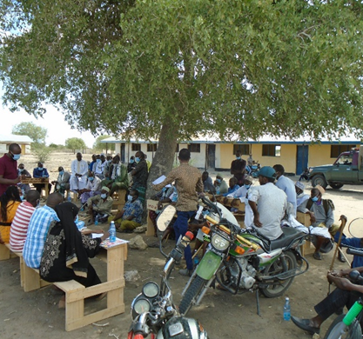
Road Network: Roads connectivity within the area is also poor and not regularly maintained. The main forms of transport within the area are, taxis and Matatus and boda-bodas (very common). The route connecting Kotile to Ijara is a simple earth road.

Plate 4. Presence of Motorcycles used a means of transport in Kotile

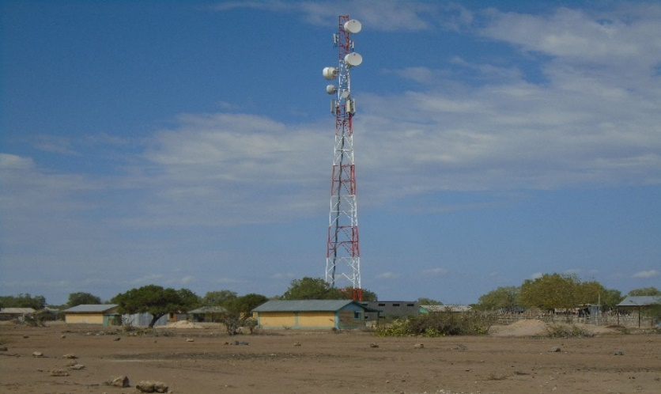
Mobile Network Coverage: Safaricom is the only Network coverage within the village and majority of people have access to the internet services.
Plate 5. Safaricom Base Transceiver Station at Kotile

Power/electricity: - the community is not connected to the mains. The population use mainly portable solar at the household for charging mobiles and torch for lighting.

  - Area of Influence
The Area of Influence (AoI) of the project comprises of the project site and the surrounding area, where the influence of the project activities is anticipated. The areas likely to be affected by the project and its associated activities include:
- The areas where project activities and facilities operated and managed by the Ministry of Energy, Kenya Power (KP), will be established,
- Project site where project components such as solar modules, control room and transmission line to power grid sub-stations; and any other selected CSR project, such as the construction water abstraction and distribution points will be established
- Areas where impacts from unplanned but predictable developments caused by the project that shall occur later or at a related location such as increase in traffic on the approach road;
- Areas where there is biodiversity or on ecosystem services upon which affected communities’ livelihood are dependent; and
- Areas where associated facilities will be established e.g., approach road construction and widening of existing road.
Further to this, the AoI with respect to the environmental and social resources was considered based on the following reach of impacts:
Air Quality
- Impact on ambient air quality from vehicle exhaust;
- Impact of air pollutants emission from construction activities and
- Dust fall- typically up to 200 m from construction activities
Noise
- Noise impact area (defined as the area over which an increase in environmental noise levels due to the project can be detected) - typically 500 m from operations and 200 m from the access road
Water
- Surface water body- typically 500 m upstream and downstream of water intake point and downstream of discharge point
- Other surface water bodies within 1 km of the project footprint
- Groundwater in 1-2 km radius of project footprint
Flora and Fauna
- The direct footprint of the project comprising the project site
- The areas immediately adjacent to the project footprint within which a zone of ecological disturbance is created through increased dust, human presence and project related activities (e.g., trampling, water intake/outfall, transportation). This kind of disturbance has been estimated to occur within the project footprint and surrounding areas of about 500 m to 1 km from the activity areas. Based on the above the AoI for environmental studies was limited to 5 km from the project site.

APPLICABLE AND REGULATORY FRAMEWORK

Introduction
This Chapter outlines the existing national and international environmental and social legislation, policies, and institutions applicable to energy generation that guide the development of the Project.
As Kenya is a signatory to various international conventions and laws, national projects need to be aligned with their requirements; relevant international conventions and laws are therefore presented in this chapter.
Finally, a summary of the World Bank (WB) Environmental and Social operational policies relevant to this Project are presented.

Kenya Policy Provisions

Kenya Energy Policy, 2014
The Energy Policy sets out the national policies and strategies for the energy sector that align to the Constitution of Kenya and Kenya’s Vision 2030.
The Energy Policy envisages promoting an energy mix that includes solar energy at both the household/institutional levels as well as large-scale solar energy generation. The Government of Kenya has initiated and has been promoting programmes for the provision of electricity to institutions far from the grid through solar PV systems. The Government has also embarked on a programme to provide solar/diesel and solar/wind hybrid generation capacity to off-grid stations.
The Policy strategizes the need to:
- promote the widespread use of solar energy while enforcing existing regulations and standards.
- provide incentives to promote the local production and use of efficient solar systems.
- provide a framework for connecting electricity generated from solar energy to the national and isolated grids, through direct sale or net metering.
- promote the use of hybrid power generation systems involving solar and other energy sources; and
- facilitate the generation of electricity from solar energy by, among other things, funding, provision of land, fast-tracking issuance of permits and licenses, as well as acquisition of data and information to realize at least 100 MW from solar by 2017, 200 MW by 2022 and 500 MW by 2030.
The Kenya Electricity Supply Industry (ESI) is one of the sub-sectors in the energy sector which the Ministry of Energy and Petroleum oversees on behalf of the Government of Kenya (GoK). Under the Energy Act of 2006, the Ministry is responsible for formulation and articulation of policies to provide an enabling environment for operators and other stakeholders in the energy sector. Relevant stakeholders in the ESI are briefly described below.

Policy paper on Environment and Development (Sessional Paper No. 6 of 1999)
The overall goal of this Sessional Paper is to ensure that environmental concerns are integrated into the national planning and management processes and provide guidelines for environmentally sustainable development. The objectives of the Paper are to conserve and manage the natural resources of Kenya including air, land, flora, and fauna and promote environmental conservation about soil fertility and conservation, biodiversity, to foster afforestation activities, and to protect water catchment areas. More importantly, the Policy emphasizes the enhancement of public awareness and appreciation of the essential linkages between development and environment, involving NGOs, private sector, and local communities in the management of natural resources and their living environment and ensures that an environmental impact assessment report is undertaken for all public and private projects and programmes.
The proposed solar plant facility must ensure that it promotes this integrated approach to environmental management and development, without compromising the livelihoods of the local community.

National Policy on Water Resources Management and Development, 1999
While the National Policy on Water Resources Management and Development enhances a systematic development of water facilities in all sectors for promotion of the country’s socio-economic progress, it also recognizes the by-products of this process as wastewater. The Policy therefore calls for development of appropriate sanitation systems to protect people’s health and water resources from institutional pollution. This implies that industrial and business development activities should be accompanied by corresponding waste management systems to handle the wastewater and other waste emanating therefrom.
During construction, water will be required for concrete works and during the operational period water supply may be necessary for cleaning the PV modules. Appropriate water treatment and waste handling must be incorporated into the Project design to be in alignment with this policy.

Sessional Paper No. 10 of 2014 on the National Environmental Policy, 2014
The overall goal of this Session Paper is to ensure better quality of life for present and future generations through sustainable management and use of the environment and natural resources. This Session Paper calls for the use of environmentally sound technologies based on the best available techniques and policies as a way of minimizing negative impacts to the environment.
Section 5.6 of this Session Paper focusses on infrastructure development and environment and makes explicit policy statements to ensure sustainable management and use of the environment and natural resources during the construction and operation of infrastructure developments. These policy statements require the commitment of the government to:
- Ensure Strategic Environmental Assessment (SEA), Environmental Impact Assessment, Social Impact Assessment and Public participation in the planning and approval of infrastructural projects.
- Develop and implement environmentally friendly national infrastructural development strategy and action plan.
- Ensure that periodic Environmental Audits are carried out for all infrastructural projects
In line with the above policy statements, this ESIA has been conducted for the proposed solar project (including the associated infrastructure) to ensure that environmental and social issues are appropriately addressed.
Once approved by NEMA, the Project Proponent will also need to conduct periodic Environmental Audits to ensure continuous conformity with the overall goal of this Session Paper. In addition, this ESIA has considered analysis of alternatives including alternatives to technology to ensure that the best available and appropriate technology is used.

National Legal Framework

Administrative Framework
In 2001, the Government established the administrative structures to implement the Environmental Management and Co-ordination Act of 1999 (EMCA). The main administrative structures are described in the following sections:
Table 8. Administrative stakeholders and their roles
Stakeholders | Role
NEC | The National Environmental Council is responsible for policy formulation and directions for the purposes of EMCA. The Council also sets national goals and objectives and determines policies and priorities for the protection of the environment.  The proponent should ensure that the project abides by the set goals and objectives of the Council.
NEMA | The responsibility of NEMA is to exercise general supervision and co-ordination over all matters relating to the environment and to be the principal instrument of Government in the implementation of all policies relating to the environment.  This ESIA has been prepared for submission to NEMA for review and approval prior to the commencement of the Project activities, in compliance to the EMCA.
PCC | EMCA has also established a Public Complaints Committee, which provides the administrative mechanism for addressing environmental harm. The Committee has the mandate to investigate complaints relating to environmental damage and degradation. The members of the Public Complaints Committee include representatives from the Law Society of Kenya, NGOs, and the business community.  The proponent should address all issues arising from the Project in accordance with the above requirements, including a clear policy of stakeholder engagement and feedback.
WRA | Water Resources Authority is responsible for regulation of water resources issues such as water allocation, source protection and conservation, water quality management and pollution control and international waters. One of its functions among others is to receive water permit applications for water abstraction, water use and recharge and determine issue, vary water permits; and enforce the conditions of those permits as well as formulate and enforce standards, procedures and Regulations for the management and use of water resources and flood mitigation.  The project area experiences serious water scarcity. The proponent will have to purchase water for use during construction.

Relevant statutes
The current legal provisions for natural resource management in Kenya are contained in over seventy sector-specific statutes. For a long time, the country lacked an umbrella legislative guide for harmonious and holistic environmental management. As such, resources were managed sectoral in accordance with the statutes that were in place.
As these statutes were contradictory at times, in 1999, the Government of Kenya enacted the Environmental Management and Co-ordination Act (EMCA) which is an umbrella legal framework under which the environment is being managed. EMCA establishes the institutional framework under which environmental management is to be coordinated. EMCA prevails over all other Sectoral laws relating to the environment in cases of conflict or contradictions. It also grants the public a locus standi in matters of the environment.

Table 9. Policy and Legal Framework
No | Legislation/  Guidelines | Description of the Legislation/Guideline | Relevance of the legislation/regulations in terms of license, permits, and other requirements
 | NATIONAL POLICY FRAMEWORK
 | Vision 2030 | Kenya Vision 2030 is the current national blueprint for development from its inception in 2008 until the milestone year of 2030. This plan is the national long-term development policy that aims to transform Kenya into a newly industrialised, middle-income country by 2030. The Vision is comprised of three key pillars (economic, social, and political), two of which are projected to be positively affected by project implementation. | - Under Vision 2030, Energy is identified as one of the key sectors that form the foundation for socio-political and economic growth. Promoting equal opportunities across the entire Kenyan territory and enhancing access to competitively priced, reliable, quality, safe and sustainable energy is essential to the achievement of this vision.
 | The Poverty Reduction Strategy Paper (PRSP) of 2001 | The PRSP has the twin objectives of poverty reduction and enhancing economic growth. The paper articulates Kenya ‘s commitment and approach to fighting poverty; with the basic rationale that the war against poverty cannot be won without the participation of the poor themselves. | - The proposed project aims at provision and access of renewable electricity geared towards improved economic performance and thus will contribute to poverty alleviation in the project area.
 | National Environmental Action Plan (NEAP) of 1994 | The NEAP for Kenya was prepared in mid 1990s. It was a deliberate policy whose main effort is to integrate environmental considerations into the country ‘s economic and social development. The integration process was to be achieved through multi-sectoral approach to develop a comprehensive framework to ensure that environmental management and the conservation of natural resources forms an integral part of societal decision-making. | - The NEMA does not approve a development project unless the impacts of the proposed project are evaluated and mitigation measures proposed for incorporation in the project ‘s development plan, which is in line with the requirements of the NEAP. The project will be reviewed by NEMA for approval before implementation.
 | Environmental and Development Policy (Session Paper No.6 1999) | As a follow-up to the foregoing, the goal of this policy is to harmonize environmental and developmental goals to ensure sustainability. The paper provides comprehensive guidelines and strategies for government action regarding environment and development. | The proponent:  - Is undertaking an Environmental Impact Assessment, Social Impact Assessment and Public participation as part of the planning and approval of infrastructural projects.  - Will ensure that periodic Environmental Audits are carried out for the project
 | The National Energy and Petroleum Policy 2015 | The overall objective of the energy and petroleum policy is to ensure affordable, competitive, sustainable, and reliable supply of energy to meet national and county development needs at least cost, while protecting and conserving the environment. This policy stipulates the transformation of the Rural Electrification Authority (REA) to Rural Electrification and Renewable Energy Corporation (REREC) to be the lead agency for development of renewable energy resources. | The policy is relevant to the project in the sense that the project will provide sustainable and reliable energy supply and measures will be put in place to protect and conserve the environment during its development. REREC will oversee the development of the mini grid and maintenance.
 | The Gender and Development Policy (Sessional paper no.2 2019) | The overall goal of this policy is to achieve gender equality by creating a just society where women, men, boys, and girls have equal access to opportunities in the political, economic, cultural, and social spheres of life. | - In the absence of appropriate measures, the project can exacerbate gender inequalities and sexual and gender-based violence. In adherence to this policy, measures will be put in place to:  - ensure gender inclusivity in decision making, employment opportunity and access to the energy generated from the Mini-Grid  - mitigate social risks including sexual and gender-based violence, and any form of discriminations
 | The HIV/ AIDS Policy 2009 | In summary, the policy aims at:  - Establishing and promoting programmes to ensure non-discrimination and non- stigmatization of the infected.  - Contributing to national efforts to minimize the spread and mitigate against the impact of HIV and AIDS.  - Ensuring adequate allocation of resources to HIV and AIDS interventions; | - The proposed project is to be implemented in the rural setting at Kotile area. The area is not economically empowered hence few HIV/AIDS prevention resources are available. This policy shall provide a framework to both the project proponent and contractor to address issues related to HIV/AIDS during the entire project phase.
NATIONAL LAWS
 | The Constitution of Kenya, 2010 | The Constitution of Kenya promulgated in 2010 is the supreme law of the republic and binds all persons and all State organs at all levels of government. The Constitution provides the broad framework regulating all existence and development aspects of interest to the people of Kenya, and along which all national and sectoral legislative documents are drawn. | The proposed project complies with the Constitution by proposing a structure in its ESIA on how to deal with Social, Health, safety and environmental issues for sustainable development.
 | Environmental Management and Coordination Act, 1999 (And the Amendments Of 2015) | The EMCA is a framework environmental law in Kenya. This Act (assented to on January 14, 2000) provides a structured approach to environmental management in Kenya. With the EMCA coming into effect, the environmental provisions within the sectoral laws were not superseded; instead, the environmental provisions within those laws were reinforced to better manage Kenya’s ailing environment. | The proposed project will be undertaken in accordance with relevant sections of the EMCA, specifically Clauses 58 – 63. These sections of the Act are operationalised by subsidiary legislation promulgated under the Act and specifically Legal Notice (L.N.) 101: Environment (Impact Assessment and Audit) Regulations, 2003.
 | L.N. 101: EIA/EA Regulations, 2003 And 2016 Amendments | These regulations provide the framework for undertaking EIAs and EAs in Kenya by NEMA licensed Lead Experts and Firms of Experts. An EIA or EA Study in Kenya is to be undertaken by a firm duly licensed by the NEMA. The EIA/EA Regulations also provide information to project proponents on the requirements of either an EIA or EA as required by the EMCA. | - The proposed project is subject to relevant provisions of these regulations and subsequently, the ESIA has been undertaken in accordance with the requirements.
 | L.N. 120: Water Quality Regulations, 2006 | This regulation provides for the sustainable management of water used for various purposes in Kenya. The regulation contains discharge limits for various environmental parameters into public sewers and the environment. | - The contractor will be required to properly manage the effluent from construction activities in accordance with the above regulations prior to discharge into the environment.
 | L.N. 121: Waste Management Regulations, 2006 | Generally, it is a requirement under the regulations that a waste generator segregates waste (hazardous and non-hazardous) by type and then disposes them in an environmentally acceptable manner. | - Waste to be disposed in accordance with these regulations.
 | L.N. 61: Noise and Excessive Vibration Control Regulations, 2009 | The general prohibition of these regulations states that no person shall make or cause to be made any loud, unreasonable, unnecessary, or unusual noise which annoys, disturbs, injures, or endangers the comfort, repose, health, or safety of others and the environment. | - Rules 13 and 14 of the regulations define the permissible noise levels for construction sites. These noise limits will be applicable to the proposed project.
 | Licenses and Permits Required Under The EMCA | The subsidiary legislations under the EMCA are partially monitored using permits and licenses. Subsequently all licenses and permits required during the construction phase shall be the responsibility of the individual contractors and their agents. During the operational phase, all permits, and licenses required to operate the project will be the responsibility of the proponent. | The following permits to be available for inspection during the construction and operational phases of the project:  - Waste Transport License under Legal Notice 121: The Environment Management and Coordination (Waste Management) Regulations 2006 for disposal of all types of wastes; and  - Noise Permit under Legal Notice 61: The Environment Management and Coordination (Noise and Excessive Vibration Control) Regulations, 2009.
 | Occupational Health and Safety Act, 2007 | The Occupational Safety and Health Act (OSHA) was enacted to provide for the health, safety and welfare of persons employed in workplaces, and for matters incidental thereto and connected therewith. | The contractors will be required to fully comply with  Legal Notice 40 titled: Building Operations and Works of Engineering Construction Rules, 1984 (BOWEC). Each contractor will develop and implement a formal construction health and safety plan.
 | L.N. 31: The Safety and Health Committee Rules, 2004 | These rules came into effect on April 28, 2004, and require that an Occupier formalise a S&H Committee if there is a minimum of 20 persons employed in the workplace. The size of the S&H Committee will depend on the number of workers employed at the place of work | The contractor will be required to constitute Health and Safety Committee to oversee safety and health at the construction site
 | L.N. 24: Medical Examination Rules, 2005 | These rules provide for Occupiers to mandatorily undertake pre-employment, periodic, and termination medical evaluations of workers whose occupations are stipulated in the Eighth Schedule to the OSHA and the First Schedule to this Rules. Workers that fall under the above two schedules are required to undergo medical evaluations by a registered medical health practitioner duly registered by the DOSHS. | The contractor should that the workers exposed to hazards and or accidents undergo requisite medical examinations as required by these rules
 | L.N. 25: Noise Prevention and Control Rules, 2005 | The rules set the permissible level for occupational noise in any workplace (which includes construction sites)  The Proponent is to ensure that  - any equipment brought to the site for use shall be designed or have built-in noise reduction devices that do not exceed 90 dB(A).  - those employees that may be exposed to continuous noise levels of 85 dB(A) are medically examined as indicated in Regulation 16. If found unfit, the occupational hearing loss to the worker will be compensated as an occupational disease. | The contractor to ensure that equipment is serviced properly and/or use equipment that complies with the threshold noise values provided in the act. Alternatively, each contractor will be required to develop and implement a written hearing conservation programme during the construction phase.
 | L.N. 59: Fire Risk Reduction Rules, 2007 | Several sections of the rules apply to the proposed project as enumerated below.  - Regulation 16 requires Proponents to ensure that electrical equipment is installed in accordance with the respective hazardous area classification system. It is also a requirement that all electrical equipment is inspected every six months by a competent person and the Proponent is required to keep records of such inspections.  - Regulation 22 provides a description of the functions of a fire-fighting team.  - Regulation 23 requires Proponents to mandatorily undertake fire drills at least once a year.  - Regulation 34 requires Proponents to develop and implement a comprehensive written Fire Safety Policy  - Regulation 35 requires a Proponent to notify the nearest Occupational S&H area office of a fire incident within 24 hours of its occurrence and a written report sent to the Director of DOSHS within 7 days. | The proponent is expected to comply with the requirements of L.N. 59: Fire Risk Reduction Rules, 2007 by  - Carrying out, and record, a fire risk assessment identifying any possible dangers and risks.  - Reducing, or where possible remove, the risk of fire and take precautions to deal with the remaining risks.  - Developing an emergency plan should a fire occur which includes evacuation procedures etc
 | The Energy Act, 2019 | The Energy Act of 2019 deals with all matters relating to all forms of energy including the generation, transmission, distribution, supply and use of electrical energy as well as the legal basis for establishing the systems associated with these purposes. The Act also established the Energy and Petroleum Regulatory Authority (EPRA). | The proponent is in line with the Energy act regulations in the following ways.  - The proponent has identified an available site  - alignment of the Mini-Grid Project to County development plans.  - the Mini-Grid proponent has the technical and financial capability to conduct the project  - The proponent has conducted the necessary engagement with the community.
 | The Energy (Solar Photovoltaic Systems) Regulations, 2012 | These regulations shall apply to a solar PV system manufacturer, importer, vendor, technician, contractor, system owner, a solar PV system installation and consumer devices. The Regulations prohibits any person from designing or installing any solar PV system unless he/she is licensed by EPRA. | - The Regulations regulates the design and installation of PV systems. The persons engaged in the designing and installation of the Mini-Grid shall be licensed by EPRA
 | The Public Health Act (Cap. 242) | The Act prohibits the proponents from engaging in activities that cause environmental nuisance or those that cause danger, discomfort or annoyance to inhabitants or is hazardous to human and environmental health and safety. | - The proponent will be in line with the regulations of this act and will ensure suppression of infectious diseases and maintain proper sanitation during all the phases of the project.
 | The Land Act, 2012 | An Act of Parliament to give effect to Article 68 of the Constitution, to revise, consolidate and rationalize land laws; to provide for the sustainable administration and management of land and land- based resources, and for connected purposes  Forms of Tenure. 5. (1) There shall be the following forms of land tenure- (a) freehold; (b) leasehold; (c) such forms of partial interest as may be defined under this Act and other law, including but not limited to easements; and (d) customary land rights, where consistent with the Constitution.  Methods of acquisition of title to land. 7. Title to land may be acquired through— (a) allocation; (b) land adjudication process; (c) compulsory acquisition; (d) prescription; (e) settlement programs; (f) transmissions; (g) transfers; (h) long term leases exceeding twenty-one years created out of private land; or (i) any other manner prescribed in an Act of Parliament.  Conversion of land. 9. (1) Any land may be converted from one category to another in accordance with the provisions of this Act or any other written law.  (d) Community land may be converted to either private or public land in accordance with the law relating to community land enacted pursuant to Article 63(5) of the Constitution. | Land in Kotile is community land whose tenure falls under customary land rights. KPLC will observe all the relevant provisions of the Act. The proponent shall compensate the community land through a ‘compensation in kind’ approach
 | Community Land Act, 2016 | This Act is critical for the proposed project is within community land. Section 6(1) of the Act provides that ‘county governments shall hold in trust all unregistered community land on behalf of the communities for which it is held’. Furthermore, Section 6(2) maintains that ‘the respective county government shall hold in trust for a community any monies payable as compensation for compulsory acquisition of any unregistered community land’.  Section 30(1) states that ‘Every member of the community has a right to equal benefit from community land’. Section 26(1) provides that ‘a community may set aside part of the registered community land for public purposes and Sub-section (2) holds that ‘where land is set aside for public purposes under Sub-section (1), the (Land) Commission shall gazette such parcel of land as public land’. These provisions offer a window for the proposed project to acquire land for project works legally for communities as necessary and to convert the same into public land. This is useful for the project as once done powerful groups will not have opportunity to exclude them on account of their socio - economic statuses. In any event, Section 35 holds that, ‘subject to any other law, natural resources found in community land shall be used and managed-  (a) Sustainably and productively.  (b) For the benefit of the whole community including future generations.  (c) With transparency and accountability; and  (d) On the basis of equitable sharing of accruing benefits.  The concept of community land has been defined broadly enough to include VMGs. Women, children, old people, and future generations have been thought of as PAPs and thus their rights secured in this Act | - The proposed project site falls on community land and the land belongs to the community pastoralist in Kotile. The community has since offered to the land in kind for project use. The establishment of the mini grid will convert communal land to industrial use for long term. Further, based on community need assessment the proponent will undertake in kind development project to support the community water needs.  - The proponent should adhere to the provision of this legislation
 | The Physical and Land Use Planning Act, 2019 | This Act of Parliament makes provision for the planning, use, regulation, and development of land and for connected purposes. | The proposed site is not in contravention of any Zoning regulations. The project site is within unregistered community land; necessary county approvals will be sought by the proponent e.g., Project design approval and change of use. The approvals shall be issued by the Physical planner in the department of Lands, Housing and Urban Development – Garissa County.
 | Land Registration Act, 2012 | Section 27 (2) provides that a transfer without valuable consideration shall have the same effect as a transfer for valuable consideration when registered. | Once the KOSAP PIU finalizes stakeholder engagements in all the identified counties, the transfer process shall be commenced to ensure that the land  rights are secured. This gives the project the required land security to allow project implementation, which is in compliance with this legal requirement.
 | Land value amendment Act 2019 | It aims at standardizing the value of land in Kenya for the primary purpose of enhancing efficiency and expediting the compulsory land acquisition process for public projects.  It introduces Section 107A into the Land Act, which provides the criteria for the valuation of freehold and community land that is the subject of compulsory acquisition. Community Land, like freehold land, shall be valued based on the criteria outlined in Section 107A and the Land Value Index which will be jointly developed by the national government and county government. Section 5 introduces a list of the forms in which compensation can be made. | Land in Kotile is community land and shall be allocated by the community for the proposed mini-grid will be acquired for the project. The MOE will pay compensation in kind through implementation of projects based on the community preference; water project.
 | The Employment Act No 11 of 2007 | This Act is important since it provides for employer – employee relationship that is important for the activities that would promote management of the environment within the energy sector. | With the Contractor and the Project Proponent being primary employers during the construction and operational phases of the Project, respectively, they are bound by this law to abide to its stipulations on employee management and relations
 | The Children Act, 2012 | Part 2 of the Act denotes the rights of the children and their welfare shall be protected from child labor and armed conflict i.e. Every child shall be protected from economic exploitation and any work that is likely to be hazardous or to interfere with the child’s education, or to be harmful to the child’s health or physical, mental, spiritual, moral or social development.  The Act also notes that a shall be protected from sexual exploitation and use in prostitution, inducement or coercion to engage in any sexual activity, and exposure to obscene materials. | Sensitization to the community on the need to ensure the protection of children has been done and will continue throughout the project cycle. In addition, the contractor will sensitize workers against abuse and exploitation of children.
 | The Sexual Offenses Act 2006 | This is a comprehensive law that criminalizes a wide range of behaviors including rape, sexual assault, defilement, compelled or induced indecent acts with child imbeciles or adults, gang rape, child pornography, child trafficking, child sex tourism, child prostitution, exploitation of prostitution, incest by male and female persons, sexual harassment, deliberate transmission of HIV or other life threatening sexually transmitted disease, stupefying with sexual intent, forced sexual acts for cultural or religious reasons among others. The Act also has orders for medical treatment for victims including free HIV prophylaxis, emergency pregnancy pill and counselling. The Act provides stiff penalties in which most of the crimes attract minimum of ten years imprisonment which can be enhanced to life imprisonment. | Implementation of a project creates changes in a community in which it is implemented and is has potential to can cause shifts in power dynamics between community members and within households. For instance, male drunkenness is a key driver of Gender Based Violence (GBV) which can be triggered by labor influx on a project when workers are believed to be interacting . Hence, abusive behavior can occur not only between project-related staff and those living in and around the project site, but also within the homes of those affected by the project.
 | Persons with Disability Act, Chapter 133 | This Act provides for the protection of the rights of people with disabilities ensuring they are not marginalized and that they enjoy all the necessities of life without discrimination. The Act guarantees that (1) No person shall deny a person with a disability access to opportunities for suitable employment. (2) A qualified employee with a disability shall be subject to the same terms and conditions of employment and the same compensation, privileges, benefits, fringe benefits, incentives or allowances as qualified able-bodied employees. (3) An employee with a disability shall be entitled to exemption from tax on all income accruing from his employment. | The Act will be adhered to in order to ensure that persons with disability are included in all decision making that affects their lives. This will be monitored to make sure they are not excluded from project benefits and exposed to negative impact from the project that could adversely affect them.
 | The Work Injury Benefit Act, 2007 | This is an Act of Parliament to provide for compensation to employees for work related injuries and diseases contracted in the course of their employment | The Proponent and Contractor will maintain an insurance policy cover for its employees, record of accident, carryout proper accident investigations; organize for pre-employment and regular medical examinations for staff.
 | Air Quality Regulations (2014) | Regulation 3 stipulates that the objective of these Regulations is to provide for the prevention, control, and abatement of air pollution to ensure clean and healthy ambient air. | The Proponent and contractor will implement mitigation during construction to ensure neighbouring properties are not impacted by nuisance dust

National Administrative Requirements
A brief description of the relevant enforcement agencies with respect to the institutional framework is described in table 6.
Table 10: Relevant Enforcement agencies
Main Actors | Key Functions
Ministry of Energy | Under the leadership of a Cabinet Secretary, the ministry is responsible for formulation and articulation of energy policies through which it provides an enabling environment for all stakeholders. Its tasks include national energy planning, training of manpower and mobilization of financial resources.
Energy and Petroleum Regulatory Authority (EPRA) | The Energy Act establishes the EPRA to, among other functions: regulate production, conversion, distribution, supply, marketing and use of renewable energy; collect and maintain energy data; ensure, in collaboration with the Kenya Bureau of Standards, that only energy-efficient and cost-effective appliances and equipment are imported into the country; and co-ordinate the development and implementation of a national energy efficiency and conservation action plan.  The powers of the Authority include, but are not limited to, the power to: issue and renew licenses and permits for all undertakings and activities in the energy sector; manage electric power tariffs and tariff structures; investigate tariff charges; formulate, set, enforce and review environmental, health, safety and quality standards for the energy sector; approve electric power purchase and network service contracts for all persons engaging in electric power undertakings; investigate and determine complaints or disputes between parties over any matter relating to licenses and license conditions under the Energy Act; and impose such sanctions and fines as may be appropriate for violation.
Energy and Petroleum Tribunal | The Energy Act establishes the Tribunal to hear and determine civil disputes and appeals from the EPRA and any other licensing authority relating to the energy and petroleum sector. The Tribunal has powers to grant equitable reliefs including, but not limited to injunctions, penalties, damages, specific performance, and the power to, on its own motion or upon application by an aggrieved party, review its judgments and orders.
Rural Electrification and Renewable Energy Corporation (RERC) | The main purposes of the RERC are to spearhead development of renewable energy resources in Kenya and to accelerate the pace of rural electrification in the country. The RERC is mandated under the Energy Act to undertake feasibility studies and maintain data with a view to availing the same to developers of renewable energy resources and provide an enabling framework for the efficient and sustainable production, conversion, distribution, marketing, and utilization of renewable sources in Kenya.
Renewable Energy Resource Advisory Committee | The Committee is intended to play an advisory role to the Cabinet Secretary for the Ministry of Energy and Petroleum on the criteria for allocation of renewable energy resource, licensing of renewable energy resource areas, management of water towers and catchment areas, development of multi-purpose projects such as dams and reservoirs for power generation and management and development of renewable energy resources.

International Safeguard Requirements
The table below shows the applicability of World Bank Operational Safeguards as it applies to the proposed project in Kotile site.

Table 11: World Bank safeguards
OP | TITLE | APPLICABILITY | COMMENTS
4.01 | Environmental and Social Impact Assessment. | Applicable | The proposed project is likely to have potential environmental and social impacts. The objective of OP 4.01 is to ensure that Bank-financed projects are environmentally sound and sustainable, and that decision-making is improved through appropriate environmental and social screening, analysis of actions and mitigation of their likely environmental and social impacts and monitoring. Therefore, OP 4.01 has been triggered, and in line with this operational policy, the environmental and social screening process for the mini-grid project.
4.04 | Natural Habitats | Applicable | The proposed project may be in or close to areas with natural unique flora and fauna though the component is unlikely to have significant negative impacts on natural habitat. Works will nevertheless be implemented in an area in Kotile that may not negatively affect diverse flora, fauna, and avifauna. The area is dependent on pastoralism.
4.12 | Land Acquisition and Involuntary Settlement | Applicable | The proposed project anticipates land acquisition for the installation of mini grids. The consultant has described land tenure and implications for the project such as what the preferred nature of compensation.
4.12 | Involuntary Resettlement | Applicable | The proposed project will involve land take for construction purposes including, solar panels; generator rooms and distribution lines, as well as contractor yard and workers camp site

Environmental and Social Management Framework (ESMF) for KOSAP
An Environmental & Social Management Framework (ESMF) for KOSAP was prepared by the Environment & Social Unit, Safety, Health & Environment (SHE) Department of Kenya Power in liaison with REA (now REREC) and MoEP now (MOE). The purpose of the Environmental and Social Management Framework (ESMF) was to provide a procedure for environmental and social assessment of the proposed REA, KPLC and MoEP subprojects.
The framework was prepared because the geographic coverage for KOSAP was generally known but the exact locations for the sub projects had not been identified. The ESMF provides guidelines for MoEP, KPLC & REREC in determining the appropriate level of environmental and social assessment required for the sub-projects and in preparing the necessary environmental and social mitigation measures for these sub-projects.
This ESIA report for Kotile Project Site is guided by this KOSAP ESMF.

Resettlement Policy Framework (RPF) for KOSAP
A resettlement policy framework report was prepared following the Kenyan laws and World Bank policy (O.P 4.12) on involuntary resettlement. The RPF states that K-OSAP component 1 (Mini-grids for Community Facilities, Enterprises, and Households) which involves installation of mini-grids will require land acquisition.
The Framework seeks to avoid, manage, and/or mitigate potential risks arising out of damage to assets, disruption to work, temporary negative impacts on livelihoods and/or in the unlikely case of displacement. The RPF proposes guidelines to develop a Resettlement Action Plan and propose an implementation framework for RAP to mitigate such effects. The RPF states that involuntary resettlement and land acquisition will be avoided where feasible, or minimized or compensated where it cannot be eliminated. Where involuntary resettlement and land acquisition are unavoidable, resettlement and compensation activities will be conceived and executed as sustainable development programs, providing resources to give PAPs the opportunity to share project benefits.
The Ministry of Energy has partnered with the community who are the owners of the land and the County government of Kwale in identifying land for the proposed project. The sub-project site will be acquired compulsorily by NLC, and in-kind compensation in form of priority community projects provided to affected communities. Further, A-RAPs will be prepared and implemented in sub-project sites on community land (unregistered and registered) and private land. The A-RAP will stipulate procedures and actions for acquiring land and compensating affected communities. The A-RAP will also document the land acquisition consultations undertaken with affected communities.

Vulnerable and marginalized Groups Framework (VMGF) for KOSAP
As noted above the KOSAP project trigged O.P 4.10 policy on Indigenous People and therefore a Vulnerable and Marginalized Groups Framework (VMGF) was prepared for use by the Ministry of Energy (MOE) and the implementing agencies KPLC and REREC and other stakeholders. The framework was prepared then because was known that IPs are present in all the 14 target project counties. However, at that stage of project preparation, the exact sub-project sites were not yet identified and the exact impacts of the project on VMGs were not yet completely known. The VMGF describes the policy requirements and planning procedures that during the preparation and implementation of components especially those identified as occurring in areas where VMGs are present.
The purpose of the VMGF is to guide management of issues related to Vulnerable and Marginalised Groups (VMGs) during the development and operation of proposed sub projects and to ensure effective mitigation of potentially adverse impacts while enhancing sharing of benefits.

In regards to the Solar Mini-grid in Kotile, the main inhabitants of Kotile- the Somali community- are classified as VMGs in Kenya. The Kamba and Pokomo community are also present in Kotile and they will be among the PAPs of the proposed solar mini-grid. The ESIA did not identify any adverse impact on the Somali community therefore, a Vulnerable and Marginalized Group Plan (VMGP) will not be required however, elements of the VMGP such as the principle of Free, Prior, Informed Consent (FPIC), inclusion of Somali in the stakeholder engagement process as well as representation on the locational grievance redress committee will be incorporated in the ESMP, to ensure that the Somali access culturally appropriate project benefits and opportunities, in a gender sensitive and intergenerationally inclusive manner.

Comparison between the World Bank and Kenyan Laws to this Project
A comparison between the WB policies and the Kenyan law is presented in this section. The objective is to find out any gaps and propose a recommendation.

Comparison between the WB safeguard policies and the Kenya Legislation
World Bank safeguard Policies | Kenyan laws | Comparison | Recommendation
O.P 4.01 requires screening to determine level of environmental and social assessment to be done  An ESIA is prepared before project implementation | EMCA requires screening of project to determine level of environmental and social assessment to be done  An ESIA is required once determination is done | Similar both require screening | Screening has been done and the project is established as medium risk which requires and ESIA
ESIA is needed once determination had been established and should be prepared identifying all environmental and social impacts and mitigation measures proposed to address the impacts | ESIA is needed once determination had been established and should be prepared identifying all environmental and social impacts and mitigation measures proposed to address the impacts | Similar-both require ESIA depending on the project impacts | ESIA is prepared in line with EMCA /EIA regulations and makes reference to WB safeguard policies
O.P 4.12 Land Acquisition and Involuntary resettlement should be avoided wherever possible or minimized and exploring all alternatives | The Government and any other organization shall prevent internal displacement linked to development projects to the extent possible by exploring other alternatives. | Similar- displacement in projects should be avoided to the extent possible by exploring alternatives. | WB policy is more elaborate than the Kenyan Law.
O.P 4.10 on indigenous people seeks to promote the inclusion of these group in development project and especially through consultation to ensure they also share in the project benefits and ensure negative impacts do not disproportionately fall on them  The policy requires these groups to be consulted separately to enhance their participation | The COK 20.10 article 56 provides for the right of marginalized communities and the importance of their input in decision making that regards them.  National Gender and Equality Act and the Children’s Act and Persons with disability Act seeks to promote the inclusion of these persons in all issues as they are often overlooked and left out.  Emphasis is also on consulting with them | Similar-both seek to promote inclusion of these group so that they do can share the projects benefits and ensure that negative impacts of the project do not fall on them disproportionately  WB needs a social assessment to be conducted | WB policy more elaborate and the two are being used to compliment
Project affected persons should be meaningfully consulted and be given opportunities to participate in planning and implementing of projects and especially where there is resettlement | EMCA requires that the project owner seeks the views of the people who are affected and explain the project information to them and especially the impacts f project and also obtain their opinions or comments | Both are similar | Consultation has been done and will be progressed in line with the two WB policy and Kenya legislation

STAKEHOLDER ENGAGEMENT
This section profiles the key stakeholders for the Kotile site solar project and assesses their potential concerns and levels of influence. The process of stakeholder engagement involved.
- Stakeholder identification and analysis
- Planning how the engagement with stakeholders will take place.
- Disclosure of information.
- Consultation with stakeholders
- Addressing and responding to grievances; and
- Reporting to stakeholders

Stakeholder Consultation and Disclosure Requirement for the Project
The World Bank Environmental and Social Safeguards OPs 4.01 emphasizes on engagement in meaningful consultations with all stakeholders. The stakeholders with timely, relevant, understandable, and accessible information, and consult with them in a culturally appropriate manner, which is free of manipulation, interference, coercion, discrimination, and intimidation.
A documented record of stakeholder engagement, including a description of the stakeholders consulted, a summary of the feedback received, and a brief explanation of how the feedback was considered is in place.
The respective minutes and list of participants for the public consultation undertaken at Kotile baraza is enclosed under appendices of this report. Further, the public participation meeting was held on 22nd October 2021 at Kotile Township primary school compound.

Stakeholder Characterization and Identification
A stakeholder is “a person, group, or organization that has a direct or indirect stake in a project/organization because it can affect or be affected by the Project/organization's actions, objectives, and policies” Stakeholders thus vary in terms of degree of interest, influence and control they have over the project.
Stakeholders are classified in the following two categories.
- Primary Stakeholders- Stakeholders who have a direct impact on or are directly impacted by the project.
- Secondary Stakeholders- Stakeholders who have an indirect impact or are indirectly impacted by the project.
In line with the nature of the project and its setting in Kotile the stakeholders have been identified and listed in the table given below.
Table 13: Identified Stakeholders
Stakeholder Category | Stakeholder Group | Connection to the KOSAP | Consultation tool
Project Affected Persons | Local Community | - Local communities to be affected either directly or indirectly by the project  - Vulnerable Individuals and Households  - Health institutions  - Education institutions | Public Meeting  - 1 public meeting was held in Kotile under an acacia tree on 22/10/2022.  - The meeting was held with attendance of 62 people.  Focus Group Discussions (FGD)  - The FGDs were conducted with the men, women, youth.  Key Informant Interviews (KII)  - The KIIs for Kotile Primary School and Dispensary were conducted through one-on-one interviews.  The chief was also interviewed on the Community Profile of Kotile.
Interested Parties | - Government agencies  - National regulatory bodies | National Government are of primary importance in terms of establishing policy | Meeting  A meeting was held with the Garissa County Commissioners
 | County government | - County government are also of primary importance in county energy requirements and proposed interventions  - They will play an important role in implementation and sustainability of the project

Stakeholder Mapping
Stakeholder mapping” is a process of examining the relative influence that different individuals and groups have over a project as well as the influence of the project over them. The purpose of a stakeholder mapping is to:
- Identify each stakeholder group.
- Study their profile and the nature of the stakes.
- Understand each group’s specific issues, concerns as well as expectations from the project
- Gauge their influence on the Project.
The significance of a stakeholder group is categorized considering the magnitude of impact (type, extent, duration, scale, and frequency) or degree of influence (power and proximity) of a stakeholder group and urgency/likelihood of the impact/influence associated with the stakeholder group in the project context. The magnitude of stakeholder impact/influence is assessed taking the power/responsibility and proximity of the stakeholder group and the group is consequently categorized as negligible, small, medium, or large. The urgency or likelihood of the impact on/influence by the stakeholder is assessed in a scale of low, medium, and high. The overall significance of the stakeholder group is assessed as per the matrix provided in Table below.
Table 14: Stakeholder Significance and Engagement Requirement
 |  | Likelihood of Influence on/ by Stakeholder
 |  | Low | Medium | High
Magnitude of impact | Negligible | Negligible | Negligible | Negligible
 | Small | Negligible | Minor | Moderate
 | Medium | Minor | Moderate | Major
 | Large | Moderate | Major | Major

Stakeholder Analysis
The table below has been used to classify the identified stakeholders (directly or indirectly impacting
the project) in accordance with their levels of influence on the project. The influence and priority have
both been primarily rated as:
- High Influence: This implies a high degree of influence of the stakeholder on the project in terms of participation and decision making or high priority to engage with the stakeholder.
- Medium Influence: Which implies a moderate level of influence and participation of the stakeholder in the project as well as a priority level to engage the stakeholder which is neither highly critical nor are insignificant in terms of influence; and
- Low Influence: This implies a low degree of influence of the stakeholder on the project in terms of participation and decision making or low priority to engage that stakeholder.

The intermediary categories of low to medium or medium to high primarily imply that their influence
and importance could vary in that range subject to context specific conditions or also based on the responses of the project towards the community.

The coverage of stakeholders as stated above includes any person, group, institution, or organization that is likely to be impacted (directly or indirectly) or may have interest/influence over project. Keeping this wide scope of inclusion in stakeholder category and the long life of project, it is difficult to identify all potential stakeholders and gauge their level of influence over project at the outset of the project. Therefore, the project proponent is advised to consider this stakeholder mapping as a live document which should be revised in a timely manner to make it comprehensive for any given period.

Summary of Community Consultation Meeting Leading to Land Identification and GRC Constitution-(screening level)
Project: Proposed Kotile solar Mini-grid

Venue of meeting; Kotile Village (identified site) in Kotile sub location in Kotile location, Garissa East Sub County of Garissa County.
Date: 24/6/2021

The Chief of Kotile location called the meeting to order at 11:10 a.m. The minutes and list of attendance have been appended in this report.

Mr. Koech, (the environmentalist) explained that the national government is implementing KOSAP in partnership with County Government in 14 Counties in areas that are far away from the national grid. He said the proposed project is called KOSAP- (Kenya Off-grid Solar Access Project) is being implemented jointly by the Ministry of Energy, the Kenya Power and Lighting Company (KPLC) and the Rural Electrification and Renewable Energy Corporation (REREC) in partnership with the World Bank as a development partner, County Government as a partner and the communities in Off-grid areas being the PAPs.

He further noted that the agenda of the visit was to undertake
- Undertake an environmental and social screening of the proposed sites to check suitability in terms of environmental, technical, social and health requirements.
- Undertake community engagement to sensitize the community on the project.
- Explain the land requirements for the project and sensitize the community on their rights in regard to land so that they can make an informed decision.
- Need to set up Grievance Redress Mechanism for the project.
- Guide the community in electing Grievance Redress Mechanism committee members and sensitize the members of their work during project implementation

The environmentalist (Koech) explained the benefits and negative impacts and their proposed mitigation measures of the project.

Land for the Project
Mr. Koech further informed the community, one of the agendas was to check the land/site that the community was willing to offer for the project. The need to identify the land was to be able to conduct environmental and social screening to determine whether the land offered is appropriate for the proposed solar project. The community were advised by Irene (from KPLC), on what to consider when identifying the size of land for the project.

The surveyor (Kuria-KPLC) explained to the community members that the surveyor will need to pick exact GPS points of the agreed area so that the process of land allocation may be progressed

The community(PAPs) of the project will pay Ksh 1000 for power connection and also pay for consumption of power to KPLC.

Plenary Session
The community members were given the opportunity to ask questions or seek clarifications on the information shared. The project officers wrote the questions asked and answer accordingly.

 | NAME | QUESTIONS/SUGGESTION | RESPONSE | RESPONSE BY AGENCY ON HOW FEEDBACK WILL BE USED OR ACTED UPON
1. | Mohammed Abdi Yussuf | Will the mini grid work during rainy seasons? | Yes the mini grid will work. There will be power through out | _
2. | Yussuf Omar | REREC were here two months ago and picked our names have you consulted with them? | No. but it will be done so as we can be on same page | _
3. | Aden Omar | We have delights all over. Is the mini grid for each individual or is for all | We will have all the mini grid accessories assembled in one site then power will be distributed to those who will have paid Ksh. 1000 and done wiring into their houses or business. The mini grid is for the community
4. | Mohammed Hassan | How much will we be paying per month after connection to the mini grid? Or because sun is natural it will be free | The amount will differ depending on the amount of units you use. Someone with a fridge and a deep freezer will have to pay much more because they consume a lot of power. The monthly payments will be useful to the company and also for maintenance of the mini grid
5. | Mohammed Said | When will the project start? | We are in the preliminary stages once we finish with consultation, we will do an ESIA then we can start
6. | Farah Ibrahim | Where will we be buying tokens from? | Through your phones or registered token vendors

Photo of the community Meeting at Kotile
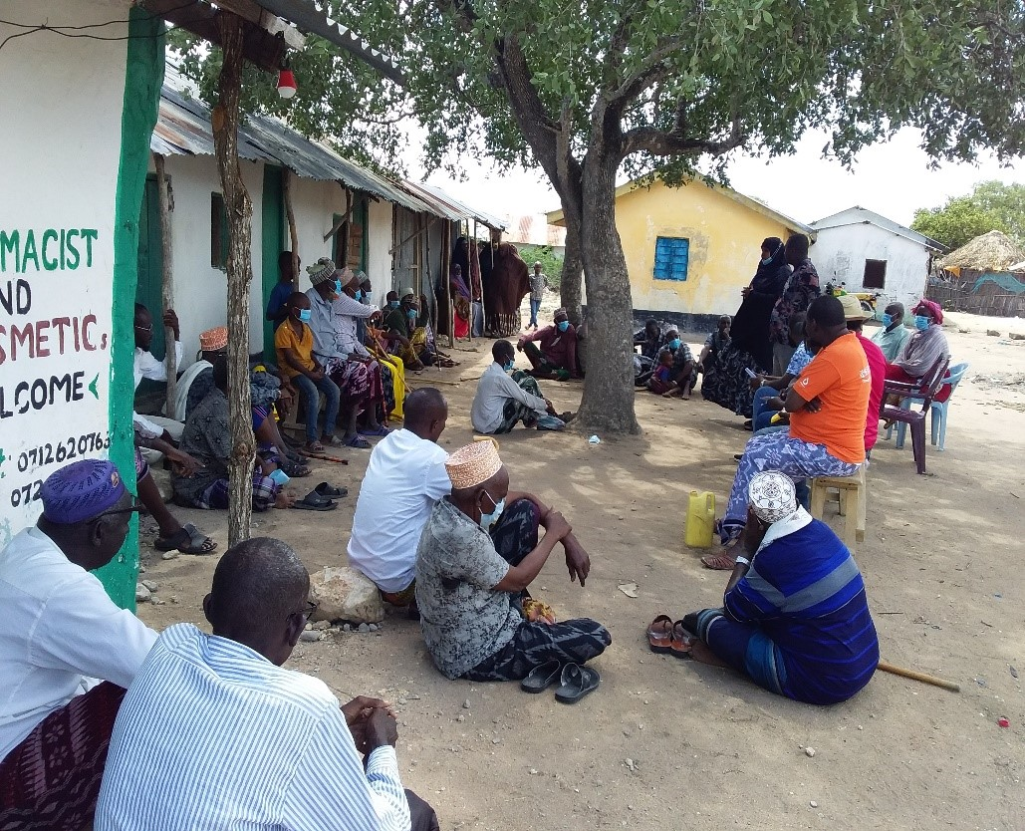

5.4.3 Project Grievance Redress Mechanism
Mr. Koech explained to the community that it is important to put in place a project grievance redress mechanism (GRM). The community members have been addressing grievances or conflict through elders and chiefs office.Mr. Koech further noted that the GRM to be set should borrow heavily from the existing conflict resolution structures in the community. He explained that the need for a GRM is to provide the community and other stakeholder’s opportunity to share project information and raise questions and grievances about the project. He told the community that they are free to raise any complain or request information about the project. He explained that the project will have a three-tier grievance redress mechanism as follows:

1. Locational grievance redress committee. This is where the community will get project information and also ask questions. The community members will select project committee members who will also act as grievance redress committee. The membership will comprise; elders/men representatives, representatives from women, youth, special needs (persons with disability), and the office of the chief as Ex-officials. This will be the first stop for receiving information and raising grievances. The members to be chosen should possess leadership skills and it is hoped that most of the grievances will be resolved at this level
2. County Grievance Redress committee. This will consist members of the County working group. They are tasked with resolving any complains or issues that are unable to be resolved at the local level. The chairman at the community level has to forward complain to the County committee through CREO who is also responsible for giving feed back to the local committee.
3. National Grievance Redress committee. Matters that not resolved at the County level will be escalated to this National GRC by the CEC-Energy
4. The last level of the GRM for the community or project affected persons will be arbitration or legal redress in a court of law once all the three levels have been exhausted.

He explained further that, the members of the project/ grievance redress committee will be chosen by the community members themselves. The committee chosen will be in charge of giving project information to the community and be a focal point for reporting project related issues of concern or grievances. He added that the composition of the committee should have representatives from all groups in the community including men, women, youth and persons with disability

5.4.4 Focus Group Discussions
The community members were told of the need to have focus group discussions to discuss the project further and allow the people more opportunities to ask questions or give suggestions regarding the project. Therefore, three separate meetings for men, women and youth were held. In these meetings the message on the project was echoed again especially on benefits and impacts (both positive and Negative) of the project to the community, rights of the community in regard to land and the need to have a grievance redress committee with representation from all groups in the community.

a) Focus Group Discussion with the Women
As an act to enfold Kenya’s two-third gender rule, women were allowed time to ask questions, give suggestions and or seek clarifications

Table 6-3: Question, Suggestions, Feedback and Response for the Focus Group Discussion with Women
Name of Person making the contribution (e.g. comment or question) | Question, Comment, Suggestion | Feedback/Responses by project team | Response by agency on how feedback will be used or acted upon
No question was asked by the women | We are honoured to host you and come again

Photo of the focus group discussion with the women
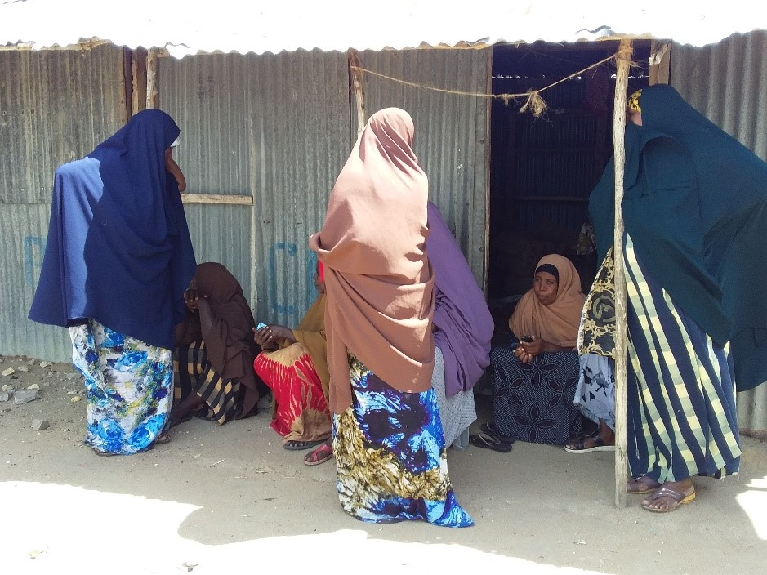

b) Focus Group Discussion with the Youth
Mr.Pius ( from KPLC), lead the group discussion with the youth, as they are also key to the decisions that are made in the community and so discussion with them was necessary. He gave a summary of the project in terms of its positive and negative impacts and their mitigation measures
Plenary Session of the youth
Name of Person making the contribution (e.g. comment or question) | Question, Comment, Suggestion | Feedback/Responses by project team | Response by agency on how feedback will be used or acted upon
Hassan Farah | Where will we be buying tokens from? | Through your phones or registered token vendors

c) Elders/Men Discussions
Koech took the initiative of informing on the relevance of holding separate discussion so that the community get enough opportunities to be informed of the project and be free to ask questions.The elders said they welcome the project and that they had already agreed on the portion of land where the project would be implemented i.e., part of the land which had already been set aside by the community for public utilities and one of the utilities under construction was a dispensary. The discussion was then opened up for questions.
Plenary Session
Name of Person making the contribution (e.g. comment or question) | Question, Comment, Suggestion | Feedback/Responses by project team | Response by agency on how feedback will be used or acted upon
Hussein Dakane | We are very great full. We need this power like yesterday. The land is ready it you who are late.

Summary of ESIA Stakeholder Consultation Process

A Consultative Public Participation (CPPs) session is conducted to provide project information and facts to the local community and other stakeholders especially local government administrator thus giving them a platform to enable them to express their appreciation, concerns and fears as well as contribute ideas and opinions towards the project sustainability.
A detailed CPP and community engagement for Kotile Solar Mini Grid was held at Kotile Primary on 22nd October 2021 chaired by the area chief.

During the consultative forum, there were remarks from Kotile community including the following.
No | Concerns | comments discussed
1. | Concerns on whether the site would be protected from wild animals, livestock and children | The consultant explained that the site will be well fenced to avoid accidents and also for security purpose, it will be in appropriate surveillance everyday by members from KP.
2. | Concerns on how employment opportunities will be distributed for the skilled and unskilled personnel | The consultant expounded and informed the community that the available opportunities will always be advertised and information provided on basic requirements and qualifications. He informed them that those who will be eligible will be considered, local capacity is encouraged. The study team further informed that during project implementation, the contractor will be encouraged to source locally available materials from within so as to create more opportunities for the community
3. | Concerns on whether there would be compensation in case of injuries as a result of construction | The consultant informed the community that the project was being undertaken by qualified and experienced power distribution firm (KP/REREC) and is being implemented in conjunction with the Ministry of Energy. They further noted that the implementation will follow set out guidelines and Kenyan law during construction and implementation including the Work Injury Benefit Act that will be useful in case of injuries/Accidents.
5. | Concerns on how power will be distributed around the area. | The consultants informed that power will be generated from the project site and distributed to an average distance of 1.5km radius around the area.  They further informed that the project has an additional component for installation of standalone solar systems which will be used to electrify institutions and areas outside the 3km diameter zones. He also clarified that this will be provided at a later stage
6. | Concerns on whether women will be engaged on available job opportunities for the project | The study team informed that the project will ensure that opportunities are available for everyone irrespective of their gender. They also informed that women will be considered and integrated into the project.

Positive Comments about the Project from the Participants
Some of the positive impacts that were identified by the participants include the following.
- Employment opportunities will increase for the youth due to increase in business opportunities
- Learning will improve due to availability of lighting
- Medical services will improve due to availability of refrigeration services
- Security will improve due to availability of lighting
- The electricity will assist in pumping of water from the water sources

The identified negative impacts of the project
Some of the positive impacts that were identified by the participants include the following.

- Dust and Waste Generation: The participants expressed concern over possibility of generation of large amounts of dust and waste within the project site and surrounding areas because of demolition, excavation works and transportation of building materials.
- Environmental Aesthetics It was seen that the aesthetics of the area would be affected negatively during construction. It was suggested that the proponent should ensure landscaping is conducted after construction.
Other concerns
- Questions were also raised on whether the power would be provided inform of tokens.
- Some of the members asked whether they be required to pay the cost of connection or only the daily usage
- The proponent will ensure that dust levels at the site are minimized through sprinkling water in areas being excavated and along the tracks used by the transport trucks within the site. The proponent will also ensure that the solid waste generated within the site will be stored on site and later disposed of in an environmentally acceptable manner. Additional mitigation measures presented in this report will be fully implemented to minimize the impacts of dust generation.

Consultant’s Response
The consultant while addressing the community’s issues raised, gave the following response.
- Every resident, business or public facility will be connected to the electricity at a thousand (1000) Kenya shillings per household.
- That the Contractor/KOSAP will rehabilitate and plant trees after the construction phase of the project
- The electricity will be provided in tokens and payments will be made according to the consumption rate for every household.

Consent
The Community members present agreed and accepted the Project Proposal.

Community Presentation

Adult to youth Representation
During the stakeholder’s consultation adults were more represented than the youth as shown in the diagram below.

Gender Representation

Males were more represented as shown below
Figure 7: Adult/Youth representation

Figure 6: Gender representation

Heads of Households
Male were the household heads during the stakeholder consultation

Focused Group Discussions analysis
The in-depth interviews were used as a tool for stakeholder identification and mobilization as well as collection of baseline data to enable identification of the likely project impacts. In addition, it provided an opportunity to the participants to raise their fears and concerns as well as make recommendation as pertains to the project.
During the discussions, information was gathered different roles, livelihood, health issues, challenges, perception of quality of life, education options for children, health care and project perception.
The consultative meeting had a wide representation as follows:
Table 15: The consultative meeting had a wide representation
Category | Male | Female | Total
Youth | 10 | 0 | 10
Adult | 31 | 21 | 52
TOTAL | 41 | 21 | 62
The target groups of the FGD were Males, Females, Health sector, Education sector as well as and the Youths.

Female Stakeholders’ Consultation and Participation
The females’ participants in the FGD were 8 and between 20-50 years of age. There was a good number of females headed households in the meeting. The following were their responses.
The project perception
The women indicated that the project would have a positive impact in the whole community and improve the quality of their lives through provision of lighting especially to be used by children for homework, establishment of businesses and others.
Women in Kotile community and their roles as reported by the FGD
- Building houses, fetching of firewood and water.
- Childcare providers in their homes
- Cooking and other house chores
- Women do not have equal opportunities in the community, men get the opportunities first and they have control of all assets.
- Women always feel unsafe in the community since they boarder with Somalia, however they have not experienced any conflict.
- The challenges encountered by women is that they are unable to provide for their families.
- Women receive information about local issues and development or news through local authority or word of mouth.
- Cooking -wood fuel
- Charging mobile-a few uses portable solar

- The village has limited sources of power as the main challenge.

Male Stakeholders’ Consultation and Participation
- The male participants were 13 in number between 50-82 years of age. The male participants are household heads. The following were the response during the male FDG.
The project perception
- The men indicated that they had heard about the project and that they were aware that the County and National government were planning to install the solar to provide electricity to the community.
- According to the male the project would have positive impact such as provision of power for cooling their milk and other drinks thereby boosting micro-business and provision of lighting at homes.
Role of Men as per the FGD
- The findings showed that the roles of men are mainly siring of children, herding, and watering of livestock, providing leadership and security at the household level.
- They indicated that men have more opportunities in the community
- Men have more control over livestock and land than women
- Men generally feel safe in the community and although they experience some few cases of Livestock raiding.
- The main challenges encountered by men in Kotile community mainly include drought which greatly affect the animals thus forcing them to trek for long distances in search of water and pasture, animal diseases such as tsetse fly, foot and mouth diseases.
- Men generally receive information about local issues and development or news through radios, word of mouth
- Men do not have any cultural groups and their top three community development priorities include water9Water can be pumped from river Tana for irrigation), Need for coolers for storing milk and meat hence financing, Improvement of Kotile Dispensary especially maternity

Mosques are the main religious sites within Kotile community.
- The main festivals undertaken by men include religious festivities e.g., Idd, weddings and rituals during good harvest.

Youth Stakeholders’ Consultation and Participation
- The youth participants were 10 in number, and all were males. The following opinions were provided by the youth participants during the FDG.
The project perception
- The youth disclosed that they were aware and understood the importance of the project to the community.
- They suggested that the project had positive impact since power will be available for lighting, refrigeration services for water cooling, more employment opportunities and improved security of the area.
- They however noted that negative impact as likely injuries through electric shocks and noise from vehicle. They suggested great care while handling electrical appliances.
The Youth Group
- The youth established a youth group in 2020 called Kotile Amal Youth Group, however the youth group was not functioning risks include domestic violence among the community.

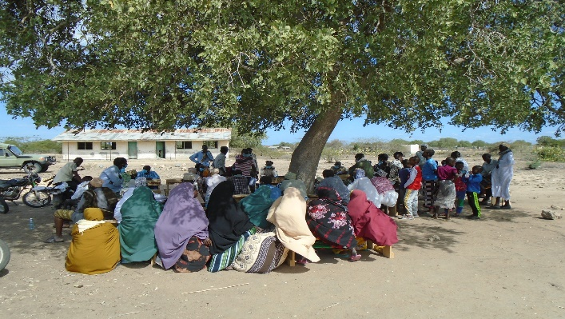
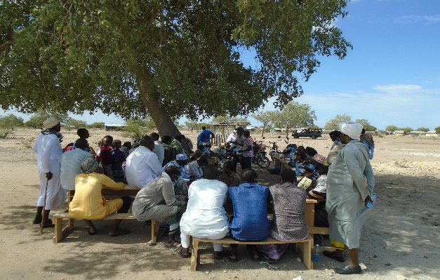
Plate 10. Male FGD
Plate 11. Female FGD

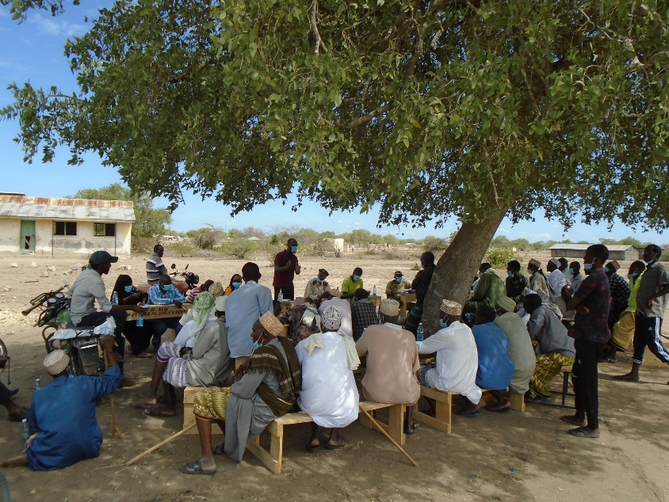

Plate 12. Public Meeting

IDENTIFICATION OF POTENTIAL IMPACTS AND PROPOSED MITIGATION MEASURES.

Introduction
This section provides an assessment of potential environmental and social impacts from the proposed Projects as well as the proposed mitigation measures to avoid, reduce, remediate or compensate for potential negative impacts and to enhance positive impacts. A description of the assessment methodology used to assess the significance of potential impacts, taking into account impact magnitude and sensitivity of receptors and resources affected, is provided below. To facilitate the reading of the ESIA, the same heading structure in terms of environmental indicators, receptors or resources affected by the project activities were considered as the ones used in the baseline. All the mitigation measures identified in this chapter have been collated into the Environmental and Social Management and Monitoring Plan (‘ESMMP’) matrix, including Occupational Health and Safety.

Impact Assessment Methodology
An impact is essentially any change to a resource or receptor brought about by the presence of the Project component or by the execution of a Project related activity. In general, the assessment of impacts will proceed through an iterative process considering four key elements:
- Prediction of potential impacts and their magnitude (i.e., the consequences of the development on the natural and social environment);
- Evaluation of the importance (or significance) of potential impacts taking the sensitivity of the environmental resources or human receptors into account;
- Development of mitigation measures to avoid, reduce or manage the potential impacts or enhancement measures to increase positive impacts; and
- Assessment of residual significant impacts after the application of mitigation and enhancement measures.
Where significant residual impacts remain, further options for mitigation may be considered and impacts re-assessed until they are as low as reasonably practicable for the Project and would be deemed to be within acceptable levels:

Defining Impact
Impacts will be defined in a number of ways, including:
- Nature of impact: positive or negative;
- Type of impact: direct, indirect, or cumulative;
- Duration of impact: temporary, short-term, national, international
- Scale of impact: onsite, local, regional, national, international.

Assessment of Significance
Criteria for assessing the significance of impacts will stem from the following key elements:
- Status of compliance with relevant Kenyan legislation, policies and plans and any relevant Kenyan or industry policies, standards or guidelines, as well as international best practice standards and guidelines;
- The magnitude (including nature, scale and duration) of the change to the natural or socioeconomic environment (e.g. an increase in coastal erosion, or an increase in employment opportunities), expressed, wherever practicable, in quantitative terms. The magnitude of all impacts is viewed from the perspective of those affected by considering the likely perceived importance as understood through stakeholder engagement;
- The nature and sensitivity of the impact receptor (physical, biological, or human). Where the receptor is physical, the assessment considers the quality, sensitivity to change and importance of the receptor. For a human receptor, the sensitivity of the household, community or wider societal group is considered along with their ability to adapt to and manage the effects of the impact; and
- The likelihood (probability) that the identified impact will occur. This is estimated based upon experience or evidence that such an outcome has previously occurred.
It is generally accepted that significance is a function of the magnitude of the impact and the likelihood of the impact occurring.
For this assessment, significance has been defined in Table 6-1 below based on five levels;
Table 6-1: Categories of Significance
Category | Significance
Positive impacts | Positive impacts provide resources or receptors, most often people, with positive benefits. It is noted that concepts of equity need to be considered in assessing the overall positive nature of some impacts such as economic benefits, or opportunities for employment
Negligible impacts (or Insignificant impacts) | Negligible impacts (or Insignificant impacts) are where a resource or receptor (including people) will not be affected in any way by a particular activity or the predicted effect is deemed to be ‘negligible’ or ‘imperceptible’ or is indistinguishable from natural background variations.
Minor | An impact of minor significance (‘Minor impact’) is one where an effect will be experienced, but the impact magnitude is sufficiently small (with or without mitigation) and well within accepted standards, and/or the receptor is of low sensitivity/value.
Moderate | An impact of moderate significance (‘Moderate impact’) is one within accepted limits and standards. Moderate impacts may cover a broad range, from a threshold below which the impact is minor, up to a level that might be just short of breaching a legal limit. Clearly to design an activity so that its effects only just avoid breaking a law and/or cause a major impact is not best practice. The emphasis for moderate impacts is therefore on demonstrating that the impact has been reduced to a level that is ALARP (as-low-as-reasonably-possible). This does not necessarily mean that ‘Moderate’ impacts have to be reduced to ‘Minor’ impacts, but that moderate impacts are being managed effectively and efficiently.
major | An impact of major significance (‘Major impact’) is one where an accepted limit or standard may be exceeded, or large magnitude impacts occur to highly valued/sensitive resource/receptors. An aim of EIA is to get to a position where the Project does not have any major residual impacts, certainly not ones that would endure into the long-term or extend over a large area. However, for some aspects there may be major residual impacts after all practicable mitigation options have been exhausted (i.e., ALARP has been applied). It is then the function of regulators and stakeholders to weigh such negative factors against the positive ones in coming to a decision on the Project.

For environmental impacts the significance criteria used in this ESIA is shown in Table 6-2: .

Table 6-2: Overall Significance Criteria for Environmental Impacts
Receptor sensitivity (or resource value)  Low | Impact Magnitude
 | Low | Medium | High
 | Minor | Minor | Medium
Medium | Minor | Medium | Major
High | Medium | Major | Major

For the social impact assessment, the perceptions of stakeholders, expressed as opinions around certain issues, can be as important as actual impacts. Consequently, the concept of perception is explicitly brought into the evaluation of significance after an impact is evaluated. When an impact is of significant stakeholder concern, this may be causing to raise the significance rating. This prompts the formulation of more rigorous and appropriate mitigation measures which focus on the source of the impact and also address stakeholder perceptions. The risk of not addressing stakeholder perceptions is that reputational damage could arise, resulting in the loss of a social licence to operate.

Magnitude of Impact
The impact assessment describes what will happen by predicting the magnitude of impacts and quantifying these to the extent practical. The term ‘magnitude’ covers all the dimensions of the predicted impact to the natural and social environment including:
- the nature of the change (what resource or receptor is affected and how);
- the spatial extent of the area impacted, or proportion of the population or community affected;
- its temporal extent (i.e., duration, frequency, reversibility); and
- where relevant (accidental or unplanned events), the probability of the impact occurring.
For social impacts, the magnitude considers the perspective of those affected by taking into account the likely perceived importance of the impact, the ability of people to manage and adapt to change and the extent to which a human receptor gains or loses access to, or control over, socio-economic resources resulting in a positive or negative effect on their well-being (a concept combining an individual's health, prosperity, their quality of life, and their satisfaction).

Sensitivity of Resources and Receptors
Sensitivities are defined as aspects of the natural or social environment which support and sustain people and nature. Once affected, their disruption could lead to a disturbance of the stability or the integrity of that environment. For ecological impacts, sensitivity can be assigned as low, medium or high based on the conservation importance of habitats and species. For habitats, these are based on naturalness, extent, rarity, fragility, diversity and importance as a community resource.
For socio-economic impacts, the degree of sensitivity of a receptor is defined as ‘a stakeholder’s (or groups of stakeholders’) resilience or capacity to cope with sudden changes or economic shocks. The sensitivity of a resource is based on its quality and value/importance, for example, by its local, regional, national or international designation, its importance to the local or wider community, or its economic value.

Likelihood
Terms used to define likelihood of occurrence of an impact are explained in Table 6-3 below.

Table 6-3: Explanation of Terms Used for Likelihood of Occurrence
An impact with a
High probability | Refers to a very likely impact | Refers to very frequent impacts
Medium probability | Refers to a likely impact | Refers to occasional impacts
Low probability | Refers to rare impacts | Refers to rare impacts
 | As far as one-time events (e.g., air emissions) or slowly developing effects are concerned (e.g., impacts on local life style) | As far as possibly recurring impacts are concerned, such as accident or unplanned events (e.g., traffic accident, fire)

Definition of mitigation measures
Mitigation measures are developed to avoid, reduce, remedy or compensate for significant potential negative impacts, and to create or enhance potential positive impacts, such as environmental and social benefits. In this context, the term “mitigation measures” includes operational controls as well as management actions. These measures are often established through industry standards and may include:
- Changes to the design of the project during the design process (e.g., changing the development approach);
- Engineering controls and other physical measures applied (e.g., waste water treatment facilities);
- Operational plans and procedures (e.g., waste management plans); and
- The provision of like-for-like replacement, restoration or compensation.
For potential impacts that are assessed to be of major significance, a change in design is sometimes required to avoid or reduce the significance. For potential impacts assessed to be of moderate significance, specific mitigation measures such as engineering controls are often sufficient to reduce these impacts to ALARP (‘as-low-as-reasonably-possible’) levels. This approach takes into account the technical and financial feasibility of mitigation measures. Potential impacts assessed to be of minor significance are usually sufficiently managed through good industry practice, operational plans and procedures.

In developing mitigation measures, the first focus is on measures that will prevent or minimise potential impacts through the design and management of the Project rather than on reinstatement and compensation measures.

Assessing residual impacts
Impact prediction takes into account any mitigation, control and operational management measures that are part of the project design and project plan. A residual impact is the impact that is predicted to remain once mitigation measures have been designed into the intended activity. The residual impacts are described in terms of their significance in accordance with the categories identified in Table 6-1 and Table 6-2 above.
Social, economic and biophysical impacts are inherently and inextricably interconnected. Change in any of these domains will lead to changes in the other domains.

Positive impacts - Pre-Construction
- Employment opportunities arising from recruitment of workers
- Skill acquisition and enhancements to locals and future workforce
- Improvement in quality of life from the in-kind compensation agreed by the community member

Negative Impacts – Pre-Construction Phase

Land Acquisition
The proposed project will entail the acquisition of a 1.1960 hectares land parcel for setting up the mini-grid. The land acquired may also be used to develop contractor facilities, worker’s camps and other ancillary facilities e.g., storage and sanitary facilities. Loss of land used by the communities for livestock grazing and farming may trigger land disputes. New settlements may arise due to migration of people to the centres near the mini-grid disrupting the existing community settlement patterns. The project proponents will use existing access roads to set up the low-voltage power distribution lines and will seek access from PAPs and clients in whose property they will undertake electricity connection to the power grid.
During the consultation, it was also reported that the community is not entirely dependent on the land for income. The land has minimal vegetation cover. After implementing the embedded controls, the impact magnitude is assessed to be minor.

Source of Impact and Overview of Baseline Conditions
- Additional employment opportunities may also be created for the local youth by the contractor.

Embedded/In-built Controls
Enabling the community to benefit from the project by supporting local projects e.g., healthcare access, schools and local water need.

Significance of Impact
The impact significance for communal land uptake is assessed minor considering the community willfully gave the land for project use.

Additional Mitigation Measures
The following additional measures may be recommended to minimise this impact:
- Providing skills-based training interventions, especially for self-employment to the young and unemployed. This will enhance their employability and create potential for income generation through self-employment;
- Procuring resources from the local sources so as to induce more employment in the supply chain.
- Community compensation in kind. The community identifying projects admissible in Water, Health and Education sector within a radius of 10 km.
In line with the RPF provisions;
- Implement an Abbreviated Resettlement Action Plan (A-RAP) to guide land acquisition for the mini-grid, wayleaves for power distribution potential economic displacement and community projects (if applicable). Further, the proponent will fast-track A-RAP preparation to ensure that land acquisition and contractor mobilization to the site is undertaken after the A-RAP is finalized, cleared, and disclosed.

Acquisition of Way leaves
The project proponent will use existing access roads to set up the power distribution lines and will seek access from PAPs and clients in whose property they will undertake electricity connection to the power grid. Supply of electricity will involve passing of low voltage (LV) lines to connect the customers to power.

Embedded/In-built Controls
The LV lines will be constructed mainly along the road reserve and along the boundaries to supply power.

Significance of Impact
The impact significance is assessed minor considering no acquisition of land is anticipated.

Mitigation measures
- Consultations with the community during construction of the low voltage lines to agree on the mode of compensation of the affected areas
- Any damage that will occur to structures, crops, trees, community facilities and other assets as a result of the acquisition of way leaves should be compensated in line with the RPF provisions.

Impact Related to Stakeholder identification and consultations
These impacts are associated with these risks:
- Inexhaustive stakeholder identification, stakeholder mapping and stakeholder information needs basis.
Mitigation measures
- Prior to construction works, identify and map all primary and secondary stakeholders (the various segments of the subproject area community – men, women, PWDs, elders, religious leaders, etc., community level CSOs, sub-county level CSOs with interest in the subproject, county level CSOs with interest in the subproject etc.).
- Assess the interest of each stakeholder category in the subproject
- Assess each stakeholder category’s subproject information needs at the various subproject phases

- Risks related to disclosure of appropriate information in line with the subproject phase
Mitigation Measures
- In consultation with the identified stakeholders, prepare a stakeholder engagement plan (SEP) that is based on their locations (maps) and their information needs at the various subproject phases
- Undertake timely and prior disclosure of relevant project information to the various stakeholder categories in line with their information needs and the project phase
- Carry out robust consultations with all identified community level (primary) stakeholders in a gender, intergenerational and culturally sensitive manner, using appropriate participatory consultative techniques
- Consult with other relevant (secondary) stakeholders (as appropriate) based on their information needs, project phase and the SEP
- Document the information disclosure and stakeholder consultation processes (including venues, dates, minutes of discussions detailing consultation agenda, issues/concerns raised for each agenda item, and responses by the implementing agency)

- Risks related to inadequate consultations with all segments of the community and exclusion of VMGs and vulnerable individuals and households in subproject activities and implementation structures
Mitigation measures
- Ensure adequate consultations prior to construction, and throughout the project cycle with all segments of the community and other relevant stakeholders. This should be based on the SEP, using appropriate consultation techniques
- Ensure all concerns or grievances raised are responded to in a timely manner.

- Risks related to establishment of subproject governance structures, e.g., selecting individuals into management or GRM committees who have not been elected by all segments of the community, or imposing people who are not trustworthy into community level leadership positions
Mitigation measures
- Consult with all segments of the community and agree on the criteria to be used to elect leaders into the subproject governance structures
- Facilitate each segment of the community to elect their representatives to the various governance structures based on the agreed criteria
- Train members of the various governance structures on their roles and responsibilities

- Risks related to exclusion of some stakeholder categories (VMGs, minority clans, disadvantaged individuals, women, youth, PWDs) from the consultation processes and the established subproject implementation structures
Mitigation measures
- Facilitate the various stakeholder groups to establish representative and proportionate subproject implementation structures (implementation committee, GRM Committee etc.) composed of people of integrity who have the interest of their stakeholder category at heart, while ensuring that there is no conflict of interest, e.g., one person should not represent the stakeholder category in more than one structure)
- Train the members of the implementation structures in their respective roles and responsibilities
- Sensitise the various stakeholder categories on the existence, roles and responsibilities of the various implementation structures

Embedded/In-built Controls
Stakeholder engagements regarding the project to get their views and consent done prior to construction works. The consultations include public barazas, focus group discussions and key informant interviews.

Significance of Impact
The impact significance would be major, however, if the mitigation measures are used the residue impact is minor.

Positive Impacts- construction Phase

Impact on Employment
The construction of the mini-grid will provide employment opportunities for skilled and unskilled labour. Receptors in the Social area of Interest that may be able to make the most of the direct and indirect employment opportunities in the project are those who have some level of experience in formal employment, as well as those who have gained a basic education. This will be a source of income for the labourers.
Thus, anticipated benefits of the Project include Direct employment opportunities mainly during construction of the mini-grids The local community is likely to benefit from the opportunities to be created from the following:
- Civil works during construction phase including, construction of solar PV module mounting area, transformer yard, inverter room, internal roads, laydown areas, labour camp, distribution line; and
- Skill transfer from the contractors to the locals that will be given opportunities during the implementation of the project.
The area is characterised by major unemployment. This has affected the community members including the youths, men and woman as reported during Focused group discussion sessions. Thus, the contractor should develop and implement an employment management plan to promote local content. This will ultimately resolve conflict which can be arise if the community feels left out in employment opportunities.

Impact Significance
The impact significance will be moderate due to the high impact magnitude and the low receptor sensitivity. Due to expected limited job opportunities, a few locals will get jobs at the site that will impact their lives substantially.

Enhancement Measures
A significant segment of labour requirement during the construction phase will be sourced locally. While, the significance of the impact on employment opportunities during the construction phase is understood to be positive, the following measures should be put in place to ensure that the local community receives maximum benefit from the presence of the project;
- Preference should be provided to local labour; and
- Preference should be provided to the vulnerable population in the Study Area.

Impact on Local Trade
Where possible, construction materials will be sourced locally in order to promote local businesses.
Thus, anticipated benefits of the Project include indirect employment generated by the procurement of goods and services for the Project; induced employment related to jobs ensuing from the expenditure of incomes. The local community is likely to benefit from the economic opportunities to be created from the following:
- Self- employment options for individuals possessing vocational or technical training skills like electricians, welders, fitters etc;
- Contracting opportunities for local’s residents including men, women and youths. During the public meeting the community insisted that all the unskilled labour force must be given to the locals; and
- Creation of indirect employment for local community through establishing small shops like tea stalls, supply of intermediate raw materials, repair outlets, hardware stores etc. However, these are likely to be temporary.

Impact Significance
The impact significance will be moderate due to the high impact magnitude and the low receptor sensitivity. Due to expected limited job opportunities, a few locals will get jobs at the site that will impact their lives substantially.

Enhancement Measures
- Preference should be provided to local sub-contractors or suppliers to pass on maximum economic benefit locally; and
- The project proponent will establish a mechanism to audit sub-contractors and suppliers with respect to compliance of utilizing local labour and resources.

Negative Impacts – Construction phase

Change in Land Use
The study area consists of communal land with patches of open scrubland. The internal distributions lines will be laid by Kenya Power. The land procured for the project site was uncultivated, and undeveloped. During consultation, it was established that the land belongs to the Kotile Community. The community has since allocated the land in kind for project use. The establishment of the mini-grid will convert communal land to industrial use for long term.
For the purpose of assessment of impacts on land use of the area, the following project activities leading to an alteration in land use of the area during construction phase have been considered:
- Installation of PV modules;
- Establishment and operation of temporary structures such as temporary site office and store yard.
The land use receptor sensitivity criteria will be low. This is due to the fact that there will be visual change upon installation of the mini-grid. There is no major dependency for grazing or agriculture on the land offered for the project. The magnitude criteria of this impact will be medium because there will be noticeable of change over the restricted site area. The change may be medium to long term and is reversible.

Embedded/In-built Control
- The construction activities will be restricted to within the allocated land and the immediate surroundings only.
- After construction work, any land taken for a temporary basis for storage of material will be restored to their original form.
- The existing earth roads at Kotile will be used for access to the project site.

Significance of Impact
The overall impact significance on land use will be Moderate. This is the case due to the fact that the receptor sensitivity is medium and the impact magnitude is medium.

Additional Mitigation Measures
- On completion of construction activities, land used for temporary facilities such as store yard should be restored to the extent possible;
- The land use in and around permanent project facilities should not be disturbed.
- Construction activities should be restricted to the designated area.

Vegetation Clearance
The construction process of the proposed Mini-grid and other associated facilities and structures will involve clearing of the existing vegetation cover (mainly grass) and trees. The project site is located in open area with minimal settlement around besides the dispensary and residential homes. Both the magnitude and sensitivity of this impact will be low. The impact will be direct, permanent and minor.
Mitigation Measures
- Clear only the necessary areas
- Ensure proper demarcation and delineation of the project area to be affected by construction works.
- Specify locations for vehicles and equipment, and areas of the site which should be kept free of traffic, equipment, and storage.
- Designate access routes and parking areas
- Re-vegetation including planting of trees around the plant/facility

Impact on Topography
The topography of the project site is an open area with gentle slope of about 1.7% and mild undulations. There are no water bodies that pass though directly the proposed project site. Typically, solar power projects do not undertake levelling of topography and since the proposed project, along with the access road, is mostly on a flat terrain the receptor sensitivity has been assessed to be low.

Due to undulating topography, study area may exhibit presence of micro drainage channels. Therefore, the impact magnitude has therefore been assessed as minor.

Embedded/In built Control
The contractor will be instructed to avoid any unnecessary changes in the topography.

Significance of Impact
The overall impact significance will be Minor. This because the impact magnitude is low and there will be no major changes to the topography and the receptor sensitivity is low.

Additional Mitigation Measures
- Appropriate number of cross drainage channels should be provided during construction to maintain flow in existing natural channels.
- Disruption/alteration of micro-watershed drainage pattern should be minimized to the extent possible.

Impact on Soil
The project activities that may impact the environment are described below:

- Vegetation clearance and top soil removal;
- Storage of oil and lubricants onsite;
- Storage of construction materials; and
- Disposal of different type of waste generated from the temporary project site.
- Storage of oil and lubricants onsite;
- Disposal of municipal solid waste and waste water from site office; and
- Storage of waste materials onsite.
- Removal of PV modules;
- Removal of associated infrastructure including battery and generators.

Significance of Impacts
The significance of the impact to the soil will be minor due to the nature of the works and the fact that construction and operational activities will be confined in the small project area.

Additional Mitigations
- Vehicles will utilize the existing roads to access the site;
- No unauthorized dumping of used oil and other hazardous waste should be undertaken at site;
- Avoid groundbreaking during the seasons of high rainfall to avoid erosion.
- Monitoring of areas of exposed soil during rainy seasons to ensure that any incidents of erosion are quickly controlled
- All waste should be stored in a shed that is protected from the elements (wind, rain, storms, etc.) and away from natural drainage channels;
- Solid waste should be Segregated in color coded waste receptacles.
- In case of accidental/unintended spillage on small area, the contaminated soil should be immediately collected and stored as hazardous waste;
- Compacting of loose soil in excavated areas.
- Enclose the construction site and protect the soil to prevent the waste soils and other debris from being washed away by surface runoff and wind.
- All dug up soil that is not needed on-site to be removed promptly and disposed of to appropriate areas.
- Re-use the dug-up soil in backfilling and landscaping.
- Any soil potentially contaminated by chemicals, oils, fuels to be collected and disposed of by a NEMA authorized waste

Impact on Air Quality
The assessment with respect to air quality of the study area has been done for the following project activities:
- Fugitive emissions from site clearing, excavation work, material handling etc.;
- Fugitive emission from traffic movement;
- Exhaust emission from operation of machineries like pile drivers, vehicles; and
- Point source emission from diesel generator.

Embedded/in-built control
Vehicle engines need to be properly maintained to ensure minimization in vehicular emissions.

Significance of Impact
There are few Receptors (settlements) within 500 m of the project site, that include the community borehole and some residential homes, and the impact magnitude will be moderate and sensitivity medium hence the impact significance will be moderate.
Sensitive receptors of air and emissions were identified by observation during field visit to project site. They were noted to be mainly residential and commercial in nature. The distances from a source that dust impacts can occur is highly site specific and will depend on the extent and nature of incorporated mitigation measures, prevailing wind conditions, rainfall and the presence of natural screening. Due to the variability of the weather, it is impossible to predict what the weather conditions will be when specific construction activities are being undertaken. Therefore, the assessment of construction dust impacts is typically qualitative.

Additional Mitigation Measures
- Spraying water on soil before excavation and periodic access road wetting to reduce nuisance dust levels.
- Visual inspection of dust pollution from roads and the construction site and appropriate intervention if dust levels are high.
- Speed restriction of construction vehicles to a speed of 10-15km/h or less on the site and on the access roads to the site.
- Maintenance and servicing of machines and engines off-site.
- Grievance procedure for dust complaints.
- The use of appropriate Personal Protective Equipment (PPE) such as dust masks, in particular, for construction workers.
- All construction materials will be transported in designated trucks which will be covered.
- Stockpiles of excavated soil should be enclosed/covered/watered during dry or windy conditions to reduce dust emissions
- Burning of woody debris & construction waste to be prohibited
- Plant short trees to break speed of wind

Impact on Ambient Noise
As most of the noise generating activities will be performed within the site area, construction activities will likely have a small to insignificant incremental impact on the existing noise levels. The sources of noise in the construction phase include construction activities, operation of generator sets and movement of vehicles. There will also be increased noise levels because of increased anthropogenic movement in the area.
There are some residents within the 500m from the site and will most likely be affected by increasing noise levels. The receptor sensitivity is therefore considered as medium. Impact magnitude is considered to be minor to medium considering the construction period of the project that will last for not more than 12 months.

Assessment Criteria for Impact on Ambient Noise
The assessment with respect to ambient noise quality of the study area has been done for the following project activities:
- Construction activities including site preparation, piling work, construction of ancillary facilities;
- Transportation of construction materials, machinery and personnel; and
- Operation of generator sets.
The ambient noise levels have been assessed with respect to Noise Pollution (Regulation and Control) Rules, 2000 and WHO Guidelines.

Embedded/in-built control
Normal working hours of the contractor to be defined (preferable 0800hrs to 1700hrs). If work needs to be undertaken outside these hours, it should be limited to activities which do not generate noise.

Significance of Impact
The impact significance has therefore been assessed moderate. This due to the fact that the impact magnitude is low and the receptor sensitivity is medium.

Additional Mitigation Measures
- Only well-maintained equipment should be operated on-site;
- If it is noticed that any particular equipment is generating too much noise then lubricating moving parts, tightening loose parts and replacing worn out components should be carried out to bring down the noise and placing such machinery far away from the households as possible;
- Machinery and construction equipment that may be in intermittent use should be shut down or throttled down during non-work periods; and
- Minimal use of vehicle horns and heavy engine breaking in the area needs to be encouraged.
- Construction machineries should be maintained regularly to reduce noise resulting from friction;
- Normal working hours of the contractor to be defined (preferable 8 am to 5pm). If work needs to be undertaken outside these hours, it should be limited to activities which do not generate noise;
- Sensitize construction truck drivers to switch off vehicle engines while offloading materials.

Visual Intrusions and Changes in Landscape Impact
The project site is located on plain terrain with slight undulation. There will be no significant change to visual quality of the area resulting from development or change in land use that will alter the landscape. Changes in the visual landscape will range from construction phase to commissioning of the mini-grid and associated structures and further during operations. This Project is the first major solar power Project in the vicinity of project area and the new development will have impact on the surrounding area.

The project area is primarily a rural area and with agriculture as a primary activity. Although the solar panels, inverter, Transformers and associated components would be manufactured off site and the construction phase would be relatively short-term in duration (less than one year), it would still require large number of equipment or infrastructure when being erected such as dumpers and transportation vehicles on site. Additionally, the presence of bare soil along the access roads would increase the potential visual impact. The significance of the visual impacts will reduce at increasing distance from the development.
The construction of the mini-grid sites may involve the site clearance of vegetation (minimal vegetation at the site) and other natural attributes. The erection of the solar PV panels and the resulting glare from the sun will make it a standout feature from the natural surroundings and this would the lower the visual appeal of the area.
Even though the Mini grid facilities will be small, the solar panels may have minimal visual impact. However, being visible is not necessarily the same as being intrusive. Aesthetic issues are by their nature highly subjective.

Embedded/In-built Control
Proper siting decisions can help to avoid aesthetic impacts to the landscape. The project site is located in open area with minimal settlement around besides the dispensary and residential homes.

Significance of Impact
Construction activities will mainly be inside the site footprint and will have moderate impact on the present visual environment. The sensitive receptors include the residents near the site. The impact magnitude will however be low hence the visual change during construction phase will be assessed as minor.

Additional Mitigation Measures
The following mitigation measures will have to be implemented to minimise potential visual impacts during the construction phase:
- The extent of the labour camp and storage area should be limited in area to only that which is essential;
- Minimize presence of ancillary structures on the site and minimize roads disturbance;
- Upon completion of construction work, areas utilized for labour camp, storage area to be restored to original form.

Impacts on Waste Generation and Soil Contamination
General construction waste generated onsite will comprise of concrete, steel cuttings/filings, packaging paper or plastic etc. solid wastes consisting of food waste, plastic, glass and waste paper will also be generated by the construction workforce. A small proportion of the waste generated during construction phase will be hazardous and will include waste fuel, grease and waste oil containing rags. Used transformer oil which is also categorized as hazardous waste will be generated from the plant. If improperly managed, solid waste could create impacts on soil quality. Therefore, the receptor sensitivity has been assessed as medium.

The impact magnitude has been assessed as low since the proponent has managed other solar power projects as well and has effective management systems for waste and hazardous substances being generated or utilized during the project life cycle as part of their Environmental and Social Management Framework.

Embedded/in-built control
Hazardous material and waste should be properly labelled, stored onsite at a location provided with impervious surface and in a secondary containment system.

Significance of Impact
The impact significance for waste generation and soil contamination has been assessed as minor. Given the low sensitivity of the surrounding areas and the medium magnitude of the potential consequences of soil contamination, the potential impact significance is rated as minor.

Additional Mitigation Measures
- Contractor should ensure that no unauthorized dumping of used oil and other hazardous waste is undertaken at the site;
- Designated areas should be provided for Solid Waste and daily collection and period disposal should be ensured;
- Construction and Demolition Waste should be stored separately and be periodically collected by an authorized treatment and storage facility;
- All waste should be stored in a shed that is protected from the elements (wind, rain, storms, etc.) and away from natural drainage channels;
- A log book should be maintained for quantity and type of hazardous waste generated; and
- In case of accidental/unintended spillage, the contaminated soil should be immediately collected and stored as hazardous waste.
- Ensure spoil from excavations is arranged according to the various soil layers. This soil can then be returned during landscaping and then rehabilitation, in the correct order which they were removed that is top soil last; The contractor should comply with the requirement of OSHA ACT 2007 and Building rules on storage of construction materials
- Use of durable, long-lasting materials that will not need to be replaced as often, thereby reducing the amount of waste generated over time
- Recovery of materials remains and return to stores
- Re-use of materials where possible
- Proper disposal of waste in line with solid waste regulation
- Construction wastes to be managed in accordance with construction standards in Kenya
- Contractor to put in place and comply with a site waste management plan

Impacts on Water Quality
During construction, excavation activities will involve soil exposure which results in soil erosion due to wind and surface runoff due to rains. Seepage from spilled fuels and oils and leaking machinery can also negatively impact groundwater water which could lead to potential contamination.

Significance of Impact
Generally, due to the localized area of impact, the overall significance of the related impacts on water quality is considered to be minor, provided the necessary mitigation/ management measures are implemented.

Mitigation Measures
Measures shall be put in place to minimize erosion and sediment mobility, especially during construction. These measures include:
- Clear the necessary areas only.
- Appropriate remedial measures shall be implemented by the contractor in the event of erosion.
- Infrastructure shall be designed to ensure that contaminated run-off does not reach watercourses.
- In the event of an oil spill the procedures contained in the emergency response plan of the contractor will come into effect.
- No vehicle maintenance and service shall be done at project site but in approved garages or service stations to avoid any possible oil and fuel spills that could contaminate soils and possibly ground water quality.
- Ensure that potential sources of petro-chemical pollution are handled in such a way to reduce chances of spills and leaks.
- Construction activities to avoid any unchanneled flow of water at the site
- Storage areas that contain hazardous substances should be bundled with an approved impermeable liner and provision for a pit to be made in case of oil spill.
- The excavation and use of rubbish pits during construction should be strictly prohibited.
- A waste disposal area should be designated within the active construction area and this should be equipped with suitable containers i.e., skips or bins of sufficient capacity and designed to contain and prevent refuse from being blown by wind,
- Areas contaminated by spilled concrete and/or fuels and oils leaking from vehicles and machinery should be cleaned immediately.
- The contractor to source for alternative source of water for construction purposes to avoid potential conflict with the community.

Impacts from Hazardous Materials
Some hazardous materials will be used during construction phase of the project. They include insulating oil, paints, solvents and oils. Spilled chemicals can contaminate soil as well as pollute water resources. Additionally, hazardous and flammable substances if improperly stored and handled on site become potential health hazard for construction workers and the public.

Significance of Impact
The amount of hazardous waste generated will be minimal. The significance of the impact will be minor due to a low magnitude and medium sensitivity.

Mitigation Measures
- Maintenance of construction vehicles will not be done on site
- All hazardous products and waste should be labelled and handled properly to avoid contact with the ground
- Material handling to be done by trained and qualified staff
- The contractor site should have designated area (concrete bunded) for storing hazards materials

Fire Hazards
During construction of the project, fire hazards are likely to occur especially when precaution measures are not taken to account. Smoking is one of causes of fires and this can happen if cigarette butts are left carelessly. Additionally, keeping of fuels onsite during construction can be a potential cause of fire.

Significance of Impact
This impact is evaluated to be of moderate significance. All the construction activities will be confined at the project site hence high sensitivity and low magnitude.

Mitigation Measures
The following measures should be put in place to prevent fire hazards:
- Create awareness to the construction workers on potential fire hazards
- Provision of firefighting equipment (extinguishers) on site during construction.
- No smoking shall be done on construction site
- ‘No smoking’ signs shall be posted at the construction site
- A fire evacuation plan must be posted in various points of the construction site including procedures to take when a fire is reported.

Impacts of construction material sourcing (e.g., quarrying)
The construction of the project will utilize materials such as; stone, ballast, sand and hardcore. It is anticipated that they will be obtained from quarry and mining operations. Conscious or unwitting purchase of these materials from unlicensed operations indirectly supports, encourages and promotes environmental degradation at the illegal quarry sites and causes medium to long term negative impacts at source, including landslides.

Significance of Impact
The significance of this impact will be moderate due to high sensitivity and low magnitude.

Mitigation Measures
- The contractor should source all building materials such as stone, sand, ballast and hard core from NEMA approved sites.
- Ensure accurate budgeting and estimation of actual construction materials to avoid wastage.
- Reuse of construction materials where possible.

Energy Consumption
The construction works will consume fossil fuels (mainly diesel) to run transport vehicles and construction machinery. Fossil energy is non-renewable and its excessive use may have serious environmental implications on its availability, price and sustainability.

Significance of Impact
This impact will be negligible owing to the size of the project that will require very few trucks during the construction phase.

Mitigation Measures
- Proper planning of transportation of materials will ensure that fossil fuels (diesel, petrol) are not consumed in excessive amounts. Complementary to these measures, the contractor shall monitor energy use during construction and set targets for reduction of energy use.
- Regular maintenance of vehicles to ensure efficient consumption of fuels.

Impact on Occupational Health and Safety
The construction activities include site preparation, infrastructure utilities installation, building structures. As a result, will be potential impacts on workers’ health and safety due to exposure to risks through construction activities that lead to accidents causing injuries and death. The most probable risks cause of accidental death and injury are:
  - Safety risks such as: tripping; falling due to working at heights; potential fire due to hot work, smoking, failure in electrical installations; electric shocks.
  - Health risks: Injuries such as: lifting, lowering, pushing, pulling and carrying; temporary or hearing loss which usually comes from noise generated from machinery used for excavation or piling work and from compressors and concrete mixers etc.; heat stress and working during high temperatures
  - Occupational hazards due to dust and noise pollution from operating of heavy machinery and vehicular movement in the project sites.
  - Safety risk due to working at heights during installation of power lines
  - Risks of road accidents during the transportation of material and equipment to the project sites owing to the poor road network leading to Kotile village.

Embedded/in-built control
- All construction activities will be carried out during daytime hours and vigilance should be maintained for any potential accidents;
- Personal Protective Equipment (PPEs) including safety shoes, helmet, goggles, ear muffs and face masks;
- Cranes and other lifting equipment are operated by trained and authorised persons;
- Training of the workers on climbing techniques, and rescue of fall-arrested workers; and
- Excavated areas should be temporarily fenced to avoid access to outsiders and animals.

Significance of Impacts
The impact on occupational health and safety during the construction phase is evaluated to be of moderate significance. All the construction activities will be confined at the project site hence high sensitivity and low magnitude.

Additional mitigation measures
- All workers (regular and contracted) should be provided with training on Health and Safety management system of the contractor during construction stage;
- Obtain and check safety method statements from contractors;
- Monitor health and safety performance and have an operating audit system; and
- Permitting system should be implemented to ensure that cranes and lifting equipment is operated by trained and authorized persons only;
- Appropriate safety harnesses and lowering/raising tools should be used for working at heights;
- All equipment should be turned off and checked when not in use; and
- A safety or emergency management plan should be in place to account for natural disasters, accidents and any emergency situations.

Community Health and Safety
The receptors for impacts on community health and safety include project site workers, settlements in the close proximity of the project which will be exposed to health impacts from the project activities. The construction phase activities such as installation of solar panels, construction of distribution lines and substations and movement of material and personnel may result in impacts on the health and safety of the community.
Construction activities will involve the use of machinery and installation of distribution power
lines. Furthermore, the movement of material and personnel via the access roads may result in damage to human life or livestock due to accidents. The major community health and safety risks include structural failure of project infrastructure e.g., power line, fire safety and management of emergency situations.

Embedded/in-built control
Consultations with the proponent team and policy review indicated that the following embedded/in built control measures will be put in place during the construction phase;
- The excavated areas will be properly fenced for safety and sign boards in local languages will be put up;
- No hazardous waste or any waste be stored within the site for long periods of time and be in contact with the soil in order to prevent against ground water contamination
- The truck drivers carrying construction machinery and materials will be instructed to drive within speed limits with careful consideration for village traffic;
- Movement of heavy equipment and construction materials will be regulated during peak hours (0900hrs to 0500hrs).

Significance of Impact
Impact significate is rated as moderate considering the high impact magnitude and low receptor sensitivity.

Additional Mitigation Measures
The following risk mitigation measures are suggested to minimize the risks/ hazards of construction activities onsite;
- Developing an onsite ESMS and EHS Policy by the developer;
- Ensuring that the sub-contractor agreements that the developer enters into require all contractors to possess an EHS plan with provisions for monitoring of the EHS performance of contractors and their workers;
- As part of the stakeholder engagement and information disclosure process, providing an understanding to the community concerning the activities proposed to be undertaken and the precautions being adopted for safety; and
- Implementing the existing grievance redress mechanism.

Child labour
Implementation of the Kotile project could lead to increased opportunities for the host communities to sell goods and services to the incoming workers. This can lead to child labour to produce and deliver these goods and services, which in turn can lead to increased cases of school truancy and dropout.

Significance of Impact
The impact is rated minor. This is based on low sensitivity of the receptor and medium magnitude of the impact.

Mitigation measures
- The contractor should develop a code of conduct to ensure children are protected from any negative impact from the construction works.
- The contractor should strictly hire people who are above 18yrs and ensure they provide their Identity Cards.
- The contractor shall ensure every worker under their jurisdiction signs a document committing themselves to the protection of the area children.

Impacts on Cultural Heritage
Cultural and paleontological artifacts and cultural landscapes may be disturbed by the construction of the mini grid facilities. These could include community burial sites, sacred shrines. It is expected that a number of workers will be on-site during project construction of the project including skilled, semi-skilled, and unskilled personnel. During the consultation and field survey, no cultural artefact was established at the proposed project site.

Significance of Impact
Based on the analysis provided above, impacts on cultural heritage during the construction phase will be Minor considering low sensitivity of the receptor and low magnitude of the impact.

Additional Mitigation measures (Execution of a Chance Find Procedure)
In order to minimize the potential for impact to sub-surface cultural archaeological material, the proponent should establish a Chance Find Programme which includes the following provisions:
- A chance find can be reported by any member of the Project. Accordingly, if a chance find is encountered, the first course of action is to stop work in the vicinity of the find. Then the following steps will be undertaken:
- Inform site supervisor/foreman.
- Install temporary site protection measures (warning tape and keep off signs).
- Inform all personnel of the Chance Find if access to any part of the work area is restricted.
- Establish a localized no-go area needed to protect the Chance Find.
- The National Museum of Kenya will be contacted to perform a preliminary evaluation to determine whether the Chance Find is cultural heritage and if so, whether it is an isolate or part of a larger site or feature.
- Artefacts will be left in place when possible; if materials are collected, they will be placed in bags and labelled by an archaeologist and handed over to the National Museum of Kenya; no Project personnel are permitted to take or keep artefacts as personal possessions.
- Document find through photography, notes, GPS coordinates, and maps (collect spatial data) as appropriate.
- If the Chance Find proves to be an isolated find or not cultural heritage, the specialists brought in from the National Museum of Kenya will authorize the removal of site protection measures and activity in the vicinity of the site can resume.
- If the archaeological specialists from National Museum of Kenya confirm the Chance Find is a cultural heritage site, they will inform the project team and initiate discussions with the latter about treatment.
- Prepare and retain archaeological monitoring records including all initial reports whether they are later confirmed or not.
- Develop and implement treatment plans for confirmed finds using the services of qualified cultural heritage experts.
- If a Chance Find is a verified cultural heritage site, prepare a final Chance Finds report once treatment has been completed.
- While investigation is on-going, co-ordinate with on-site personnel keeping them informed as to status and schedule of investigations, and informing them when the construction may resume.
- If mitigation is required, then expedient rescue excavations will be undertaken by the National Museum of Kenya specialist, except in the case that the chance find is of international importance (i.e., Critical Cultural Heritage). If an archaeological site of international importance is encountered special care will be taken and archaeologists with the appropriate expertise in addressing the find will be appointed.

Gender Based Violence, SEA & SH
Gender Based Violence (GBV), Sexual Exploitation and Abuse (SEA) may be committed against the communities by the construction workers and by staff during the operation and maintenance of the mini-grids. Incidences of Sexual Harassment (SH) may occur among the staff during construction phases of the project. This may be experienced while the women are searching for jobs and those giving the jobs may ask for sexual favours.

Significance of Impact
GBV cannot be ruled out during project implementation. Thus, the significance of this impact is considered to be Minor considering low sensitivity of the receptor and low magnitude of the impact.

Mitigation measures
- Prepare an Awareness Raising Strategy, which describes how workers and local communities will be sensitized to GBV risks, and the worker’s responsibilities;
- Identify GBV Services Providers to which GBV survivors will be referred, and the services which will be available;
- Elaborate GBV Allegation Procedures i.e. How the project will provide information to employees and the community on how to report cases of GBV breaches to the grievance committee.
- An Accountability and Response Framework, to be finalized with input from the contractor, should include at minimum:
    - GBV Allegation Procedures to report GBV issues to service providers, and internally for case accountability procedures which should clearly lay out confidentiality requirements for dealing with cases; and,
    - A Response Framework which has:
      - Mechanisms to hold accountable alleged perpetrators associated to the project;
      - The GM process for capturing disclosure of GBV;
      - A referral pathway to refer survivors to appropriate support services.

Exclusion of VMGs, Vulnerable Individuals and Households
A significant risk associated with this project is the potential for the exclusion of Vulnerable and Marginalized Groups (VMGs), vulnerable individuals and households including the elderly, PLWDs, widows, widowers, orphan-led households, minority clans/sub-clans from participating and or benefiting from the mini-grids project. VMGs participation and inclusion could be disadvantaged based on social identity, which may be across dimensions of gender, age, location, occupation, race, ethnicity, disability, sexual orientation and religion. There is potential risk of lack of intentional actions by the mini-grids contractor(s) and implementing agencies for the inclusion of VMGs in the project activities and benefits. This potentially leads to the exclusion of VMGS from the benefits and opportunities derived from the proposed mini-grid facilities.

The activities of component 1 envisages upon completion of the MG, that the relevant Implementing Agencies will connect customers from community facilities, enterprises and households to the electricity grid on a commercial basis under a market driven approach. There is a high likelihood that the targeted PAPs of the new electricity connections to the mini-grids network will be dominated by the local elites. This may lead to the exclusion of those without the financial resources to connect to the mini-grid electricity distribution network. This could result in a situation where a majority persons or households with adequate financial resources in the project area will be able to take advantage of the provision to connect to the electricity grid. This will negate a key objective of the project of overcoming energy poverty.

During the ESIA study the community identified the people and households considered vulnerable in the community as:
Women headed households
Orphans
Persons Living with Disabilities - Albinos
The elderly (80 years and above)

Significance of Impact
Considering the high sensitivity of the VMGs and the vulnerable individuals and households identified in the project and high magnitude, the impact significance is considered to be major. However, it is important to put into account the project site inhabitants are predominantly the Somali community.

Mitigation measures
- Participation will be through meetings with the different groups of the vulnerable people identified primarily to ensure that;
    - The VMGs and the vulnerable individuals and households are aware of the project and its impacts
    - The VMGs and the vulnerable individuals and households are Aware of any restrictions and negative impacts
    - Provide support to VMG and the vulnerable individuals and households participation arrangements in the project
- Confer with the VMGs and the vulnerable individuals and households at the outset on how they wish to be engaged
- Understand and respect local entry protocols as they relate to permission to enter a community and access traditional lands
- Commit to open and transparent communication and engagement from the beginning and have a considered approach in place
- Ensure that all representatives of the contractor and Proponent staff carrying out the specific sub project investment including third party subcontractors and agents are well briefed on local customs, history and legal status, and understand the need for cultural sensitivity
- Regularly monitor performance in engagement
- Enlist the services of reputable advisers with good local knowledge
- Implement the existing grievance redress mechanism

Risk of Communicable Diseases
The mini-grids will lead to increased migration of labour into the mini-grid sites. Local communities can be exposed to increased risk of communicable diseases such as HIV/AIDS, STIs and COVID-19 through risky behaviours involving job seekers and people employed on the project.

Significance of Impact
Based on the fact that the receptor sensitivity will be medium and the impact magnitude low, the impact significance will be Moderate pre-mitigation.

Mitigation measures
- The Contractor should develop and implement pre-employment screening measures for workers, which should include communicable diseases. Individuals found to be suffering from these diseases will need to be sensitized on prevention of transmission to others and management of the disease prior to mobilisation to site.
- The Contractor should develop and implement a Communicable Diseases Policy and an information document for all workers directly related to the Project. The document should address factual health issues as well as behaviour change issues around the transmission and infection of diseases.
- The Contractor will make condoms available to employees and communities neighbouring the site office during construction.
- All project personnel should be inducted on a Code of Conduct that gives guidelines on worker-worker interactions, worker-community interactions and development of personal relationships with members of the local communities.
- If workers are found to be in contravention of the Code of Conduct, which they will be required to sign at the commencement of their contract, they will face disciplinary action including dismissal from duty.
- Sensitize all community segments and project workers on Covid 19 and precautionary measures that need to be observed;
- Restrict site access to only Authorised persons; and
- Continuously adhere to the MoH, WHO and World Bank guidelines on Covid-19 management.

Increased Water Demand
During the construction of the project there will be increased demand for water by the construction workers and the construction works. Water will be mostly used in the construction works and for wetting surfaces or cleaning completed structures. It will also be used by the construction workers to wash themselves and even drink.

Significance of Impact
Although the sensitivity of the receptor (surface water) in the project area is high owing to unavailability of feasible alternative source of water for the local community, the overall significance of impacts is assessed to be negligible due to negligible magnitude of the impact.

Mitigation Measures
- Prudent use of available water
- Consultations with the project local committee on use of water in the community to avoid conflicts with the community
- Contractor to make own arrangements to provide water for construction works different from the community dam to avoid any conflicts with community.

Forced Labor
During construction of the mini-grid the risk of forced labour could occur and precaution is need to safe guard the community from being subjected to forced labour.

Significance of Impact
The impact significance is rated minor, based on low sensitivity of the receptor and medium magnitude of the impact.

Mitigation Measures
- Contractor must adhere to the employment Act which outlaws any form of forced labor
- Community to report any form of forced labor at the site
- Contractor to ensure that all workers have a national ID card or documentation to show they are adults (above 18 years).

Accidental Oil Spills or Leaks
There is possibility of oil leaks from construction vehicles. The construction machines on the proposed site have moving parts which will require continuous oiling to minimize the usual corrosion or wear and tear. These processes may lead to oil spill to the ground. The impact significance will be minor due to the nature of the works and the fact that construction activities will be confined in the small project area.

Mitigation Measures
- In the event of accidental leaks, contaminated top soil should be scooped and disposed of appropriately.
- It is proposed that the refueling and maintenance of vehicles will not take place at the construction site.
- Contractor to create awareness for the employees on site on procedures of dealing with spills and leaks from oil for the construction machinery
- Vehicles and equipment must be serviced regularly and kept in good state to avoid leaks.
- In case of spillage the contractor should isolate the source of oil spill and contain the spillage using sandbags, sawdust, absorbent materials and/or other materials approved by materials.
- Proper training for the handling and use of fuels and hazardous material for construction workers.
- All chemicals should be stored within the bunded areas and clearly labeled detailing the nature and quantity of chemicals within individual containers.

Positive Impacts- Operation Phase

Impact on Economy and Employment
Community consultations and observations made during the site visit suggest that the existing scenario of the agriculture in the study area is not capable enough to meet requirements of the people who are solely dependent upon it; especially due to limited water availability and growing population.

During the operations phase, the requirement for unskilled and semi-skilled labour is expected to reduce to 5 and 15 respectively. The locally procured services will include maintenance work of the facility, 24-hour security, bush and undergrowth cleaning and housekeeping activities. In addition to this, the community will improve their livelihood and businesses by using the electricity from the project.

Significance of Impact
The overall impact significance of the impact on economy and employment during the operations phase is Major, the receptor sensitivity will be medium and the impact magnitude will be high.

Enhancement Measures
While, the significance of the impact on economy and employment opportunities during the operations phase is understood to be positive, the following measures should be put in place to ensure that the local community receives maximum benefit from the presence of the project:
- Priority should be provided to local labour or suppliers to pass on maximum economic benefit locally;
- Opportunities should be provided to the vulnerable population in the Study Area

Quality, Reliable Power Supply
There is no electricity in Kotile. This is a maiden project with an aim of supplying power through solar because the area is far away from the national power grid. Once operational, household and public institutions in the area will greatly benefit from the stable power supply.

Significance of Impact
The impact significance is high as it will provide power where it wasn’t for a long period

Enhancement Measures
- KPLC should ensure that they have a functional customer support team and a field response team;
- KPLC should ensure that they communicate power outages early to consumers

Reduction of Pollution Associated with Thermal Power Generation, Kerosene and Wood Fuel Usage:
Residents in the area use different sources of energy. Electricity supply will imply that as many as are willing can apply for connection and get connected. This will result in reduced individuals and organizations using diesel generators, less reliance on kerosene, wood fuel and charcoal. This would mean less carbon dioxide is released to the environment and destruction of forests will be reduced hence decreasing greenhouse gases.

Significance of Impact
The impact significance is high as it will provide cleaner energy over a long period of time for many households

Enhancement Measures
- KPLC should ensure that the power provided cost is competitive to discourage the locals from using unclean source of power.
- KPLC should ensure that they communicate power outages early to consumers

Improvement of Local and National Economy
The mini-grid project will ensure supply of a stable power that will reduce damage to the electronics and this will result in promotion of businesses both in the formal and informal sectors. Availability of power will enable businessmen to scale up their businesses while making it is possible to set up businesses such as salons, barber shops, photocopying machines, cyber cafes, welding, refrigeration of drinks among others. This will result in income improvements at the individual level and for the national economy. More customers will be connected and retail of reliable electricity by the power utility firm will attract increased tax revenues to the government.

Significance of Impact
The impact significance is low as it will buy few materials over a long period of time

Enhancement Measures
- KPLC should ensure that their contractors/suppliers remit taxes and have a tax compliance certificate
- Prioritise local purchases over imports.
- Remit taxes on behalf of employees

Education
Access to electricity at the household level and schools will create opportunities for children be able to study even for longer hours. Additionally, children in households can also access education programs being aired through different radio and T.V. channels. Schools will be able to take advantage of information technology and communication that are becoming a way of life in education sector and learning in general.’

Significance of Impact
The impact significance is high as it will provide power to schools over a long period for additional study time in the night and morning

Enhancement Measures
- KPLC should consider having the transmission lines are closer to schools for them to benefit from the power supply;
- KPLC should consider partnering with the county government in providing street lighting to improve security for children and teachers leaving for school early or leaving late for home

Health Benefits of the Project
Solar energy for lighting is better than kerosene lamps that are in use currently. This is because kerosene lamps emit particles that cause air pollution. The health risks posed by this indoor air pollution mainly include acute lower respiratory infections. Additionally, insufficient illumination (low light) conditions can cause some degree of eye strain and reading in these conditions over long periods of time may have the potential to increase the development of near-sightedness in children and adults. The project will result in many families replacing kerosene lamps for lighting with electricity there-by reducing chances of the afore mentioned disease incidences.

Enhancement Measures
- Educate the consumers on the benefits of lighting with electricity as opposed to the other sources of lighting

Improved Standard of Living
Availability of power will result in lifestyle changes through improved night lighting, pumping of water instead of manual pumping and refrigeration to maintain food safety and quality.

Enhancement Measures
- Educate the consumers on the uses of electricity to improve their lifestyles

Security
The area will benefit from improved security since houses, businesses and public institutions will be well lit using electricity. This is as a result of more security flood lights bulbs which helps keep off opportunistic crimes including gender-based violence.

Enhancement Measures
- KPLC should consider partnering with the county government in providing street lighting to improve security of the area.

Communications
Access to electricity will lead to improved communication. This will be enabled by the fact that charging of mobile phones will be easier and cheaper. Access to mass media like radio and T.V will provide opportunity for the households to access a wide range of information which is useful for decision making.

Enhancement Measures
- Ensure that the power supply is reliable.

Negative impacts – Operation phase

Impact on Soil

Soil compaction and Erosion
In the operation phase, soil compaction and erosion may occur due to vehicle movement, which only happens during the occasional maintenance activities. Soil compaction for the operation phase has therefore been considered to be infrequent and low. Since the chances of soil compaction and erosion during the O&M phase are less, the impact magnitude is assessed to be small.

Embedded/in-built control
Vehicles will utilise the existing access road to undertake maintenance activities at the solar plant.

Significance of Impact
The overall impact significance on soil erosion and compaction has been assessed as negligible. Both the receptor sensitivity and the impact magnitude will be low.

Additional Mitigation Measures
No further mitigation measures are suggested as embedded/in-built control will be sufficient to reduce the impact on soil environment.

Waste Generation and management
During operation phase, the waste generated from project includes domestic solid waste building and substation and hazardous waste like waste oil and lubricants and oil containing jutes and rags will be generated during maintenance activities.

The quantity of hazardous and non-hazardous waste generated will be much lesser quantity than during the construction phase. Thus, the receptor sensitivity Impact magnitude has been assessed too small.

Embedded/in-built control
The waste generated will be disposed of through approved NEMA waste handlers.
The hazardous wastes will be stored onsite at separate designated covered area provided with impervious flooring and disposed through NEMA approved hazardous waste handler.
During operation phase, the quantity of municipal waste and hazardous waste generated is less and probability of the hazardous waste generation is only during plant maintenance and therefore occasional. The waste generated would be routed through proper collection and containment.

Additional Mitigation measures
- The Contractor shall develop a Solid Waste Management Plan in accordance with the guidelines.
- All Project staff will be trained on this plan and attendance will be recorded.
- Preparation and implementation of a Waste Management Plan (WMP) will be done.
- Fuel shall be stored on site in temporary above ground storage tanks.
- Adhere to Kenyan laws and regulations applicable to waste management and the MSDS.
- Proper waste segregation and colour coding of the waste receptacles.
- Provision of temporary ablution facilities and ensure treatment and/or removal of sewage wastes off site.
- Hazardous wastes such as damaged solar panels and batteries that contain heavy metals shall be collected and stored prior to disposal offshore at a licensed facility as per the requirements of the solid waste management plan. This will be done by a Licenced NEMA Waste Handler.
- Any Solar Panel or batteries removed from the array for disposal will first be collected and stored in the covered 10ft container before being disposed off.
- Hazardous waste shall be shipped offshore to a facility licensed by NEMA to handle hazardous waste.
- Maintain all waste tracking documents (Transportation, treatment and disposal)
- Solid Waste Management Code of Practice will be integrated into SOP

Significance of Impact
The overall impact significance on land due to waste disposal during O&M phase has been assessed as minor due to medium sensitivity and low magnitude.

Additional Mitigation Measures
- Municipal domestic waste generated at site to be segregated onsite;
- Ensure hazardous waste containers are properly labelled and stored onsite provided with impervious surface, shed and secondary containment system;
- Ensure routinely disposal of hazardous waste through NEMA approved waste Handlers and records are properly documented; and
- Maintain all the waste tracking documents (Transport, treatment and disposal)
- The overall impact significance on land due to waste disposal during O&M phase has been assessed as minor.
- Disposal of hazardous wastes shall be done strictly as per the conditions of authorisation granted by NEMA.
- Ensure hazardous waste is properly labelled, stored onsite at a location provided with impervious surface, shed and secondary containment system.

Impact on Water Quality and Scarcity
Water is required during operation phase to meet domestic requirements of O&M staff and for cleaning solar panels. For that purpose, the water requirement will most likely be sourced from existing local water vendors in the nearby area. During operation phase, there will be no wastewater generation from the power generation process.
Discussions with the residents in Kotile confirmed that water is one of the major concerns in the area. As noted earlier, the local community rely on ground water sources; borehole, with no feasible alternative. Therefore, the receptor (water resource) sensitive is assessed as high.
Since the project is likely to generate very little or negligible amount of wastewater during the O&M phase, the impact on water resources will be negligible as there will be no perceptible or readily measurable change from baseline conditions.

Embedded/in-built control
Planning of toilets and waste collection areas should be away from natural drainage channels.

Significance of Impact
Although the sensitivity of the receptor (surface water) in the project area is high owing to unavailability of feasible alternative source of water for the local community, the overall significance of impacts is assessed to be negligible due to negligible magnitude of the impact.

Additional Mitigation Measures
- The workforce will be given training towards proactive use of designated areas/bins for waste disposal and encouraged to use toilets. Open defecation and random disposal of sewage shall be strictly restricted;
- Workers to be sensitised about water conservation and encouraged use of water optimally;
- Recycling/reusing water to the extent possible.
- There is need to source for a sustainable water source for use
- Install water-conserving automatic taps
- Encourage water harvesting from rooftops and storage for cleaning purposes (washing the panels off dust)
- Any water leaks through damaged pipes and faulty taps should be fixed promptly.

Landscape and Visual Impacts
The solar panels will be spread over a horizontal form with a maximum height of 2m above the ground level. The current use of land surrounding site is grazing, mixed commercial and residential. The permanent change of current landscape to area spread with solar panels will have potential visual impact for nearest habitations and passers.

Significance of Impacts
It is important to note that whether the visual impact is seen as positive or negative is highly subjective, and people’s attitude towards and perception of the visual impacts associated with the any project including solar power project. The project and its surrounding area are new for such developmental project and will have visual impacts during initial period of Project and the same will disappear over a period of time. Based on the above, significance of visual impact on landscape during operation phase of the project has been assessed as minor due to low receptor sensitivity and impact magnitude being medium.

Suggested mitigation measures
The following mitigation measures are proposed to reduce the visual impacts on the surroundings during operational phase:
- Signage related to the mini-grid must be discrete and confined to entrance gates.
- The footprint of the operations and maintenance facilities, as well as parking and vehicular circulation, should be clearly defined, and not be allowed to spill over into other areas of the site;
- Construction of fencing or compound wall around the project boundary;
- Landscaping area around the site with the participation of the local community.

Increased oil Consumption
The proposed Mini-grid shall consume fuel/oil in the process of backing up the solar energy required. The fuel is produced mainly through non-renewable resources, implying this will have adverse impacts on these non-renewable resources base and their sustainability.

Significance of Impact
The impact will be of minor significance.

Mitigation Measures
To ensure efficient energy consumption during the operation phase of the project, the contractor to install an energy-efficient lighting system at the project site facilities. This will contribute immensely to energy saving during the operational phase of the project. In addition, the plant operators will be sensitized to ensure energy efficiently in their daily operations.

Increased Storm Water Flow
The panels, building roofs and pavements of the proposed Mini-grid will lead to increased volume and velocity of storm water or run-off flowing across the area covered by the solar panels during operation phase. This will lead to increased amounts of storm water entering the drainage systems.

Significance of Impact
The impact will be of minor significance.

Mitigation Measures
- Construct the drainage system in a way to follow natural drain of the water
- Concrete only the required area and leave the rest of the land with vegetation like grass
- Construct rain harvesting system on the control buildings/office and harness into storage tanks for use

Fire Outbreaks
Carelessness and negligence both at the solar mini-grid and by the PAPs of electricity may cause fires.

Significance of Impact
With the mitigation measures in place the impact is evaluated to be of moderate significance due to high sensitivity and low magnitude.

Mitigation Measures
- The power plant must contain firefighting equipment (Portable fire extinguishers) of recommended standards and in key strategic points
- Detection/alarm systems that can detect fire should be considered and installed
- A fire risk assessment and evacuation plan should be prepared and posted at strategic points and should include procedures to take when a fire is reported.
- Workers especially operators of the plant must be trained on fire fighting and management
- ‘No smoking’ signs shall be posted within the Mini-grid area
- A fire Assembly point should be identified and marked

Sanitation
Although there are few people who will be running the Mini-grid during operation phase provision for disposal of waste must be put in place through septic tanks.

Significance of Impact
The impact is assessed to be negligible due to very low magnitude of the impact.

Mitigation Measures
The area is not served by a sewer system and the waste will be drained through use of septic tanks.

Flooding
Flooding may occur and cause damage to the plant and other associated infrastructure but the risk of occurrence is low since the area is not known for regular flooding.

Significance of Impact
The impact is assessed to be negligible due to very low magnitude of the impact.

Mitigation measures
- Ensure drainage channels are free of any obstruction at all times i.e., not blocked
- Construct more channels and or expand existing ones
- Raise foundations of the solar panels and ensure a proper and firm concrete base
- Create flooding diversions and or spill ways to divert water from getting into the solar power facility

Noise and Vibration
Negligible noise and vibration will be produced during operation phase of the project and would be from the backup generator.

Mitigation Measures
The generator room should be made sound proof to ensure no noise of a nuisance level will be produced. The contractor should also monitor noise levels by taking tests and putting in appropriate measures.

Electric and magnetic fields (EMFs)
Electric magnetic fields are only anticipated during operation period, but these are negligible. The exposure to would be little EMFs is highly negligible because the EMFs produced by the electrical installation are low. Consequently, the study does not anticipate impacts of EMFs.

Dust emissions
During operation phase not much dust will be generated from the facility but wind and dust storms are potential impacts. This impact will be negligible because there will be no activities on site that will have the potential to generate dust.

Mitigation Measures
- Trees can be planted around the plant/facility provided they do not cast shadows to the solar panels to act as wind breakers and hence decrease dust pollution
- Ensure planting of grass around and within the facility compound

Vehicle exhaust emissions
Exhaust emissions are likely to be generated by the vehicles coming to the facility though on a low risk.

Significance of Impact
Due to the low magnitude of the impact and the low sensitivity, the significance will be minor.

Mitigation Measures
- Drivers of the vehicles must be sensitized so that they do not leave vehicles idling so that exhaust emissions are lowered.
- Company vehicles should be well maintained

Collision and Electrical hazards from Distribution Infrastructure
A number of birds’ species were identified during the impact assessment. These include Speckled Pigeon, Purple-crested Turaco, Common Swift, Black-headed Heron, Speckled Mousebird, European Roller, Cardinal Woodpecker, Black-crowned Tchagra, Red-backed Shrike, Hunter's Sunbird among others.
The distribution lines and poles can potentially constitute an electrocution and collision hazard to birds. Some birds also utilize the distribution towers for nesting.

Embedded/ in-built Control
There are no embedded controls to prevent birds from roosting/nesting on distribution poles and colliding with distribution wires.

Significance of Impacts
The receptor sensitivity is low and the impact magnitude will be medium hence the minor impact significance.

Additional Mitigation Measures
The following mitigation measures will further reduce the impact significance on avifaunal species:
- Design of distribution towers and transformers should be such so as to minimize the risks of electrocution of birds;
- The distribution poles should be raised with suspended insulators in order to reduce the electrocution of bird species; and
- Marking overhead cables using bird-flight deterrents and avoiding use in areas of high bird concentrations of species vulnerable to collision.

Impact on Occupational Safety and Health
During the operation phase, maintenance and repair will be done on the site. Therefore, there will be potential impacts on workers’ health and safety due to exposure to risks through such activities that lead to accidents causing injuries and death. The most probable risks cause of accidental death and injury are:
- Safety risks such as: tripping; falling due to working at heights; potential fire due to hot work, smoking, failure in electrical installations; electric shocks.
- Health risks: Injuries such as: lifting, lowering, pushing, pulling and carrying; heat stress and working during high temperatures
- Safety risk due to working at heights during installation of power lines
- Exposure of workers to electro-magnetic field (EMF) during operation and maintenance of the mini-grids

Embedded/in-built control
- All maintenance activities will be carried out during daytime hours and vigilance should be maintained for any potential accidents;
- Personal Protective Equipment (PPEs) including safety shoes, helmet, goggles, ear muffs and face masks;
- Lifting equipment should be operated by trained and authorized persons;
- Training of the workers on climbing techniques, and rescue of fall-arrested workers;

Significance of Impacts
Because the maintenance activities will be conducted less frequently, the impact magnitude on occupational Safety and Health will be low. Considering that the accidents may result in injuries and death, the sensitivity is considered to be High. Therefore, the significance is Moderate.

Additional mitigation measures
- All workers (regular and contracted) should be provided with training on Health and Safety management system of the contractor during construction stage and EHS policies and procedures during the operation stage;
- Obtain and check safety method statements from contractors;
- Monitor health and safety performance and have an operating audit system; and
- Permitting system should be implemented to ensure that the lifting equipment is operated by trained and authorized persons only;
- Appropriate safety harnesses and lowering/raising tools should be used for working at heights;
- All equipment should be turned off and checked when not in use; and
- A safety or emergency management plan should be in place to account for natural disasters, accidents and any emergency situations.

Impact on Community Safety and Health
The receptors for impacts on community health and safety include settlements in the close proximity of the project which will be exposed to health impacts from the project activities. The operation phase activities that involve maintenance of the mini-grid components may result in impacts on the health and safety of the community.
The major community health and safety risks include electrocution, structural failure of project infrastructure e.g., power line, fire safety and management of emergency situations.

Embedded/in-built control
Consultations with the proponent team and policy review indicated that the following embedded/in built control measures will be put in place during the construction phase;
- The mini-grid site will be properly fenced for safety and sign boards in local languages will be put up;

Significance of Impact
Impact significate is rated as moderate considering the high impact magnitude and low receptor sensitivity.

Additional Mitigation Measures
The following risk mitigation measures are suggested to minimize the risks/ hazards of operation activities;
- Implementing the existing grievance redress mechanism
- Implementing the existing grievance redress mechanism
- Fencing off the facility to keep of community members, children and livestock from entering into the facility
- Controlled access to the site only with prior approval
- Maintain records of any person who comes to site
- The local community recommended that a technical operator should be stationed within or near the site in order to handle emergencies in the event that they occur

Gender Based Violence, SEA & SH
Gender Based Violence (GBV), Sexual Exploitation and Abuse (SEA) may be committed against the communities by the staff during the operation and maintenance of the mini-grids. Incidences of Sexual Harassment (SH) may occur among the staff during operation and phase of the project. This may be experienced while the women are searching for jobs and those giving the jobs may ask for sexual favours.

Significance of Impact
GBV cannot be ruled out during project implementation. Thus, the significance of this impact is considered to be Minor considering low sensitivity of the receptor and low magnitude of the impact.

Mitigation measures
- Prepare an Awareness Raising Strategy, which describes how the staff and local communities will be sensitized to GBV risks, and the staff’s responsibilities;
- To manage GBV risks, the contractor will prepare a SEA/SH Prevention and Response Action Plan that will include a GRM that ensures confidentiality. The plan will include the necessary measures for prevention and response and must ensure survivor-based approach
- Identify GBV Services Providers to which GBV survivors will be referred, and the services which will be available;
- Elaborate GBV Allegation Procedures i.e. How the project will provide information to employees and the community on how to report cases of GBV breaches to the grievance committee.
- An Accountability and Response Framework, to be finalized with input from the contractor, should include at minimum:
    - GBV Allegation Procedures to report GBV issues to service providers, and internally for case accountability procedures which should clearly lay out confidentiality requirements for dealing with cases; and,
    - A Response Framework which has:
      - Mechanisms to hold accountable alleged perpetrators associated to the project;
      - The GM process for capturing disclosure of GBV;
      - A referral pathway to refer survivors to appropriate support services.

Exclusion of VMGs, Vulnerable Individuals and Households
A significant risk associated with this project is the potential for the exclusion of Vulnerable and Marginalized Groups (VMGs), vulnerable individuals and households including the elderly, PLWDs, widows, widowers, orphan-led households, minority clans/sub-clans from participating and or benefiting from the mini-grids project. VMGs participation and inclusion could be disadvantaged based on social identity, which may be across dimensions of gender, age, location, occupation, race, ethnicity, disability, sexual orientation and religion. There is potential risk of lack of intentional actions by the mini-grids contractor(s) and implementing agencies for the inclusion of VMGs in the project activities and benefits. This potentially leads to the exclusion of VMGS from the benefits and opportunities derived from the proposed mini-grid facilities.

There is a high likelihood that the targeted PAPs of the new electricity connections to the mini-grids network will be dominated by the local elites. This may lead to the exclusion of those without the financial resources to connect to the mini-grid electricity distribution network. This could result in a situation where a majority persons or households with adequate financial resources in the project area will be able to take advantage of the provision to connect to the electricity grid. This will negate a key objective of the project of overcoming energy poverty.

Significance of Impact
Considering the high sensitivity of the VMGs identified in the project and high magnitude, the impact significance is considered to be major. However, it is important to put into account the project site inhabitants are predominantly the Somali community.

Mitigation measures
- Participation will be through meetings with the different groups of the vulnerable people identified primarily to ensure that;
    - The VMGs are aware of the project and its impacts
    - The VMGs are Aware of any restrictions and negative impacts
    - Provide support to VMG participation arrangements in the project
- Commit to open and transparent communication and engagement from the beginning and have a considered approach in place
- Ensure that all representatives of the contractor and Proponent staff carrying out the specific sub project investment including third party subcontractors and agents are well briefed on local customs, history and legal status, and understand the need for cultural sensitivity
- Regularly monitor performance in engagement
- Enlist the services of reputable advisers with good local knowledge
- Implement the existing grievance redress mechanism

Risk of Communicable Diseases
The operation and maintenance phase of the mini-grids will lead to increased migration of labour into the mini-grid sites. Local communities can be exposed to increased risk of communicable diseases such as HIV/AIDS, STIs and COVID-19 through risky behaviours involving job seekers and people employed on the project.

Significance of Impact
Based on the fact that the receptor sensitivity will be medium and the impact magnitude low, the impact significance will be Moderate pre-mitigation.

Mitigation measures
- The Contractor should develop and implement pre-employment screening measures for workers, which should include communicable diseases. Individuals found to be suffering from these diseases will need to be sensitized on prevention of transmission to others and management of the disease prior to mobilisation to site.
- The Contractor should develop and implement a Communicable Diseases Policy and an information document for all workers directly related to the Project. The document should address factual health issues as well as behaviour change issues around the transmission and infection of diseases.
- The Contractor will make condoms available to employees
- All project personnel should be inducted on a Code of Conduct that gives guidelines on worker-worker interactions, worker-community interactions and development of personal relationships with members of the local communities.
- If workers are found to be in contravention of the Code of Conduct, which they will be required to sign at the commencement of their contract, they will face disciplinary action including dismissal from duty.
- Sensitize all community segments and project workers on Covid 19 and precautionary measures that need to be observed;
- Restrict site access to only Authorised persons; and
- Continuously adhere to the MoH, WHO and World Bank guidelines on Covid-19 management.

Shocks and electrocutions to the PAPs
Majority of the PAPs who will be customers and users of the power have not used electricity before. Failure to take appropriate precaution while interacting with electricity can result in electric shocks, fires and even electrocution/death.

Significance of Impact
The Impact is rated as moderate considering the high impact magnitude and low receptor sensitivity.

Mitigation Measures
The following precaution/preventive measures need to be observed in order to prevent risk of electric shocks, fires and electrocutions.
- Inspect the wiring of the houses before connecting power
- Safety awareness campaigns to the community before connection of power on safety precautions such as
  - Require community to engage a certified technician to do wiring in the premises
  - Use of quality materials while wiring
  - Refraining from individual illegal extensions of power lines to other houses
  - Observing safety measures while using electricity such as not touching sockets and switches with wet hands or wiping with wet cloths
  - Keeping off all electricity infrastructure e.g., not tying livestock on electric poles, no cutting earth wires that run along some electric poles, not interfering with sockets or switches
  - Reporting any electric wire/conductors if found fallen on the ground
  - Report any incident regarding electricity at the local office –staff in charge of operating the Mini-grid

Risks related to poor or inadequate stakeholder engagement (Conflict)
During operation of the project there are grievances that may arise from community and other stakeholders related to poor or inadequate engagement of stakeholders and other need for information or challenges in using power by the community. Therefore, the contractor will design and implement a grievance redress mechanism to deal with grievances. The grievance redress mechanism committee should also include representatives from the community.

Significance of Impact
With the implementation of the mitigation measures the impact significance is minor to negligible.

Mitigation Measures
- Employ from the community to the extent possible
- Engage the community members and other stakeholders in a timely manner
- Work closely with the GRM committee members in solving the conflicts
- Solve all conflicts/grievances at the earliest time possible
- Ensure all grievances are logged and closed
- Monitoring the pattern of grievances to come up will long term measures

Decommissioning Phase

Preparation for decommissioning
The solar power plant may be decommissioned due to various reasons and there are impacts that will need to be mitigated. Once the KP makes the decision for decommissioning the following will be required;
- Prepare a Decommissioning Plan and submit to NEMA and the County Governments of Kotile to obtain approval for implementation.
- Implement the decommissioning plan including backfilling, revegetation, disposal of waste material, recycling of recyclable material among others
Some of the positive impacts associated with the proposed project during its decommissioning phase include;

Employment Opportunities
Once the project has served its purpose it will then be decommissioned. This will involve demolition and removal of the facility. During demolition, unskilled, semi-skilled and skilled employment opportunities will be available to the public.

Significance of Impact
Impact magnitude is considered to be small considering the decommissioning period to last for a short duration. The overall impact significance is envisaged to be Minor due to low sensitivity and medium magnitude.

Enhancement Measures
- Notify the GRC, Local leadership, the County Government reps of the specific jobs and the skills required for the work
- Prioritize the employment of unskilled labour from the local communities.
- Prioritize the procurement of goods and services from within Garissa County.
- Develop and implement a fair and transparent employment and procurement policy.
- Advertise all jobs and tenders. (The jobs can be advised through local administrative offices, GRC meetings)
- Ensure gender mainstreaming during employment
- The contractor shall inform the workers and local community about the duration of work; and
- Reduction of worker will be done phase wise and corresponding to completion of each activity.

Site Rehabilitation
After demolition of the proposed project, rehabilitation of the project site will be carried out to restore it to its original status or to a better state than it was. This will include replacement of topsoil and re-vegetation which will lead to restoration of the visual, vegetative and aesthetic state of the site.

Negative impacts – Decommissioning Phase

Impact on Soil
The project activities that may impact the environment during the decommissioning phase are described include: removal of PV modules, and removal of associated infrastructure including battery and generators.

Significance of Impacts
The significance of the impact to the soil will be minor due to the nature of the works and the fact that the decommissioning activities will be confined in the small project area.

Additional Mitigations
- Vehicles will utilize the existing roads to access the site;
- No unauthorized dumping of used oil and other hazardous waste should be undertaken at site;
- All waste should be stored in a shed that is protected from the elements (wind, rain, storms, etc.) and away from natural drainage channels;
- Solid waste should be Segregated in color coded waste receptacles.
- In case of accidental/unintended spillage on small area, the contaminated soil should be immediately collected and stored as hazardous waste;
- Compacting of loose soil in excavated areas.
- Enclose the demolition site and protect the soil to prevent the waste soils and other debris from being washed away by surface runoff and wind.
- Any soil potentially contaminated by chemicals, oils, fuels to be collected and disposed of by a NEMA authorized waste handler

Impact on Air Quality
The assessment with respect to air quality of the study area has been done for the following project activities:
- Fugitive emissions from site demolitions and demolition waste handling etc.;
- Fugitive emission from traffic movement;
- Exhaust emission from operation of machineries like pile drivers, vehicles; and
- Point source emission from diesel generator.

Embedded/in-built control
Vehicle engines need to be properly maintained to ensure minimization in vehicular emissions.

Significance of Impact
There are few Receptors (settlements) within 500 m of the project site and the impact magnitude will be medium and sensitivity medium hence the impact significance will be moderate.

Additional Mitigation Measures
- Periodic access road wetting to reduce nuisance dust levels.
- Visual inspection of dust pollution from roads and the demolition site and appropriate intervention if dust levels are high.
- Speed restriction of the vehicles to a speed of 10-15km/h or less on the site and on the access roads to the site.
- Maintenance and servicing of machines and engines off-site.
- Grievance procedure for dust complaints.
- The use of appropriate Personal Protective Equipment (PPE) such as dust masks, in particular, for the site workers.
- All demolition wastes will be transported in designated trucks which will be covered.

Impact on Ambient Noise
The sources of noise in the decommissioning phase include demolition activities, operation of generator sets and movement of vehicles. There will also be increased noise levels because of increased anthropogenic movement in the area.

Assessment Criteria for Impact on Ambient Noise
The assessment with respect to ambient noise quality of the study area has been done for the following project activities:
- Demolition activities;
- Transportation of demolition wastes materials, machinery and personnel;
- Operation of generator sets; and

Embedded/in-built control
Normal working hours of the contractor to be defined (preferable 0800hrs to 1700hrs). If work needs to be undertaken outside these hours, it should be limited to activities which do not generate noise.

Significance of Impact
The impact significance has therefore been assessed minor. This due to the fact that the impact magnitude is low and the receptor sensitivity is medium.

Additional Mitigation Measures
- Only well-maintained equipment should be operated on-site;
- If it is noticed that any particular equipment is generating too much noise then lubricating moving parts, tightening loose parts and replacing worn out components should be carried out to bring down the noise and placing such machinery far away from the households as possible;
- Machinery and equipment that may be in intermittent use should be shut down or throttled down during non-work periods; and
- Minimal use of vehicle horns and heavy engine breaking in the area needs to be encouraged.
- The machineries should be maintained regularly to reduce noise resulting from friction;
- Normal working hours of the contractor to be defined (preferable 8 am to 5pm). If work needs to be undertaken outside these hours, it should be limited to activities which do not generate noise;
- Sensitize the truck drivers to switch off vehicle engines while loading materials.

Impacts on Waste Generation and Soil Contamination
General demolition waste generated onsite will comprise of concrete, steel cuttings/filings, packaging paper or plastic etc. solid wastes consisting of food waste, plastic, glass and waste paper will also be generated by the workforce. A small proportion of the waste generated during construction phase will be hazardous and will include waste fuel, grease and waste oil containing rags. Therefore, the receptor sensitivity has been assessed as medium.

Embedded/in-built control
Hazardous material and waste should be properly labelled, stored onsite at a location provided with impervious surface and in a secondary containment system.

Significance of Impact
The impact significance for waste generation and soil contamination has been assessed as minor. Given the low sensitivity of the surrounding areas and the medium magnitude of the potential consequences of soil contamination, the potential impact significance is rated as minor.

Additional Mitigation Measures
- Contractor should ensure that no unauthorized dumping of used oil and other hazardous waste is undertaken at the site;
- Demolition Waste should be stored separately and be periodically collected by an authorized treatment and storage facility;
- All waste should be stored in a shed that is protected from the elements (wind, rain, storms, etc.) and away from natural drainage channels;
- A log book should be maintained for quantity and type of hazardous waste generated; and
- In case of accidental/unintended spillage, the contaminated soil should be immediately collected and stored as hazardous waste.

Impact on Economy and Employment
The major social impacts associated with the decommissioning phase are linked to the loss of jobs and associated income. This has implications for the households who are directly affected, including their families. However, the impacts are likely to be limited due to relatively small number of permanent employees (mainly security guards) who will be affected.
Impact magnitude is considered to be small considering the decommissioning period to last for a short duration.

Significance of Impact
The overall impact significance is envisaged to be Minor due to low sensitivity and medium magnitude.

Additional Mitigation Measures
The decommissioning phase will require removal of machinery, workers and other temporary structures. The mitigation measures for decommissioning shall include the following:
- Notify the GRC, Local leadership, the County Government reps of the specific jobs and the skills required for the Project
- Prioritize the employment of unskilled labour from the local communities.
- Prioritize the procurement of goods and services from within Garissa County.
- Develop and implement a fair and transparent employment and procurement policy.
- Advertise all jobs and tenders. (The jobs can be advised through local administrative offices, GRC meetings)
- Ensure gender mainstreaming during employment
- The contractor shall inform the workers and local community about the duration of work; and
- Reduction of worker will be done phase wise and corresponding to completion of each activity.

Impact on Occupational Health and Safety
There will be potential impacts on workers’ health and safety due to exposure to risks through demolition activities that lead to accidents causing injuries and death. The most probable risks cause of accidental death and injury are:
- Safety risks such as: tripping; falling due to working at heights; potential fire due to hot work, smoking, failure in electrical installations; electric shocks.
- Health risks: Injuries such as: lifting, lowering, pushing, pulling and carrying; temporary or hearing loss which usually comes from noise generated from machinery used for demolition; heat stress and working during high temperatures
- Occupational hazards due to dust and noise pollution from operating of heavy machinery and vehicular movement in the project sites.
- Risks of road accidents during the transportation of material and equipment to and from the project sites.

Embedded/in-built control
- All demolition activities will be carried out during daytime hours and vigilance should be maintained for any potential accidents;
- Personal Protective Equipment (PPEs) including safety shoes, helmet, goggles, ear muffs and face masks;

Significance of Impacts
The impact on occupational health and safety during the decommissioning phase is evaluated to be of moderate significance. All the construction activities will be confined at the project site hence high sensitivity and low magnitude.

Additional mitigation measures
- All workers (regular and contracted) should be provided with training on Health and Safety management system of the contractor during decommissioning stage and EHS policies and procedures during the operation stage;
- Obtain and check safety method statements from contractors;
- Monitor health and safety performance and have an operating audit system; and
- Permitting system should be implemented to ensure that lifting equipment are operated by trained and authorized persons only;
- Appropriate safety harnesses and lowering/raising tools should be used for working at heights;
- All equipment should be turned off and checked when not in use; and
- A safety or emergency management plan should be in place to account for natural disasters, accidents and any emergency situations.
- Ensure only qualified staff are employed to work in the facility
- All workers operating the Mini-grid must be equipped with appropriate and adequate person protective equipment (PPE) such as; safety footwear, helmet among others.
- Operators must be skilled on firefighting management
- Annual environmental audits should be done
- WIBA cover for staff is mandatory

Gender Based Violence, SEA & SH
Gender Based Violence (GBV), Sexual Exploitation and Abuse (SEA) may be committed against the communities by the workers. Incidences of Sexual Harassment (SH) may occur among the staff during decommissioning phases of the project. This may be experienced while the women are searching for jobs and those giving the jobs may ask for sexual favours.

Significance of Impact
The significance of this impact is considered to be Minor considering low sensitivity of the receptor and low magnitude of the impact.

Mitigation measures
- Prepare an Awareness Raising Strategy, which describes how workers and local communities will be sensitized to GBV risks, and the worker’s responsibilities;
- Identify GBV Services Providers to which GBV survivors will be referred, and the services which will be available;
- Elaborate GBV Allegation Procedures i.e. How the project will provide information to employees and the community on how to report cases of GBV breaches to the grievance committee.
- An Accountability and Response Framework, to be finalized with input from the contractor, should include at minimum:
    - GBV Allegation Procedures to report GBV issues to service providers, and internally for case accountability procedures which should clearly lay out confidentiality requirements for dealing with cases; and,
    - A Response Framework which has:
      - Mechanisms to hold accountable alleged perpetrators associated to the project;
      - The GM process for capturing disclosure of GBV;
      - A referral pathway to refer survivors to appropriate support services.

Exclusion of VMGs, Vulnerable Individuals and Households
A significant risk associated with this project is the potential for the exclusion of Vulnerable and Marginalized Groups (VMGs), vulnerable individuals and households including the elderly, PLWDs, widows, widowers, orphan-led households, minority clans/sub-clans from participating and or benefiting from the mini-grids project. VMGs participation and inclusion could be disadvantaged based on social identity, which may be across dimensions of gender, age, location, occupation, race, ethnicity, disability, sexual orientation and religion. There is potential risk of lack of intentional actions by the mini-grids contractor(s) and implementing agencies for the inclusion of VMGs in the project activities and benefits. This potentially leads to the exclusion of VMGS from the benefits and opportunities during the decommissioning phase.

Significance of Impact
Considering the high sensitivity of the VMGs identified in the project and high magnitude, the impact significance is considered to be major. However, it is important to put into account the project site inhabitants are predominantly the Somali community.

Mitigation measures
- Participation will be through meetings with the different groups of the vulnerable people identified primarily to ensure that;
    - The VMGs are Aware of any restrictions and negative impacts
    - Provide support to VMG participation arrangements in the project
- Commit to open and transparent communication and engagement from the beginning and have a considered approach in place
- Ensure that all representatives of the contractor and Proponent staff carrying out the specific sub project investment including third party subcontractors and agents are well briefed on local customs, history and legal status, and understand the need for cultural sensitivity
- Monitor performance in engagement
- Enlist the services of reputable advisers with good local knowledge
- Implement the existing grievance redress mechanism

Risk of Communicable Diseases
The decommissioning of the mini-grid may lead to increased migration of labour into the mini-grid site. Local communities can be exposed to increased risk of communicable diseases such as HIV/AIDS, STIs and COVID-19 through risky behaviours involving job seekers and people employed on the decommissioning of the project.

Significance of Impact
Based on the fact that the receptor sensitivity will be medium and the impact magnitude low, the impact significance will be Moderate pre-mitigation.

Mitigation measures
- The Contractor should develop and implement pre-employment screening measures for workers, which should include communicable diseases. Individuals found to be suffering from these diseases will need to be sensitized on prevention of transmission to others and management of the disease prior to mobilisation to site.
- The Contractor should develop and implement a Communicable Diseases Policy and an information document for all workers directly related to the Project. The document should address factual health issues as well as behaviour change issues around the transmission and infection of diseases.
- The Contractor will make condoms available to employees and communities neighbouring the site during decommissioning.
- All project personnel should be inducted on a Code of Conduct that gives guidelines on worker-worker interactions, worker-community interactions and development of personal relationships with members of the local communities.
- If workers are found to be in contravention of the Code of Conduct, which they will be required to sign at the commencement of their contract, they will face disciplinary action including dismissal from duty.
- Sensitize all community segments and project workers on Covid 19 and precautionary measures that need to be observed;
- Restrict site access to only Authorised persons; and
- Continuously adhere to the MoH, WHO and World Bank guidelines on Covid-19 management.

Child labour
Decommissioning of the Kotile project could lead to increased opportunities for the host communities to sell goods and services to the incoming workers. This can lead to child labour to produce and deliver these goods and services, which in turn can lead to increased cases of school truancy and dropout.

Significance of Impact
The impact is rated minor. This is based on low sensitivity of the receptor and medium magnitude of the impact.

Mitigation measures
- The contractor should develop a code of conduct to ensure children are protected from any negative impact during the decommissioning activities.
- The contractor should strictly hire people who are above 18yrs and ensure they provide their Identity Cards.
- The contractor shall ensure every worker under their jurisdiction signs a document committing themselves to the protection of the area children.

Forced Labour
During decommissioning of the mini-grid the risk of forced labour could occur and precaution is need to safe guard the community from being subjected to forced labour.

Significance of Impact
The impact significance is rated minor, based on low sensitivity of the receptor and medium magnitude of the impact.

Mitigation Measures
- Contractor must adhere to the employment Act which outlaws any form of forced labor
- Community to report any form of forced labor at the site
- Contractor to ensure that all workers have a national ID card or documentation to show they are adults (above 18 years).

Cumulative Impacts

Cumulative Impact Assessment
It was observed during the site survey that there are no other similar solar projects within the projects site. Therefore, it is assumed that there will be no cumulative impacts from the above-mentioned projects on the local soil, water, land, air and ambient noise environments section provides an assessment of potential environmental and social impacts from the proposed Projects as well as the proposed mitigation measures to avoid, reduce, remediate or compensate for potential negative impacts and to enhance positive impacts. A description of the assessment methodology used to assess the significance of potential impacts, taking into account impact magnitude and sensitivity of receptors and resources affected, is provided below. To facilitate the reading of the ESIA, the same heading structure in terms of environmental indicators, receptors or resources affected by the project activities were considered as the ones used in the baseline. All the mitigation measures identified in this chapter have been collated into the Environmental and Social Management and Monitoring Plan (‘ESMMP’) matrix, including Occupational Health and Safety

ENVIRONMENTAL AND SOCIAL MANAGEMENT AND MONITORING PLAN
A detailed Environmental and social management and monitoring plan for pre-construction, construction, operation and decommissioning phase is well illustrated in the table below:

Table 7-1: Pre-construction Phase ESMMP
IMPACT | - MITIGATION MEASURES | RESPONSIBILITY | MONITORING | COST
Social
Land acquisition and compensation for land and assets on land | In line with the RPF provisions;  -Prepare and implement an Abbreviated Resettlement Action Plan (A-RAP) to guide land acquisition for the mini-grid, and wayleaves for power distribution. Further, the proponent will fast-track A-RAP preparation to ensure that land acquisition and contractor mobilization to the site is undertaken after the A-RAP is finalized, cleared, and disclosed.  -The contractor will implement and adhere to agreements for temporal use of land and restoration of land after use.  -Compensate affected communities in-kind (priority project) for the loss of land.  -The construction activities will be restricted to within the allocated land and the immediate surroundings only.  After construction work, any land taken for a temporary basis for storage of material will be restored to their original form.  -Consultations with the community on the low voltage lines.  -The design of the distribution line will utilize the existing road reserves. However, any damage to structures, crops, trees, community facilities and other assets will be compensated in line with the RPF provisions. | Contractor- (contractors’ facilities, workers camps)  Proponent- (project land for generation assets) | Land Acquisition and consultation report (consultation (minutes and lists of participants).  -Type and amount of compensation paid to affected persons.  - Priority community project implemented and handed over to affected communities.  -Signed agreements with communities on the use and restoration of their land. | Value of compensation in kind project will be equivalent to the value of land acquired as per NLC
Stakeholder Identification and consultation | - Inexhaustive stakeholder identification, stakeholder mapping and stakeholder information needs basis.  Mitigation measures  - Prior to construction works, identify and map all primary and secondary stakeholders (the various segments of the subproject area community – men, women, PWDs, elders, religious leaders, etc., community level CSOs, sub-county level CSOs with interest in the subproject, county level CSOs with interest in the subproject etc.).  - Assess the interest of each stakeholder category in the subproject  - Assess each stakeholder category’s subproject information needs at the various subproject phases  - Risks related to disclosure of appropriate information in line with the subproject phase  Mitigation Measures  - In consultation with the identified stakeholders, prepare a stakeholder engagement plan (SEP) that is based on their locations (maps) and their information needs at the various subproject phases  - Undertake timely and prior disclosure of relevant project information to the various stakeholder categories in line with their information needs and the project phase  - Carry out robust consultations with all identified community level (primary) stakeholders in a gender, intergenerational and culturally sensitive manner, using appropriate participatory consultative techniques  - Consult with other relevant (secondary) stakeholders (as appropriate) based on their information needs, project phase and the SEP  - Document the information disclosure and stakeholder consultation processes (including venues, dates, minutes of discussions detailing consultation agenda, issues/concerns raised for each agenda item, and responses by the implementing agency)  - Risks related to inadequate consultations with all segments of the community and exclusion of VMGs and vulnerable individuals and households in subproject activities and implementation structures  Mitigation measures  - Early identification and inclusion of VMGs and disadvantaged groups  - Ensure adequate consultations prior to construction, and throughout the project cycle with all segments of the community and other relevant stakeholders. This should be based on the SEP, using appropriate consultation techniques  - Ensure all concerns or grievances raised are responded to in a timely manner.  - Access to culturally appropriate project benefits and opportunities  - Risks related to establishment of subproject governance structures, e.g., selecting individuals into management or GRM committees who have not been elected by all segments of the community, or imposing people who are not trustworthy into community level leadership positions  Mitigation measures  - Consult with all segments of the community and agree on the criteria to be used to elect leaders into the subproject governance structures  - Facilitate each segment of the community to elect their representatives to the various governance structures based on the agreed criteria  - Train members of the various governance structures on their roles and responsibilities  - Risks related to exclusion of some stakeholder categories (VMGs, minority clans, disadvantaged individuals, women, youth, PWDs) from the consultation processes and the established subproject implementation structures  Mitigation measures  - Facilitate the various stakeholder groups to establish representative and proportionate subproject implementation structures (implementation committee, GRM Committee etc.) composed of people of integrity who have the interest of their stakeholder category at heart, while ensuring that there is no conflict of interest, e.g., one person should not represent the stakeholder category in more than one structure)  - Train the members of the implementation structures in their respective roles and responsibilities  - Sensitise the various stakeholder categories on the existence, roles and responsibilities of the various implementation structures | Moe and contractor, E&S specialists | Records of stakeholder identification and consultations | Contractors’ costs

Table 7-2: Construction Phase ESMMP
IMPACT | MITIGATION MEASURES | RESPONSIBILITY | MONITORING | COST
Positive
Impact on Local Economy and Employment | - A significant segment of labour requirement during the construction phase will be sourced locally. While, the significance of the impact on economy and employment opportunities during the construction phase is understood to be positive, the following measures should be put in place to ensure that the local community receives maximum benefit from the presence of the project;  - Preference should be provided to local labour, sub-contractors or suppliers to pass on maximum economic benefit locally;  - Preference should be provided to the vulnerable population in the Study Area;  - The project proponent will establish a mechanism to audit sub-contractors and suppliers with respect to compliance of utilizing local labour and resources. | Contractor | Employment records, suppliers’ records | Contractors’ costs
Environmental
Change in land use | - On completion of construction activities, land used for temporary facilities such as store yard should be restored to the extent possible;  - The land use in and around permanent project facilities should not be disturbed.  - Construction activities should be restricted to the designated area. | Contractor | Daily inspections | No additional costs
Vegetation clearance | - Clear only the necessary areas  - Ensure proper demarcation and delineation of the project area to be affected by construction works.  - Specify locations for vehicles and equipment, and areas of the site which should be kept free of traffic, equipment, and storage.  - Designate access routes and parking areas  - Re-vegetation including planting of trees around the plant/facility | Contractor | -Number of trees cleared  -Planted trees | 50,000.00
Topography | - Appropriate number of cross drainage channels should be provided during construction to maintain flow in existing natural channels.  - Disruption/alteration of micro-watershed drainage pattern should be minimized to the extent possible. | Contractor | Daily inspections | No additional costs
Soil environment | - Vehicles will utilize the existing roads to access the site;  - Avoid groundbreaking during the seasons of high rainfall to avoid erosion.  - Monitoring of areas of exposed soil during rainy seasons to ensure that any incidents of erosion are quickly controlled  - No unauthorized dumping of used oil and other hazardous waste should be undertaken at site;  - All waste should be stored in a shed that is protected from the elements (wind, rain, storms, etc.) and away from natural drainage channels;  - Solid waste should be Segregated in color coded waste receptacles.  - In case of accidental/unintended spillage on small area, the contaminated soil should be immediately collected and stored as hazardous waste;  - Compacting of loose soil in excavated areas.  - Enclose the construction site and protect the soil to prevent the waste soils and other debris from being washed away by surface runoff and wind.  - All dug up soil that is not needed on-site to be removed promptly and disposed of to appropriate areas.  - Re-use the dug-up soil in backfilling and landscaping.  - Any soil potentially contaminated by chemicals, oils, fuels to be collected and disposed of by a NEMA authorized waste handler | Contractor, proponent and Licensed NEMA Waste Collector. | Weekly site inspections | 150000
Air Quality | - Spraying water on soil before excavation and periodic access road wetting to reduce nuisance dust levels.  - Visual inspection of dust pollution from roads and the construction site and appropriate intervention if dust levels are high.  - Speed restriction of construction vehicles to a speed of 10-15km/h or less on the site and on the access roads to the site.  - Maintenance and servicing of machines and engines off-site.  - Grievance procedure for dust complaints.  - The use of appropriate Personal Protective Equipment (PPE) such as dust masks, in particular, for construction workers.  - All construction materials will be transported in designated trucks which will be covered.  - Stockpiles of excavated soil should be enclosed/covered/watered during dry or windy conditions to reduce dust emissions  - Burning of woody debris & construction waste to be prohibited  - Plant short trees to break speed of wind | Contractor monitored by the supervising engineer | Daily site inspections | 150000
Ambient noise and vibration | - Only well-maintained equipment should be operated on-site;  - If it is noticed that any particular equipment is generating too much noise then lubricating moving parts, tightening loose parts and replacing worn out components should be carried out to bring down the noise and placing such machinery far away from the households as possible;  - Machinery and construction equipment that may be in intermittent use should be shut down or throttled down during non-work periods; and  - Minimal use of vehicle horns and heavy engine breaking in the area needs to be encouraged.  - Construction machineries should be maintained regularly to reduce noise resulting from friction;  - Normal working hours of the contractor to be defined (preferable 8 am to 5pm). If work needs to be undertaken outside these hours, it should be limited to activities which do not generate noise;  - Sensitize construction truck drivers to switch off vehicle engines while offloading materials. | Contractor monitored by the supervising engineer | Daily inspections of the vehicles and machinery | 50000
Visual intrusion and change in landscape | - The extent of the labour camp and storage area should be limited in area to only that which is essential;  - Minimize presence of ancillary structures on the site and minimize roads disturbance;  - Upon completion of construction work, areas utilized for labour camp, storage area to be restored to original form. | Contractor | Visual inspection | No additional costs
Waste generation and soil contamination | - Contractor should ensure that no unauthorized dumping of used oil and other hazardous waste is undertaken at the site;  - Ensure spoil from excavations is arranged according to the various soil layers. This soil can then be returned during landscaping and then rehabilitation, in the correct order which they were removed that is top soil last; The contractor should comply with the requirement of OSHA ACT 2007 and Building rules on storage of construction materials  - Use of durable, long-lasting materials that will not need to be replaced as often, thereby reducing the amount of waste generated over time  - Recovery of materials remains and return to stores  - Re-use of materials where possible  - Proper disposal of waste in line with solid waste regulation  - Construction wastes to be managed in accordance with construction standards in Kenya  - Designated areas should be provided for Solid Waste and daily collection and period disposal should be ensured;  - Construction Waste should be stored separately and be periodically collected by an authorized treatment and storage facility;  - A log book should be maintained for quantity and type of hazardous waste generated; and  - Contractor to put in place and comply with a site waste management plan | Proponent, Contractor | Weekly Records of Audits and Visual Inspection  Well-disposed hazardous materials | 500,000
Impact on water environment | - Clear the necessary areas only.  - Appropriate remedial measures shall be implemented by the contractor in the event of erosion.  - Infrastructure shall be designed to ensure that contaminated run-off does not reach watercourses.  - In the event of an oil spill the procedures contained in the emergency response plan of the contractor will come into effect.  - No vehicle maintenance and service shall be done at project site but in approved garages or service stations to avoid any possible oil and fuel spills that could contaminate soils and possibly ground water quality.  - Ensure that potential sources of petro-chemical pollution are handled in such a way to reduce chances of spills and leaks.  - Construction activities to avoid any unchanneled flow of water at the site  - Storage areas that contain hazardous substances should be bundled with an approved impermeable liner and provision for a pit to be made in case of oil spill.  - The excavation and use of rubbish pits during construction should be strictly prohibited.  - A waste disposal area should be designated within the active construction area and this should be equipped with suitable containers i.e., skips or bins of sufficient capacity and designed to contain and prevent refuse from being blown by wind,  - Areas contaminated by spilled concrete and/or fuels and oils leaking from vehicles and machinery should be cleaned immediately.  - The contractor to source for alternative source of water for construction purposes to avoid potential conflict with the community. | Contractor | Quarterly inspection  -Oil spill containment plan.  -Provision of fuel/oil drip and spill trays | 150000
Impacts from hazardous materials | - Maintenance of construction vehicles will not be done on site  - All hazardous products and waste should be labeled and handled properly to avoid contact with the ground  - Material handling to be done by trained and qualified staff  - The contractor site should have designated area (concrete bunded) for storing hazards materials | Contractor | Quarterly  Presence of well-maintained receptacles and centralized collection points | 100000
Accidental Oil Spills or Leaks | - In the event of accidental leaks, contaminated top soil should be scooped and disposed of appropriately.  - Refuelling and maintenance of vehicles will not take place at the construction site.  - Create awareness for the employees on site on procedures of dealing with spills and leaks  - Vehicles and equipment must be serviced regularly and kept in good state to avoid leaks.  - In case of spillage the contractor should isolate the source of oil spill and contain the spillage using sandbags, sawdust, absorbent materials and/or other materials approved by materials.  - All chemicals should be stored within the bunded areas and clearly labelled detailing the nature and quantity of chemicals within individual containers.
Fire hazards | - Create awareness to the construction workers on potential fire hazards  - Provision of firefighting equipment (extinguishers) on site during construction.  - No smoking shall be done on construction site  - ‘No smoking’ signs shall be posted at the construction site  - A fire evacuation plan must be posted in various points of the construction site including procedures to take when a fire is reported. | Contractor | Quarterly  -Records of any Fire incidences  -Fire equipment and evacuation plan | 100000
Impacts of construction material sourcing | - The contractor should source all building materials such as stone, sand, ballast and hard core from NEMA approved sites.  - Ensure accurate budgeting and estimation of actual construction materials to avoid wastage.  - Reuse of construction materials where possible. | Contractor | Quarterly  Sources of raw materials (from local community) | Contractor’s cost
Energy consumption | - Proper planning of transportation of materials will ensure that fossil fuels (diesel, petrol) are not consumed in excessive amounts. Complementary to these measures, the contractor shall monitor energy use during construction and set targets for reduction of energy use.  - Regular maintenance of vehicles to ensure efficient consumption of fuels. | Contractor | Quarterly  Energy consumption records | No additional cost
Social
Occupational safety and health | - All workers (regular and contracted) should be provided with training on Health and Safety management system of the contractor during construction stage and EHS policies and procedures during the operation stage;  - Obtain and check safety method statements from contractors;  - Monitor health and safety performance and have an operating audit system; and  - Permitting system should be implemented to ensure that lifting equipment are operated by trained and authorized persons only;  - Appropriate safety harnesses and lowering/raising tools should be used for working at heights;  - All equipment should be turned off and checked when not in use; and  - A safety or emergency management plan should be in place to account for natural disasters, accidents and any emergency situations. | Contractor, proponent and site caretakers | Daily inspection of incident reporting forms. | 200000
Community safety and health | - Developing an onsite Environmental and Social Management System (ESMS) and EHS Policy by the contractor  - Ensuring that the sub-contractor agreements that the developer enters into require all contractors to possess an EHS plan with provisions for monitoring of the EHS performance of contractors and their workers;  - As part of the stakeholder engagement and information disclosure process, providing an understanding to the community concerning the activities proposed to be undertaken and the precautions being adopted for safety; and  - Implementing the existing grievance redress mechanism.  - Proper barricading  - Hazard communication.  - Controlled access to the site by designated personnel  - Maintain records of any person who comes to site | Contractor | Inspection of GRM records | No additional costs
Labor influx and related impacts | - In contract documents for the Contractor, MOE/KPC should make explicit reference to the need to abide by Kenyan law, international best practice and the ratified ILO conventions and MOE’s policies in relation to health and safety, labour and welfare standards.  - In selection of a Contractor, MOE/KPC should refer to past performance in similar assignments as an indicator of future performance with respect to worker management, worker rights, health and safety as outlined in Kenyan law and international standards.  • Regular checks by MOE/KPC should be undertaken to ensure the relevant labour laws and occupational health and safety plans are adhered to at all times.  • The contractor should put in place mechanism to ensure no employee or job applicant is discriminated against on the basis of his or her gender, marital status, nationality, ethnicity, age, religion or sexual orientation.  • The Contractor will put in place a worker grievance redress mechanism accessible to all workers, whether permanent or casual, directly or indirectly employed. The Proponent worker grievance mechanism shall be open to the Contractor workforce in the event that their grievance is not adequately resolved by their direct employer. The Proponent will then have the authority to act to resolve this grievance. | Proponent,  Contractor | Monthly inspection of employment records | No additional cost
Child labor | - The contractor should develop a code of conduct to ensure children are protected from any negative impact from the construction works.  - The contractor should strictly hire people who are above 18yrs and ensure they provide their Identity Cards.  - The contractor shall ensure every worker under their jurisdiction signs a document committing themselves to the protection of the area children. | Contractor, Proponent | Monthly GRM records | 50000
Cultural heritage | In order to minimize the potential for impact to sub-surface cultural archaeological material, the proponent should establish a Chance Find Programme which includes the following provisions:  - A chance find can be reported by any member of the Project. Accordingly, if a chance find is encountered, the first course of action is to stop work in the vicinity of the find. Then the following steps will be undertaken:  - Inform site supervisor/foreman.  - Install temporary site protection measures (warning tape and keep off signs).  - Inform all personnel of the Chance Find if access to any part of the work area is restricted.  - Establish a localized no-go area needed to protect the Chance Find.  - The National Museum of Kenya will be contacted to perform a preliminary evaluation to determine whether the Chance Find is cultural heritage and if so, whether it is an isolate or part of a larger site or feature.  - Artefacts will be left in place when possible; if materials are collected, they will be placed in bags and labelled by an archaeologist and handed over to the National Museum of Kenya; no Project personnel are permitted to take or keep artefacts as personal possessions.  - Document find through photography, notes, GPS coordinates, and maps (collect spatial data) as appropriate.  - If the Chance Find proves to be an isolated find or not cultural heritage, the specialists brought in from the National Museum of Kenya will authorize the removal of site protection measures and activity in the vicinity of the site can resume.  - If the archaeological specialists from National Museum of Kenya confirm the Chance Find is a cultural heritage site, they will inform the project team and initiate discussions with the latter about treatment.  - Prepare and retain archaeological monitoring records including all initial reports whether they are later confirmed or not.  - Develop and implement treatment plans for confirmed finds using the services of qualified cultural heritage experts.  - If a Chance Find is a verified cultural heritage site, prepare a final Chance Finds report once treatment has been completed.  - While investigation is on-going, co-ordinate with on-site personnel keeping them informed as to status and schedule of investigations, and informing them when the construction may resume.  - If mitigation is required, then expedient rescue excavations will be undertaken by the National Museum of Kenya specialist, except in the case that the chance find is of international importance (i.e., Critical Cultural Heritage). If an archaeological site of international importance is encountered special care will be taken and archaeologists with the appropriate expertise in addressing the find will be appointed. | Contractor | Assessment of chance find programme | 200000
Gender based violence, SEA and SH | - Prepare an Awareness Raising Strategy, which describes how workers and local communities will be sensitized to GBV risks, and the worker’s responsibilities;  - Identify GBV Services Providers to which GBV survivors will be referred, and the services which will be available;  - Elaborate GBV Allegation Procedures i.e. How the project will provide information to employees and the community on how to report cases of GBV breaches to the GRM.  - An Accountability and Response Framework, to be finalized with input from the contractor, should include at minimum:  - GBV Allegation Procedures to report GBV issues to service providers, and internally for case accountability procedures which should clearly lay out confidentiality requirements for dealing with cases; and,  - A Response Framework which has:  - Mechanisms to hold accountable alleged perpetrators associated to the project;  - The GRM process for capturing disclosure of GBV;  - A referral pathway to refer survivors to appropriate support services. | Proponent, contractor, GBV expert | -Minutes of awareness creation sessions for the community and workers on GBV-SEA/SH.  -Code of conduct signed by all those with physical presence on site.  -GRM that ensures confidentiality of GBV cases in place.  Documented referral services for survivors.  -Grievances raised, aggrieved persons and status on resolution etcs | 250000
Exclusion of VMGs, Vulnerable individuals and households | In line with the provisions of the ESMF, VMGF and Social Assessment ensure the following.  - Early identification and inclusion of VMGs and disadvantaged groups.  - Meaningful consultation to effectively participate in the project.  - Timely and prior disclosure of relevant project information to VMGs and disadvantaged groups.  - Adequate and ongoing consultations with VMGs and disadvantaged groups in line with the SEP.  - All concerns or grievances raised are fully resolved in a timely manner.  - Access to culturally appropriate project benefits and opportunities. | Contractor  Proponent | Minutes of consultative meetings with all community segments including VMGs and vulnerable individuals and households, grievances raised and status on resolution etc. | No additional costs
Risk of communicable diseases | - The Contractor should develop and implement pre-employment screening measures for workers, which should include communicable diseases. Individuals found to be suffering from these diseases will need to be sensitized on prevention of transmission to others and management of the disease prior to mobilisation to site.  - The Contractor should develop and implement a Communicable Diseases Policy and an information document for all workers directly related to the Project. The document should address factual health issues as well as behaviour change issues around the transmission and infection of diseases.  - The Contractor will make condoms available to employees and communities neighbouring the site office during construction.  - All project personnel should be inducted on a Code of Conduct that gives guidelines on worker-worker interactions, worker-community interactions and development of personal relationships with members of the local communities.  - If workers are found to be in contravention of the Code of Conduct, which they will be required to sign at the commencement of their contract, they will face disciplinary action including dismissal from duty.  - Sensitize all community segments and project workers on Covid 19 and precautionary measures that need to be observed;  - Restrict site access to only Authorised persons; and  - Continuously adhere to the MoH, WHO and World Bank guidelines on Covid-19 management. | Contractor, county government | Weekly inspection of health and screening records | 200000
Increased water demand | - Prudent use of available water  - Consultations with the project local committee on use of water in the community to avoid conflicts with the community  - Contractor to make own arrangements to provide water for construction works different from the community dam to avoid any conflicts with community. | Contractor | Quarterly  Water usage records | Contractor’s cost
Forced labour | - Contractor must adhere to the employment Act which outlaws any form of forced labor  - Community to report any form of forced labor at the site  - Contractor to ensure that all workers have a national ID card or documentation to show they are adults (above 18 years). | Contractor | Quarterly  Number of reported cases of forced labor | 20000

Table 7-3: Operations and Maintenance Phase ESMMP
IMPACT | MITIGATION MEASURES | RESPONSIBILITY | MONITORING | COST
Positive
Impact on Economy and Employment | - Priority should be provided to local labour or suppliers to pass on maximum economic benefit locally;  - Opportunities should be provided to the vulnerable population in the Study Area | O&M Contractor and Proponent | Quarterly  Employment records, supplier records | Contractors’ costs
Quality, reliable power supply | - KPC should ensure that they have a functional customer support team and a field response team;  - KPC should ensure that they communicate power outages early to consumers | O&M Contractor and Proponent | Reliable power supply | No additional cost
Reduction of pollution associated with thermal power generation, kerosine and wood fuel usage | - KPC should ensure that the power provided cost is competitive to discourage the locals from using unclean source of power.  - KPC should ensure that they communicate power outages early to consumers | O&M Contractor and Proponent | Reliable power supply | No additional cost
Education | - KPC should consider having the transmission lines are closer to schools for them to benefit from the power supply;  - KPC should consider partnering with the county government in providing street lighting to improve security for children and teachers leaving for school early or leaving late for home | O&M Contractor and Proponent | Reliable power supply | No additional cost
Health benefits | - Educate the consumers on the benefits of lighting with electricity as opposed to the other sources of lighting | O&M Contractor and Proponent | Reliable power supply | No additional cost
Improved standard of living | - Educate the consumers on the uses of electricity to improve their lifestyles | O&M Contractor and Proponent | Reliable power supply | No additional cost
Security | - KPC should consider partnering with the county government in providing street lighting to improve security of the area. | O&M Contractor and Proponent | Improved security | No additional cost
Communication | - Ensure that the power supply is reliable | O&M Contractor and Proponent | Improved communication | No additional cost
Environmental
Soil environment | - No unauthorized dumping of used oil and other hazardous waste should be undertaken at site;  - All waste should be stored in a shed that is protected from the elements (wind, rain, storms, etc.) and away from natural drainage channels;  - Solid waste should be Segregated in colour coded waste receptacles.  - In case of accidental/unintended spillage on small area, the contaminated soil should be immediately collected and stored as hazardous waste;  - Any soil potentially contaminated by chemicals, oils, fuels to be collected and disposed of by a NEMA authorized waste handler | Proponent and Licensed NEMA Waste Collector. | Weekly site inspections | 150000
Waste generation and management | - The Contractor shall develop a Solid Waste Management Plan in accordance with the guidelines.  - All Project staff will be trained on this plan and attendance will be recorded.  - Preparation and implementation of a Waste Management Plan (WMP) will be done.  - Fuel shall be stored on site in temporary above ground storage tanks.  - Adhere to Kenyan laws and regulations applicable to waste management and the MSDS.  - Proper waste segregation and colour coding of the waste receptacles.  - Provision of temporary ablution facilities and ensure treatment and/or removal of sewage wastes off site.  - Hazardous wastes such as damaged solar panels and batteries that contain heavy metals shall be collected and stored prior to disposal offshore at a licensed facility as per the requirements of the solid waste management plan. This will be done by a Licenced NEMA Waste Handler.  - Any Solar Panel or batteries removed from the array for disposal will first be collected and stored in the covered 10ft container before being disposed off.  - Hazardous waste shall be shipped to a facility licensed by NEMA to handle hazardous waste.  - Maintain all waste tracking documents (Transportation, treatment and disposal)  Solid Waste Management Code of Practice will be integrated into SOP | O&M Contractor, Proponent | Weekly Records of Audits and Visual Inspection  Well-disposed hazardous materials | Contractors’ costs
Water environment | - Ensure proper cover and stacking of loose construction material to prevent surface runoff and contamination of receiving water point;  - The workforce will be given training towards proactive use of designated areas/bins for waste disposal and encouraged to use toilets. Open defecation and random disposal of sewage shall be strictly restricted;  - Construction workers to be sensitised about water conservation and encouraged use of water optimally;  - Regular inspection for identification of water leakages and preventing wastage of water from water supply tankers.  - Recycling/reusing water to the extent possible.  - The contractor should provide portable/mobile toilets for use on site | O&M Contractor, Proponent | Daily site inspection. | 200,000
Landscape and visual impacts | - Signage related to the mini-grid must be discrete and confined to entrance gates.  - The footprint of the operations and maintenance facilities, as well as parking and vehicular circulation, should be clearly defined, and not be allowed to spill over into other areas of the site;  - Construction of fencing or compound wall around the project boundary;  - Landscaping area around the site with the participation of the local community. | Proponent, O&M Contractor | Quarterly inspection of the Operations and Maintenance Records | No additional cost
Increased oil consumption | - To ensure efficient energy consumption during the operation phase of the project, the contractor to install an energy-efficient lighting system at the project site facilities. This will contribute immensely to energy saving during the operational phase of the project. In addition, the plant operators will be sensitized to ensure energy efficiently in their daily operations. | O&M Contractor, Proponent | Quarterly  Energy consumption records | No additional cost
Increased storm water flow | - Construct the drainage system in a way to follow natural drain of the water  - Concrete only the required area and leave the rest of the land with vegetation like grass  - Construct rain harvesting system on the control buildings/office and harness into storage tanks for use | O&M Contractor, Proponent | Quarterly inspection  Provision of a drainage system and a rain water harvesting system | 200000
Fire outbreaks | - The power plant must contain firefighting equipment (Portable fire extinguishers) of recommended standards and in key strategic points  - Detection/alarm systems that can detect fire should be considered and installed  - A fire risk assessment and evacuation plan should be prepared and posted at strategic points and should include procedures to take when a fire is reported.  - Workers especially operators of the plant must be trained on fire fighting and management  - ‘No smoking’ signs shall be posted within the Mini-grid area  - A fire Assembly point should be identified and marked | O&M Contractor, Proponent | Quarterly  -Provision of serviced fire equipment, evacuation plan and safety signages  -Records of fire safety training | 50000
Water demand | - There is need to source for a sustainable water source for use  - Install water-conserving automatic taps  - Encourage water harvesting from rooftops and storage for cleaning purposes (washing the panels off dust)  - Any water leaks through damaged pipes and faulty taps should be fixed promptly. | O&M Contractor, Proponent | Quarterly  Water usage records | 20000
Sanitary waste | - The area is not served by a sewer system and sanitary waste will be drained through use of septic tanks. | O&M Contractor, Proponent | Quarterly  Presence of separate and clean washrooms for both the gents and ladies | No additional cost
Flooding | - Ensure drainage channels are free of any obstruction at all times i.e., not blocked  - Construct more channels and or expand existing ones  - Raise foundations of the solar panels and ensure a proper and firm concrete base  - Create flooding diversions and or spill ways to divert water from getting into the solar power facility | O&M Contractor, Proponent | Quarterly  Provision of drainage system  -Raised foundations for the structures | 100000
Noise and Vibration | - The generator room should be made sound proof to ensure no noise of a nuisance level will be produced. The contractor should also monitor noise levels by taking tests and putting in appropriate measures. | O&M Contractor, Proponent | Noise levels-Records of noise measurements done by contractor within the project area and at distances of 30m from the Solar mini-grid | Contractor’s cost
Electric and magnetic fields (EMFs) | - None | N/A
Dust Emission | - Trees can be planted around the plant/facility provided they do not cast shadows to the solar panels to act as wind breakers and hence decrease dust pollution  - Ensure planting of grass around and within the facility compound | O&M Contractor, Proponent | Quarterly visual inspection | 50000
Vehicle Exhaust emission | - Drivers of the vehicles must be sensitized so that they do not leave vehicles idling so that exhaust emissions are lowered.  - Company vehicles should be well maintained | O&M Contractor, Proponent | Quarterly  Engine maintenance records | No additional cost
Collision and electrical hazards from distribution infrastructure | - Design of distribution towers and transformers should be such so as to minimize the risks of electrocution of birds;  - The distribution poles should be raised with suspended insulators in order to reduce the electrocution of bird species; and  - Marking overhead cables using bird-flight deterrents and avoiding use in areas of high bird concentrations of species vulnerable to collision. | O&M Contractor, monitored by the site engineer | Monitoring avifauna mortality | 100000
Social
Occupational safety and health | - All workers (regular and contracted) should be provided with training on Health and Safety management system of the contractor during construction stage and EHS policies and procedures during the operation stage;  - Ensure only qualified staff are employed to work in the facility  - All workers operating the Mini-grid must be equipped with appropriate and adequate person protective equipment (PPE) such as; safety footwear, helmet among others.  - Operators must be skilled on firefighting management  - Annual environmental audits should be done  - WIBA cover for staff is mandatory  - Obtain and check safety method statements from contractors;  - Monitor health and safety performance and have an operating audit system; and  - Permitting system should be implemented to ensure that the lifting equipment is operated by trained and authorized persons only;  - Appropriate safety harnesses and lowering/raising tools should be used for working at heights;  - All equipment should be turned off and checked when not in use; and  - A safety or emergency management plan should be in place to account for natural disasters, accidents and any emergency situations. | Proponent and site caretakers | Daily inspection of incident reporting forms. | 200000
Community safety and health-Access to site by general public | - Implementing the existing grievance redress mechanism  - Fencing off the facility to keep of community members, children and livestock from entering into the facility  - Controlled access to the site only with prior approval  - Maintain records of any person who comes to site  - The local community recommended that a technical operator should be stationed within or near the site in order to handle emergencies in the event that they occur | O&M Contractor | Inspection of GRM records | No additional costs
Gender Based Violence, SEA & SH | - To manage GBV risks, the contractor will prepare a SEA/SH Prevention and Response Action Plan that will include a GRM that ensures confidentiality. The plan will include the necessary measures for prevention and response and must ensure survivor-based approach  - Prepare an Awareness Raising Strategy, which describes how workers and local communities will be sensitized to GBV risks, and the worker’s responsibilities;  - Identify GBV Services Providers to which GBV survivors will be referred, and the services which will be available;  - Elaborate GBV Allegation Procedures i.e. How the project will provide information to employees and the community on how to report cases of GBV breaches to the GRM.  - An Accountability and Response Framework, to be finalized with input from the contractor, should include at minimum:  - GBV Allegation Procedures to report GBV issues to service providers, and internally for case accountability procedures which should clearly lay out confidentiality requirements for dealing with cases; and,  - A Response Framework which has:  - Mechanisms to hold accountable alleged perpetrators associated to the project;  - The GRM process for capturing disclosure of GBV;  - A referral pathway to refer survivors to appropriate support services. | Proponent, O&M contractor, GBV expert | Inspection of GRM records | No additional costs
Exclusion of VMGs, Vulnerable Individuals and Households | In line with the provisions of the ESMF, VMGF and Social Assessment ensure the following.  - Early identification and inclusion of VMGs and disadvantaged groups.  - Meaningful consultation to effectively participate in the project.  - Timely and prior disclosure of relevant project information to VMGs and disadvantaged groups.  - Adequate and ongoing consultations with VMGs and disadvantaged groups in line with the SEP.  - All concerns or grievances raised are fully resolved in a timely manner.  - Access to culturally appropriate project benefits and opportunities. | O&M Contractor  Proponent | Minutes of consultative meetings with all community segments including VMGs and vulnerable individuals and households, grievances raised and status on resolution etc. | No additional costs
Risk of Communicable Diseases | - The Contractor should develop and implement pre-employment screening measures for workers, which should include communicable diseases. Individuals found to be suffering from these diseases will need to be sensitized on prevention of transmission to others and management of the disease prior to mobilisation to site.  - The Contractor should develop and implement a Communicable Diseases Policy and an information document for all workers directly related to the Project. The document should address factual health issues as well as behaviour change issues around the transmission and infection of diseases.  - The Contractor will make condoms available to employees  - All project personnel should be inducted on a Code of Conduct that gives guidelines on worker-worker interactions, worker-community interactions and development of personal relationships with members of the local communities.  - If workers are found to be in contravention of the Code of Conduct, which they will be required to sign at the commencement of their contract, they will face disciplinary action including dismissal from duty.  - Sensitize all community segments and project workers on Covid 19 and precautionary measures that need to be observed;  - Restrict site access to only Authorised persons; and  - Continuously adhere to the MoH, WHO and World Bank guidelines on Covid-19 management. | O&M Contractor, county government | Weekly inspection of health and screening records | Contractors’ costs
Shocks and electrocution to the PAPs | The following precaution/preventive measures need to be observed in order to prevent risk of electric shocks, fires and electrocutions.  - Inspect the wiring of the houses before connecting power  - Safety awareness campaigns to the community before connection of power on safety precautions such as  - Require community to engage a certified technician to do wiring in the premises  - Use of quality materials while wiring  - Refraining from individual illegal extensions of power lines to other houses  - Observing safety measures while using electricity such as not touching sockets and switches with wet hands or wiping with wet cloths  - Keeping off all electricity infrastructure e.g., not tying livestock on electric poles, no cutting earth wires that run along some electric poles, not interfering with sockets or switches  - Reporting any electric wire/conductors if found fallen on the ground  - Report any incident regarding electricity at the local office –staff in charge of operating the Mini-grid | O&M Contractor, consumer | Quarterly  -Records of awareness sessions conducted  -Incidences report | No additional cost
Risks related to poor and inadequate stakeholder engagement (conflict) | - Employ from the community to the extent possible  - Engage the community members and other stakeholders in a timely manner  - Work closely with the GRM committee members in solving the conflicts  - Solve all conflicts/grievances at the earliest time possible  - Ensure all grievances are logged and closed  - Monitoring the pattern of grievances to come up will long term measures | O&M Contractor, proponent | Grievance records | 20000

Table 7-4: Decommissioning Phase ESMMP
IMPACT | MITIGATION MEASURES | RESPONSIBILITY | MONITORING | COST
Positive
Impact on economy and employment | - Notify the GRC, Local leadership, the County Government reps of the specific jobs and the skills required for the Project  - Prioritize the employment of unskilled labour from the local communities.  - Prioritize the procurement of goods and services from within Garissa County.  - Develop and implement a fair and transparent employment and procurement policy.  - Advertise all jobs and tenders. (The jobs can be advised through local administrative offices, GRC meetings)  - Ensure gender mainstreaming during employment  - The contractor shall inform the workers and local community about the duration of work; and  - Reduction of worker will be done phase wise and corresponding to completion of each activity.
Site rehabilitation | - This will include replacement of topsoil and re-vegetation which will lead to restoration of the visual, vegetative and aesthetic state of the site.
Environmental
Soil environment | - Vehicles will utilize the existing roads to access the site;  - No unauthorized dumping of used oil and other hazardous waste should be undertaken at site;  - All waste should be stored in a shed that is protected from the elements (wind, rain, storms, etc.) and away from natural drainage channels;  - Solid waste should be Segregated in colour coded waste receptacles.  - In case of accidental/unintended spillage on small area, the contaminated soil should be immediately collected and stored as hazardous waste;  - Compacting of loose soil in excavated areas.  - Enclose the demolition site and protect the soil to prevent the waste soils and other debris from being washed away by surface runoff and wind.  - Any soil potentially contaminated by chemicals, oils, fuels to be collected and disposed of by a NEMA authorized waste handler | Contractor, proponent and Licensed NEMA Waste Collector. | Weekly site inspections | 150000
Air quality | - Periodic access road wetting to reduce nuisance dust levels.  - Visual inspection of dust pollution from roads and the demolition site and appropriate intervention if dust levels are high.  - Speed restriction of the vehicles to a speed of 10-15km/h or less on the site and on the access roads to the site.  - Maintenance and servicing of machines and engines off-site.  - Grievance procedure for dust complaints.  - The use of appropriate Personal Protective Equipment (PPE) such as dust masks, in particular, for the site workers.  - All demolition wastes will be transported in designated trucks which will be covered. | Contractor monitored by the supervising engineer | Daily site inspections | 150000
Ambient Noise and Vibration | - Only well-maintained equipment should be operated on-site;  - If it is noticed that any particular equipment is generating too much noise then lubricating moving parts, tightening loose parts and replacing worn out components should be carried out to bring down the noise and placing such machinery far away from the households as possible;  - Machinery and equipment that may be in intermittent use should be shut down or throttled down during non-work periods; and  - Minimal use of vehicle horns and heavy engine breaking in the area needs to be encouraged.  - The machineries should be maintained regularly to reduce noise resulting from friction;  - Normal working hours of the contractor to be defined (preferable 8 am to 5pm). If work needs to be undertaken outside these hours, it should be limited to activities which do not generate noise;  - Sensitize the truck drivers to switch off vehicle engines while loading materials. | Contractor monitored by the supervising engineer | Daily inspections of the vehicles and machinery | 50000
Waste generation and soil contamination | - Contractor should ensure that no unauthorized dumping of used oil and other hazardous waste is undertaken at the site;  - Demolition Waste should be stored separately and be periodically collected by an authorized treatment and storage facility;  - All waste should be stored in a shed that is protected from the elements (wind, rain, storms, etc.) and away from natural drainage channels;  - A log book should be maintained for quantity and type of hazardous waste generated; and  - In case of accidental/unintended spillage, the contaminated soil should be immediately collected and stored as hazardous waste. | Proponent, Contractor | Weekly Records of Audits and Visual Inspection  Well-disposed hazardous materials | 500,000
Social
Economy and employment | - Notify the GRC, Local leadership, the County Government reps of the specific jobs and the skills required for the Project  - Prioritize the employment of unskilled labour from the local communities.  - Prioritize the procurement of goods and services from within Garissa County.  - Develop and implement a fair and transparent employment and procurement policy.  - Advertise all jobs and tenders. (The jobs can be advertised through local administrative offices, GRC meetings)  - Ensure gender mainstreaming during employment  - The contractor shall inform the workers and local community about the duration of work; and  - Reduction of worker will be done phase wise and corresponding to completion of each activity. | Contractor, GRC | Inspection of employment records | No additional costs
Occupational safety and health | - All workers (regular and contracted) should be provided with training on Health and Safety management system of the contractor during decommissioning stage and EHS policies and procedures during the operation stage;  - Obtain and check safety method statements from contractors;  - Monitor health and safety performance and have an operating audit system; and  - Permitting system should be implemented to ensure that lifting equipment are operated by trained and authorized persons only;  - Appropriate safety harnesses and lowering/raising tools should be used for working at heights;  - All equipment should be turned off and checked when not in use; and  - A safety or emergency management plan should be in place to account for natural disasters, accidents and any emergency situations. | Contractor, proponent | Daily inspection of incident reporting forms. | 200000
Gender Based Violence, SEA & SH | - Prepare an Awareness Raising Strategy, which describes how workers and local communities will be sensitized to GBV risks, and the worker’s responsibilities;  - Identify GBV Services Providers to which GBV survivors will be referred, and the services which will be available;  - Elaborate GBV Allegation Procedures i.e. How the project will provide information to employees and the community on how to report cases of GBV breaches to the GRM.  - An Accountability and Response Framework, to be finalized with input from the contractor, should include at minimum:  - GBV Allegation Procedures to report GBV issues to service providers, and internally for case accountability procedures which should clearly lay out confidentiality requirements for dealing with cases; and,  - A Response Framework which has:  - Mechanisms to hold accountable alleged perpetrators associated to the project;  - The GRM process for capturing disclosure of GBV;  - A referral pathway to refer survivors to appropriate support services. | Proponent, contractor, GBV expert | Inspection of GRM records | No additional costs
Exclusion of VMGs, Vulnerable Individuals and Households | In line with the provisions of the ESMF, VMGF and Social Assessment ensure the following.  - Early identification and inclusion of VMGs and disadvantaged groups.  - Meaningful consultation to effectively participate in the project.  - Timely and prior disclosure of relevant project information to VMGs and disadvantaged groups.  - Adequate and ongoing consultations with VMGs and disadvantaged groups in line with the SEP.  - All concerns or grievances raised are fully resolved in a timely manner.  - Access to culturally appropriate project benefits and opportunities. | Contractor  Proponent | Minutes of consultative meetings with all community segments including VMGs and vulnerable individuals and households, grievances raised and status on resolution etc. | No additional costs
Risk of Communicable Diseases | - The Contractor should develop and implement pre-employment screening measures for workers, which should include communicable diseases. Individuals found to be suffering from these diseases will need to be sensitized on prevention of transmission to others and management of the disease prior to mobilisation to site.  - The Contractor should develop and implement a Communicable Diseases Policy and an information document for all workers directly related to the Project. The document should address factual health issues as well as behaviour change issues around the transmission and infection of diseases.  - The Contractor will make condoms available to employees and communities neighbouring the site during decommissioning.  - All project personnel should be inducted on a Code of Conduct that gives guidelines on worker-worker interactions, worker-community interactions and development of personal relationships with members of the local communities.  - If workers are found to be in contravention of the Code of Conduct, which they will be required to sign at the commencement of their contract, they will face disciplinary action including dismissal from duty.  - Sensitize all community segments and project workers on Covid 19 and precautionary measures that need to be observed;  - Restrict site access to only Authorised persons; and  - Continuously adhere to the MoH, WHO and World Bank guidelines on Covid-19 management. | Contractor, county government | Weekly inspection of health and screening records | Contractors’ costs

Table 7-5: Institutional Framework and Compliance/Implementation of the ESIA/ESMMP
No | Institution | Role/Function
 | The National Environment Management Authority (NEMA) | NEMA:  - Approves the ESIA Report;  - Issues EIA License for project implementation; and  - Carries out independent Audit to determine compliance with ESMMP.
 | Directorate of Occupational Safety and Health Services (DOSHS) | DOSHS:  - Provides OSH permits for workplaces a of the project including campsites and quarries; and  - Conducts inspections to ensure conformance to OSHA.
 | Water Resources Authority (WRA) | WRA:  - Provides necessary water abstraction permits for boreholes and surface water sources (rivers, streams etc.); and  - Monitors water use in the region and provide guidance water use.
 | National Land Commission (NLC) | NLC:  - Verifies the identified land for the purposes of ascertaining land ownership; and  - Transfer of land ownership details to the proponent.
 | National Gender and Equality Commission | The Commission:  - Ensures that there is gender equality and equity throughout the implementation of the project; and  - Representatives will monitor and evaluate gender quality and equity with regards to job provision and harassment cases on site to ensure compliance with the law
 | County Government of Garissa | County Governments will:  - Provide approval for the project & project site;  - Approval of community land consent & verification; and  - Provide support.
 | Supervision Consultant | Supervising Consultant:  - Will engage the following dedicated full-time safeguards staff to support risk management:  - Supervising Engineer (RE)  - Social Safeguards Specialist  - Environmental Safeguards Specialist  - Review and approval of the ESMMPs and other plans;  - Day to day supervision of Contractor implementation of the ESMMPs and other plans;  - Regular reporting on the ESMMP implementation; and  - Has full time Environmental, Health and Safety and Social Specialists
 | Contractor | Contractor:  - Will engage the following dedicated full-time safeguards staff;  - Environmental Safeguards Specialist  - Social Safeguards Specialist  - Registered Occupational Health and Safety (OHS) Expert  - Community Liaison officer to act as link between the community and contractor and to support the social specialist.  - Will Prepare the C-ESMPs informed by the proponent’s ESMMP and other plans before commencing construction;  - Will Operationalize and implement the C-ESMPs;  - Carries out day to day management of ES, H& S risks; and  - Reports on incidents and accidents to the Resident Engineer and regulators.

Management Plan during Construction Phase
The contractor will prepare targeted management plans to deal with specific environmental and social aspects guided by the ESMMP and any other emerging issues on the ground. The contractor shall prepare these plans and have them approved by both the proponent and the Bank before they mobilize to the site:
- Construction management plan
- Rehabilitation and site closure plan
- Local recruitment plan
- Workplace health and safety plan
- Community safety plan
- Emergency management and response plan
- SEA/SH Prevention and Response plan
- Stakeholder Engagement plan
- Grievance Redress mechanism
- Labor influx management plan

Construction Management Plan
The construction management plan for the proposed project shall include the following:
- Management of Fuels and other Hazardous Materials
- The Contractor shall comply with all applicable laws, regulations, permit and approval conditions and requirements relevant to the storage, use, and proper disposal of hazardous materials.
- Management of the Construction Site
- The contractor shall prevent littering and the random discard of any solid waste on or around the construction site
- The contractor shall manage other solid and liquid waste
- Fire Prevention and Management
- The Contractor shall take all necessary precautions to prevent fires caused either deliberately or accidentally during construction process.
- The Contractor shall prepare a fire prevention and fire emergency plan as a part of the plans to be submitted to KPC.
- Management of Air Quality
- The Contractor shall institute appropriate measures to minimize or avoid air quality impacts. This can be achieved through formulation of air quality management plan.
- Neighbouring Land Owner and Occupier Relations
- The Contractor shall respect the property and rights of neighbouring landowners and occupiers at all times and shall treat all persons with deliberate courtesy.
- The contractor shall respect any special agreements between the KPC and the neighbours e.g., the wayleaves agreements signed between Kenya power and landowners will need to be respected by the contractors.
- Complaints Register
The contractor shall establish and maintain a register for periodic review by the KPC that logs all the complaints raised by the neighbours or the general public about construction activities. The register shall be regularly updated, and records maintained including the name of the complainant, his/her domicile and contact details, the nature of the complaint and any action taken to rectify the problem.
- Construction Control
The construction control for the proposed project shall cover the following:

Control of Access
The contractor shall ensure that the construction site is accessed by authorized persons only and up-to-date records kept

Control of material supply and burrow areas
- The contractor shall, as far as possible, source all material needed to construct the proposed project from the licensed quarries
- In instances where materials are to be obtained from a new burrow area; the contractor shall comply with relevant legislations.
- The contractor shall prepare a method statement including plans, detailing the expected quantity of excavation, temporary and permanent drainage control, the final contouring of the burrow pit and the proposed method of rehabilitation.

Rehabilitation and Site Closure Plan
- After completion of construction activities, the contractor shall clear the site of construction materials and dispose wastes in appropriate disposal sites.
- The contractor shall remove all temporary works on the construction site and grow grass on areas that are not covered by the installations to control erosion.

Local Recruitment Plan
The contractor will prepare a local recruitment plan to guide on recruitment of locals. The plan shall pay attention or adhere to Employment Act.
In designing the local recruitment plan contractor shall:
- Comply with the provisions of Employment Act, 2007
- Wherever possible, give priority to qualified local people when hiring employees.
The mitigation measure is:
- Prepare a local recruitment strategy that is fair and transparent to ensure all community segments - men, women, vulnerable individuals, minority clans, and VMGs who meet OP 4.10 criteria) - can access subproject benefits during construction and that prioritizes hire of locals for skilled, semi-skilled and unskilled labour.

Workplace Health and Safety Plan
The workplace health and safety plan to be implemented by the contractor and KPC shall include the following key measures:
- The contractor shall comply with all relevant legislative requirements governing worker health and safety at the work place (e.g., OSHA 2007 and its subsidiary legislations).
- The contractor shall prepare and implement measures to minimize diseases likely to be contracted by the construction workers as a result of the proposed project such as HIV &AIDs and other communicable diseases
- The contractor shall have obligations of managing the safety of its employees by;
  - Provision of appropriate PPEs to employee
  - Training employees on competence
  - Employing competence and qualified staff
  - Provision of First Aid Kits onsite
  - Should have a trained first aider
  - Document and create awareness on safe work procedures and work instruction
- The contractor will manage accidents by having an emergence response plan which will include contacts for emergency service providers e.g., ambulances, fire brigade and nearest hospitals
- Health and safety performance will be continuously monitored, and procedures reviewed with the aim of eliminating risk as far as reasonably practicable.

Community Health and Safety Plan
The community health and safety plan to be implemented by the contractor shall include:
- Adherence to OSHA 2007 Act and its subsidiary legislations to ensure that health and safety of immediate neighbours and the public is not threatened.
- The contractor to ensure that construction work is undertaken in manner not likely pose risks to community health and safety.
- The contractor shall undertake an independent risk assessment prior to construction. The findings of this assessment will inform the development of a community safety plan and create awareness to the community on the same.

Emergency Preparedness Plan
The Contractor shall develop an emergency plan that will enable rapid and effective response to all types of environmental emergencies in accordance with recognized national and international standards.
The emergency plan shall include establishment of a network of communication between the Contractor and emergency services including police, ambulance services, and fire brigades among others.

SEA/SH Prevention and Response Action Plan
The contractor will prepare a SEA/SH Prevention and Response Action Plan that will include a GRM that ensures confidentiality. The plan should have an Accountability and Response Framework. The plan will include the necessary measures for prevention and response of GBV impacts.
The mitigation measures shall include:
- Ensure that local employment opportunities are equitably accessible to all segments of the community,
- Ensure equal pay for equal work
- Prepare and implement GBV (SEA/SH management) plan that includes sensitisation of community members and subproject workers on the potential of the subproject giving rise to, exacerbating and/or mitigating SEA and SH, and the appropriate mitigation measures
- Map all GBV service providers and document referral services for survivors, and, sensitize community members and subproject workers on the referral pathways.
- Prepare and implementing a functional and accessible contractor GBV GRM for use by workers and community members (as appropriate).
- The GBV GRM should allow for anonymous incident reporting and should be GBV survivor-centric
- Sensitize community members and workers on contractor GRMs
- Prepare and sensitise Code of Conduct (CoC) for SEA and SH, and their responsibilities for the same, to demystify the stigma associated with SEA and SH

Stakeholder Engagement Plan
A Stakeholder Engagement Plan is a formal approach to communicate with project stakeholders to achieve their support for the project. The plan prepared shall specifies the frequency and type of communications, media, contact persons, and locations of communication events. The SEP is a useful tool for managing communications between the contractor and other stakeholder. The plan should meet the following objective of a SEP.
- To help improve project design and implementation
- To inform third parties about changes that affect them
- To take their views into account in the implementation of projects
- To identify adverse impacts and mechanisms to enhance project benefits
- To identify risks from and to a project
- To increase project ownership and sustainability
- To comply with Bank policies that require consultations
The plan shall put this measure in to consideration:
- In consultation with the identified stakeholders, prepare a stakeholder engagement plan (SEP) that is based on their locations (maps) and their information needs at the various subproject phases

Labor Influx Management Plan
The purpose of this plan is to provide a clear set of actions and responsibilities for the control of impacts linked to in-migration within the Project’s area of influence. This plan will be regularly reviewed and updated to reflect revised Project design, socio-economic changes and learning experienced during its implementation.
The objectives of this plan are as follows:
- Monitor the scale of project induced in-migration into the project area and specific in-migration ‘hotspots’;
- Support local government and communities to manage both internal and external immigration into the project area; and
- Mitigate and manage any negative impacts and enhance and promote any positive impact related to labor influx.
The plan shall consider these measures:
- Prepare and Implement a Labour Management Plan (LMP) with policies and measures for ensuring that:
- Subproject managers and workers are sensitised on:
  - County/National Labour laws
  - County/National Child Labour laws
  - National/International Forced Labour laws
- Enforce:
  - The Code of conduct
  - County/National Labour laws
  - County/National Child Labour laws
  - National/International Forced Labour laws

7.2 Grievance Redress Mechanism

7.2. 1 Introduction
Grievance mechanisms should receive and facilitate resolution of the affected institutional or communities’ concerns and grievances. Community concerns should be addressed promptly using an understandable and transparent process that is culturally appropriate and readily acceptable to all segments of affected communities, at no cost and without retribution. Mechanisms should be appropriate to the scale of impacts and risks presented by a project. Grievances can be an indication of growing stakeholder concerns (real and perceived) and can escalate if not identified and resolved. The management of grievances is therefore a vital component of stakeholder management and an important aspect of risk management for a project. Projects may have a range of potential adverse impacts to people and the environment in general, identifying grievances and ensuring timely resolution is therefore very necessary. As such the project has developed a grievance management process to serve as a guide during project implementation.
The constitution of Kenya section 159, Land and Environmental Court Act 2011, National Land Commission Act 2012, and Land Act 2012 advocates for alternative dispute resolution mechanisms before seeking formal legal redress in disputes relating to environment, land, and resettlement. In practice this can be the village head and other local or traditional dispute resolution mechanisms.
The Land Act 2012 and National Land Commission Act 2012 obligate the NLC to support grievances and disputes related to resettlement or land amicably in conjunction with the implementing agencies-KPLC/REREC. KPLC/REREC will be expected to put in place mechanisms and structures that arbitrate or negotiate with PAPs whenever there are any grievances concerning land or environment.

Grievance Mechanism
One of the key roles of the Grievance Redress Committees, will be to address disputes led by the administrative chiefs. All PAPs will be informed how to register grievances or complaints, including specific concerns about land and environment. The PAPs will be informed about the dispute resolution process, specifically about how the disputes will be resolved in an impartial and timely manner. Environmental and Land Court will provide opportunity for appeal when a solution will not be found using the established local mechanisms. The court will deal with land related disputes. However, the Land Act 2012 and Environment and Land Court Act 2011 advocates for Alternative Dispute Resolution (ADR) methods in tackling land related disputes. Alternative dispute resolution approaches will be given preference and based on customary rules, arbitration, or third-party mediation. ADR will be promoted or defended as a resolution to disputes related to land

National Grievances Redress Committee (NGRC)
NGRC has been established at the National level to ensure participatory and transparent implementation of the project. The NGRC will help the project carry out its mandate efficiently- particularly ensuring effective and amicable settling of disputes among the communities/PAP’s.
Members to NGRC include representation from the following agencies and entities
- Representative from the Ministry, chair of the Committee
- Representative from NLC to handle matters that involve land take
- Representative of the Implementing Agencies (IA)-KPLC and REREC
- Representative from the Ministry’s Legal office to guide on Alternative Dispute Resolution methods
- Representative from the County Grievance Redress Committee-depending on the matter at hand; Land or Environment
- Representative from Gender and Social Development Office who will be responsible for ensuring gender issues are well addressed.
- Representative from NEMA to handle environmental issues
- County Surveyor/Physical planner from the county Lands office
- Project Affected Person’s-to represent the matter before the committee

Functions of the National Grievances Redress Committee
- Ensuring effective flow of information between PAPs, the implementing agency and the County Grievance Redress committee on matters brought before the committee
- Co-ordinate County Grievance Redress Committees (LGRC)
- Co-ordinate activities between the various organizations involved; facilitate grievance and conflict resolution at the highest level
- Resolving disputes that may arise within the project. If it is unable to resolve any such problems, the PAP’s can seek legal redress.

County Grievance Redress Committees (CGRC)
CGRC has been established at the county level to ensure participatory and transparent implementation of the project. The CGRC will help the project carry out its mandate efficiently- particularly ensuring effective communication with the communities.
Members to CGRC will include representation from the following agencies and entities
- Representative of NLC, to grant legitimacy to the acquisition process and ensure that legal procedures as outlined in Land Act 2012
- Representative of the implementing agency
- Representative of NEMA to handle environmental issues
- The County Administration representative, which will provide the much-needed community mobilization, and support to the sub-project.
- County Land Survey Officer will survey all affected land and produce maps.
- The County Gender and Social Development Officer who will be responsible for ensuring gender programs are adhered to.
- The County Lands Registrar will verify all affected land and validate the same.
- Two PAP representatives from Location Grievance Resettlement Committee – act as voice for the PAPs
- NGOs and CBOs locally active in relevant fields

The CGRC will have the following specific responsibilities:
- Ensuring effective flow of information between PAPs and the implementing agency
- Coordinate Locational Grievance Redress Committees (LGRC)
- Coordinate activities between the various organizations involved; facilitate grievance and conflict resolution; and provide support and assistance to vulnerable groups.
- Conducting extensive public awareness and consultations with the affected people so that they can air their concerns, interests, and grievances.
- Resolving disputes that may arise within the project. If it is unable to resolve any such problems, channel it to the National Grievance Redress committee before utilizing the appropriate formal grievance procedures.

Locational Grievance Redress Committee (LGRC)
Subsequently, Locational Grievance Redress Committees (LGRC’s), based at Kotile was constituted by implementing agencies and representatives of CGRCs in 2021 through consultation with the PAPs and will act as the voice of the PAPs.
The LGRCs will work under guidance and coordination of CGRC and the implementing agencies. Their membership comprises of 8 members they include the following:
- The locational Chief, who is the Government administrative representative at the locational unit and who deals with community disputes will represent the Government in LGRC
- Assistant Chiefs, who supports the locational Chief and Government in managing local community disputes in village units will form membership of the team.
- Female PAP representative, elected by women PAPs, representing the women and children related issues regarding the project
- Youth representative, elected by youths, representing the youth related concerns in the LGRCs
- 2 Male representatives elected by the members of the PAPs
- Vulnerable persons representative to deal with vulnerable persons issues in the LGRCs.
- CBO representatives
Membership of LGRCs were elected by each category of PAPs except the locational Chief and assistant chiefs who are automatic members of the team by virtue of their positions.
The roles of LRCCs will include among others the following:
- Conducting extensive public awareness and consultations with the affected people.
- Help ensure that local concerns raised by PAPs as regards to the project are promptly addressed by relevant authorities.
- Resolve manageable disputes that may arise relating to the project. If it is unable to resolve/help refer such grievances to the CGRCs instituted.
- Ensure that the concerns of vulnerable persons such as the disabled, widowed women, orphaned children affected by the sub project are addressed.
- Assist the community in recording grievances, including helping those who cannot write or read.
- Help the vulnerable groups access project benefits
- Ensure that all the PAPs in their locality are informed about the project

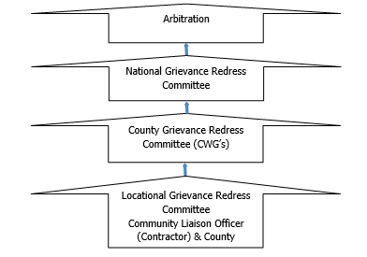

Figure 9. KOSAP Grievance Redress Mechanism
It should be noted that if complainants are not satisfied with the grievance process, even after arbitration they have the right to present their complaint through the court system. It is expected that most disputes will be resolved at the lowest level-Locational Grievance Redress Committee and since most disputes arise during the Construction and operation period the contractor’s Environmental and Social Safeguard team specifically the Community Liaison Officer will work closely with the community to be able to resolve disputes.
Responsibilities of the Community Liaison Officer include.
- Monitor day to day Implementation of the Project
- Address grievances as they arise on the project
- A member of the Locational and County Grievances Redress Management Committee to respond on issues that may have been brought to the attention of the committee before escalating to the National Grievance Redress Committee
Escalate grievances internally to get a lasting solution

World Bank Grievances Redress Mechanism
The World Bank has established 2 grievance redress mechanisms that provide avenues for individuals and communities to submit complaints directly if there is belief that they have been, or are likely to be, adversely affected by a World Bank-funded project. In this project PAPs and other stakeholders have the right to know and access at no cost these GRMs as described below.

World Bank Grievances Redress Service
The Grievance Redress Service (GRS) is an avenue for individuals and communities to submit complaints directly to the World Bank if they believe that a World Bank-supported project has or is likely to have adverse effects on them, their community, or their environment. The GRS enhances the World Bank’s responsiveness and accountability to project-affected communities by ensuring that grievances are promptly reviewed and addressed. Complaints must be in writing and addressed to the GRS and sent through the following methods namely:
Those aggrieved or their representatives can report their complaints through the following mediums; (i) Online by accessing the online form; (ii) Sending an Email to grievance@worldbank.org; or (iii) Submitting a letter to the World Bank Headquarters in Washington D.C., United States or World Bank Kenya County Office.

World Bank Inspection Panel
The Inspection Panel is an independent complaints mechanism for people and communities who believe that they have been, or are likely to be, adversely affected by a World Bank-funded project. The Panel is an impartial fact-finding body, independent from the World Bank management and staff, reporting directly to the Board. The Inspection Panel process aims to promote accountability at the World Bank, give affected people a greater voice in activities supported by the World Bank that affect their rights and interests, and foster redress when warranted. In September 2020, the Board updated the resolution that created the Panel and added to the Panel functions. At the same time, the Board approved a resolution establishing the World Bank Accountability Mechanism (AM). The new AM began operations in early 2021 and houses the Panel to carry out compliance reviews and a new Dispute Resolution Service (DRS), which will give complainants another way to have their concerns addressed. Contacts for registration of complaints to the IP are; (i) Tel: +1 202 458 5200: and (ii) Email: ipanel@worldbank.org.

Government Management of Land Acquisition Disputes
The Environment and Land Court, established under the Environment and Land Court Act 2011, is a superior court (with offices across the country) that hears and determines disputes relating to land and the environment. Likewise, the Land Acquisition Tribunal established under the Land Act 2012; (PART VIIIA 133A) has jurisdiction to hear and determine appeals from the decision of the NLC on the process of compulsory acquisition of land. Therefore, in the first instance, such appeals are referred to the Tribunal. However, a party dissatisfied with the decision of the Tribunal may appeal to the Environment and Land Court on a question of law only. The regulations to set the Land Acquisition Tribunal established under the Land Value (Amendment) Act of 2019 are underway. Besides, the Judicial Service Commission will chair the Land Acquisition Tribunal once operational

IMPACT SUMMARY AND CONCLUSION

Introduction
This chapter gives a summary of impacts conclusion and recommendations.

Conclusions
During the preparation of this report for the proposed development, it is observed and established that most of the negative social and environmental impacts can be mitigated and have potentially short term low significant effects. The positive impacts are highly rated and will benefit the community at Kotile and the county at large. The project proponent, the implementing agency and the contractor must adhere to prudent implementation of the social and environmental management and monitoring plan. The contractor should commit to obtaining all necessary permits and licenses from the relevant authorities and have qualified and adequate personnel to do the project as proposed. The ESIA has proposed adequate safety and health mitigation measures as part of the relevant statutory requirements.

The analysis of the ESIA has demonstrated that the construction and operation of the proposed Solar Mini-grid will have positive impacts to the government and Kenyan society at large. The impacts will include; Increase in reliable and sustainable clean energy, employment to local community members, increase in the national/local investment, increase in government revenue, improvement of standards of living for Kotile residents. However, despite the outlined positive impacts, the proposed development will cause some negative impacts such as; noise, dust generation, soil erosion, oil spills, fire hazards, electrocution, shocks, solid waste generation, occupational health hazards, social risks such as labour influx, demand for resources, gender-based violence, conflicts, public health impacts (HIV & AIDs, Covid 19) among others that need to be avoided, reduced and mitigated against.

It is the duty of NEMA to consider licensing the project subject to EIA study; in accordance with the Environmental Management and Coordination Act, EMCA of 1999 and its Amendment, 2015 and the Environmental Impact Assessment and Audit Regulations, Legal Notice No. 101 of 2003.

An Environmental and Socio- economic Management Plan (E&SMP) outline has been developed to ensure sustainability of the project area activities from construction through operation to decommissioning. The plan provides a general outlay of the activities, associated impacts, mitigation action plans and appropriate monitorable indicators. Implementation timeframes and responsibilities are defined, and where practicable, the cost estimates for recommended measures are also provided.

A monitoring plan that highlights some of the environmental performance indicators that should be monitored has been developed. Monitoring creates possibilities to call to attention changes and problems in environmental quality. It involves the continuous or periodic review of operational and maintenance activities to determine the effectiveness of recommended mitigation measures. Consequently, trends in environmental degradation or improvement can be established, and previously unforeseen impacts can be identified, or pre-empted and mitigation measures proposed.

From the findings of this study, the following conclusions are made:
- The proposed project will generate socio-economic benefits which would not be realized if the ‘NO development option’’ is considered.
- The community (PAPs) have been consulted among other stakeholders and project information shared including the negative impacts and the views of the stakeholders is that the project is long overdue.
- The potential adverse impacts associated with the proposed project are possible to mitigate successfully. The impacts before implementation of mitigation measures are assessed as very low to medium low and the ratings are expected to improve further with the implementation of the proposed mitigation measures
- The impacts that will be adverse will be temporary during the construction phase and can be managed to acceptable levels with the implementation of the recommendation of the mitigation measures for the project.
- The project will be designed, constructed, and operated according to the acceptable industry norms and standards. Successful implementation of the proposed ESMMP will ensure environmental sustainability

The proposed project design has integrated mitigation measures with a view to ensuring compliance with all the applicable laws and procedures. The Solar Mini-grid and associated structures will be installed to the required planning/architectural/structural designs and standards. During project implementation, operation and decommissioning stages sustainable environmental management would be ensured; avoiding inadequate use of natural resources, conserving nature sensitively and guaranteeing a respectful and fair treatment of all people working on the project, general public at the vicinity and the expected PAPs of the project.

In relation to the proposed mitigation measures that will be incorporated during construction, operational and decommissioning phases; the development’s input to the society and environment; the project is considered beneficial and important.

Recommendations
It is strongly recommended that a concerted effort is made by the implementing agency in particular, to implement the Environmental Social Management and Monitoring Plan provided herein. Following the commissioning of the project, statutory Environmental and Safety Audits shall be carried out in compliance with the national legal requirements, and the environmental performance of the site operations should be evaluated against the recommended measures and targets laid out in this report.

Recommendations
- The Kenya Power and the contractor must adhere to relevant legal and regulatory framework to ensure compliance and success of the project
- Adherence to the mitigation measures as spelt out in the ESMMP and monitoring of the same is mandatory to ensure environmental and social sustainability of the project.
- Cultivate and maintain a good working relationship with the community members
- Ensure social inclusion of the vulnerable groups by paying attention to the most vulnerable and provide ready boards as spelt out
- Contractor to plant trees in construction phase to promote environmental sustainability
- Stakeholder engagement to the carried out throughout the construction and operation and decommissioning phases.
- Contractor to ensure grievance redress mechanism is established and operational
- Environmental Audits should be carried annually or as prescribed by the Authority during the operational phase and invitation of Inspectors and Experts from NEMA to ascertain compliance with the provided ESMMP and set NEMA regulations and Standards.
- Diligence on the part of the contractor and proper supervision by the KPLC is crucial for mitigating the potential impacts and ensuring structural strength, safety, and efficient operation of the project.

Authorization Opinion
In terms of NEMA requirement the environmental practitioner is required to provide an opinion as to whether the activity should or should not be authorized. The expert is reticent to venture such an opinion since we are not an elected entity mandated to make decisions on behalf of authority. Nevertheless, in this section a qualified opinion is ventured and in this regard the Lead expert believes that sufficient information is available for NEMA to take a decision. The fundamental decision is whether to allow development which brings socio-economic advantages and is consistent with planning and certain development and social responsibility and upliftment of policies, but which may impact on an area as a result of negative impacts identified. The Lead Expert believes that the ESIA have shown that the applicant’s preferred alternative and technological alternatives are generally acceptable. The ESIA has also assisted in the identification of essential mitigation measures that will mitigate the impacts associated with the project to within acceptable limits.

In conclusion, the expert is of the opinion that on purely ‘environmental’ grounds (i.e., the project’s potential socio-economic and biophysical implications) the application as it is currently articulated in the applicant’s proposal should be approved provided the essential mitigation measures are implemented. It is in the opinion of the Environmental Consultant that the anticipated negative impacts can be readily and effectively mitigated and the proposed project does not pose any significant threat to the Environment and may be licensed to proceed.

REFERENCES
The following list of references was referred to in preparing this Project Report:
- British Standard (BS) 5228 Part 4, 1997: Noise Control on Construction and Open Sites: Code of Practice for Noise and Vibration Control applicable to piling operations
- Community Land Act, 2016
- Environmental Assessment Source Book, 1999 (World Bank),
- Garissa County Integrated Development Plan 2018-2022
- George, C. and Lee, N., 2000 Environmental Assessment in Developing and Transitional Countries, Willey: Chichester, UK
- Government of Kenya (GoK), 1999. The Environmental Management and Co-ordination Act, 1999. Government Printer.
- Government of Kenya (GoK), 2002. The Water Act 2016. Government Printer, Nairobi, Kenya.
- Government of Kenya (GoK), 2003. The Environmental (Impact Assessment and Audit) Regulations, 2003.
- Government of Kenya (GoK), 2009. The Environmental Management and Co-ordination Act, Regulations 2009, Legal Notice No. 61, 2009. Government Printer
- Government of Kenya (GoK), Building code, Building order 1968 and Grade 11 Building Order 1968
- Government of Kenya (GoK). The Public Health Act Chapter 242 Laws of Kenya.
- Government of Kenya: Factories and Other Places of Work (Noise Prevention and Control) Rules 2005
- Government of Kenya: Factories and Other Places of Work (Safety and Health Committee) Rules 2004
- Government of Kenya: Hazardous Substances Rules, 2007
- Government of Kenya: Noise Prevention and Control Rules 2005
- Government of Kenya: Occupational Safety and Health Act,2007
- Government of Kenya: The Occupational Safety and Health Act, 2007
- Government of Kenya: The Physical Planning Act 2019
- Government of Kenya: Waste Management Regulations, 2006
- Government of Kenya: Water Quality Regulations, 2006
- International Labor Organization 1983: Encyclopedia of Occupational Health and Safety Vol. II, Geneva.
- Sombroek WG, Braun HMH & Van der Pouw BJA, 1982: Exploratory Soil Map and Agro-climatic Zone Map of Kenya, 1980 (Kenya Soil Survey, Nairobi),
- The Constitution of Kenya, 2010
- The Energy Act, 2019
- The Land Act, 2012
- The Land Registration Act, 2012

APPENDICES

Minutes I: Minutes for the meeting during the ESIA

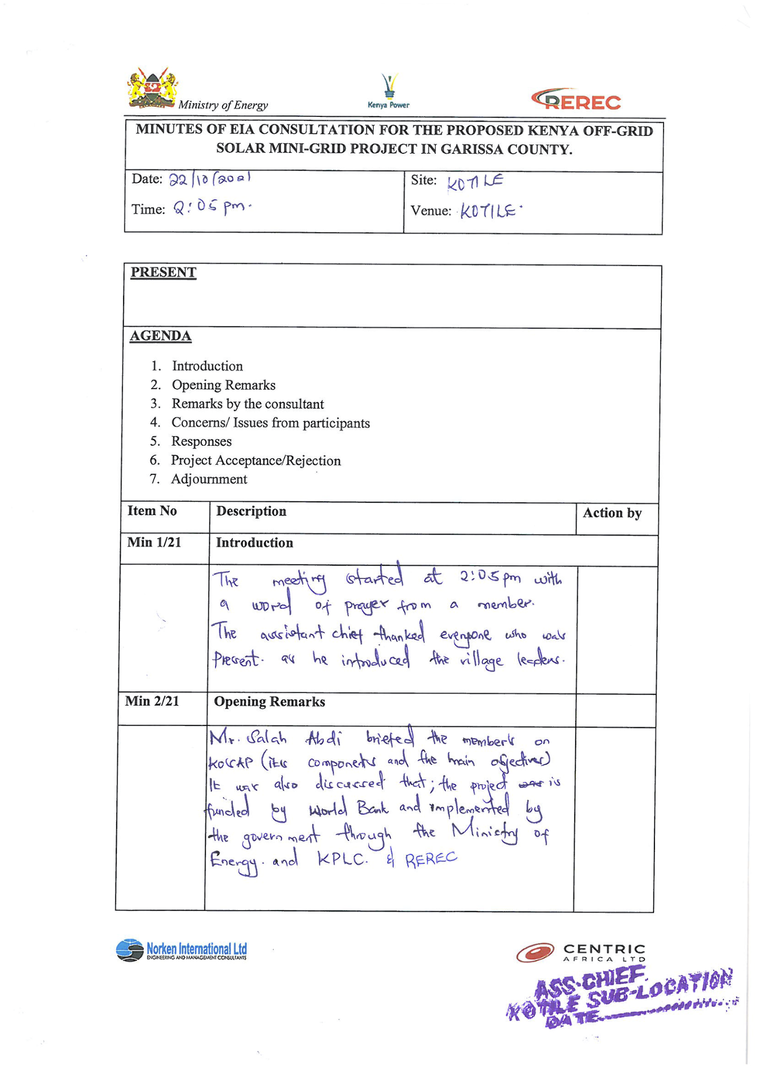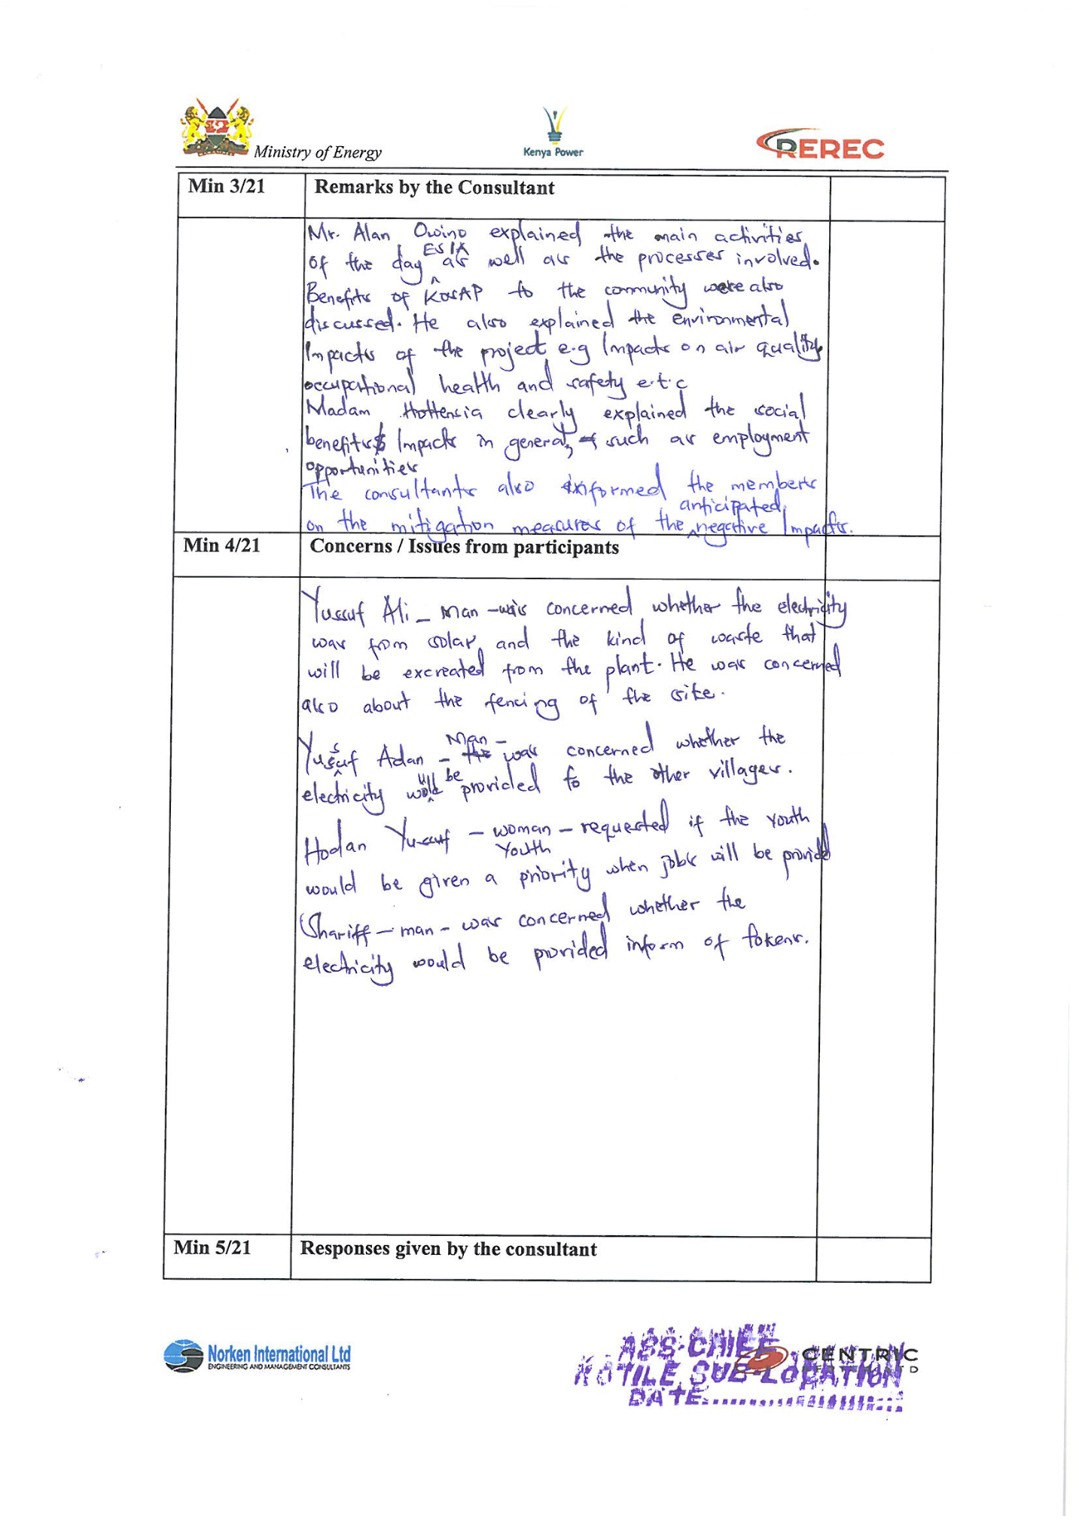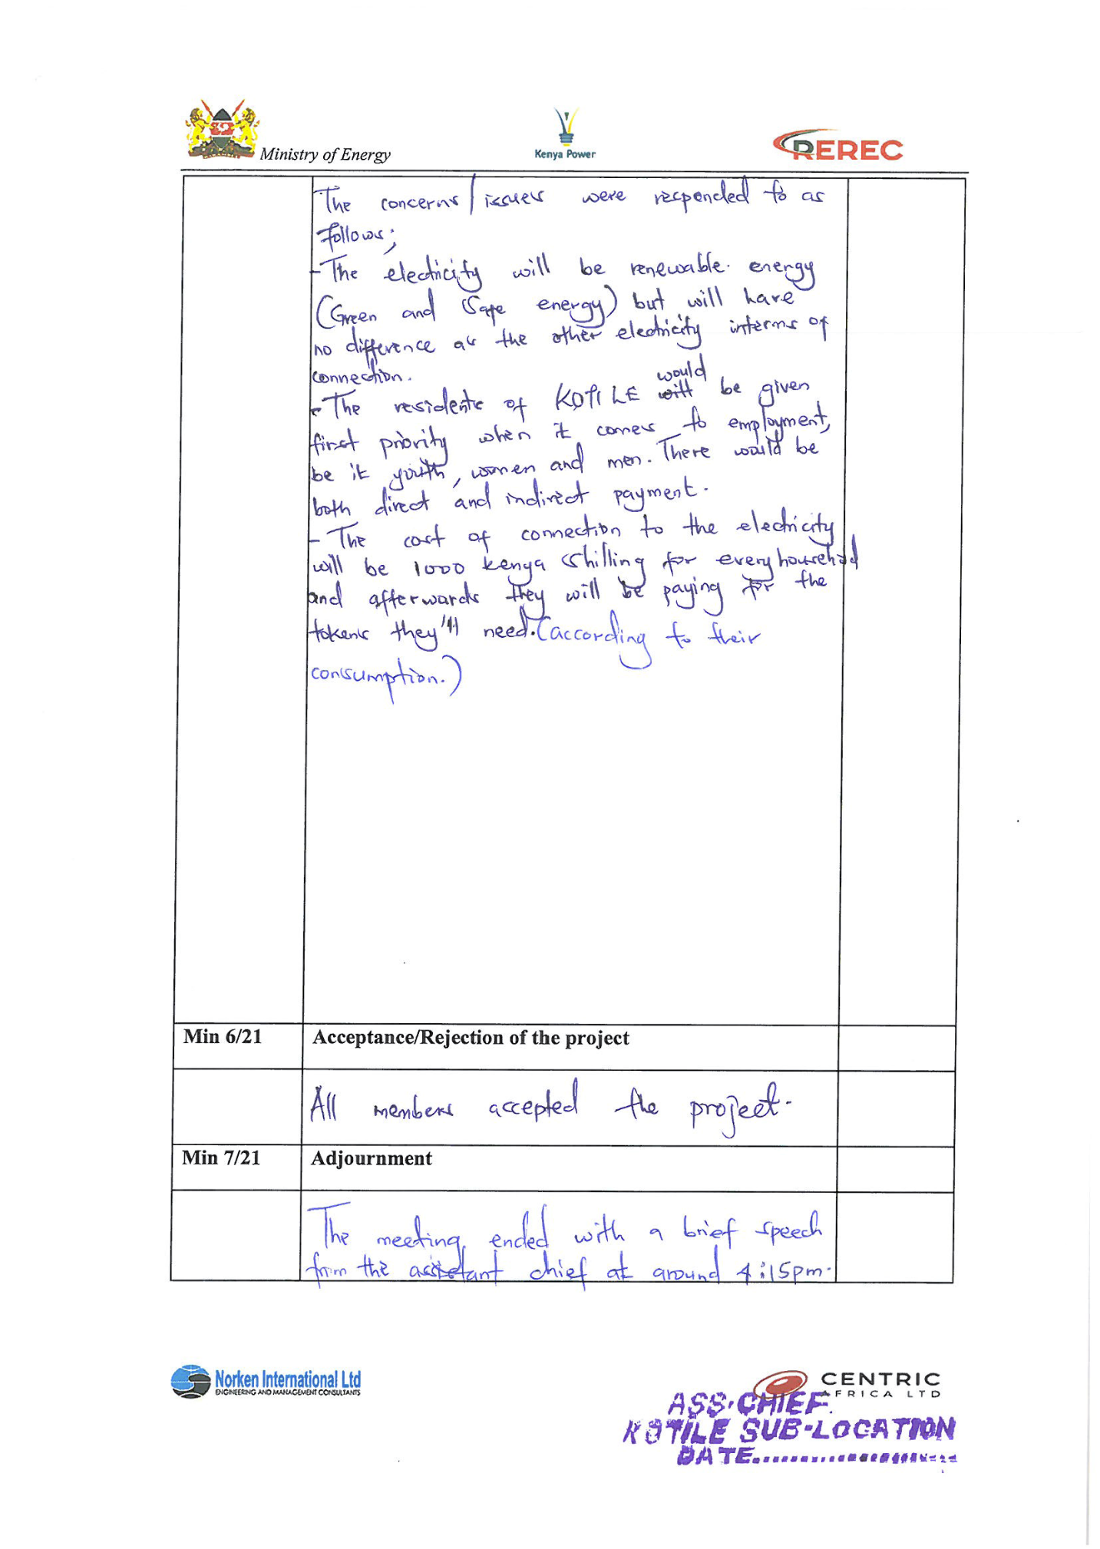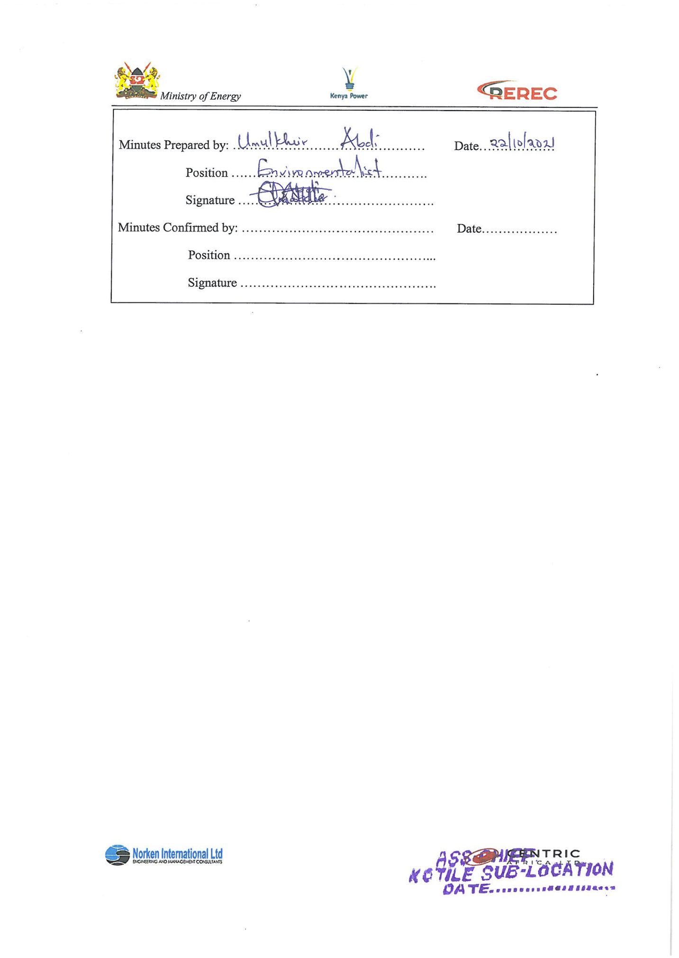

ESIA Baraza Meeting Attendance List

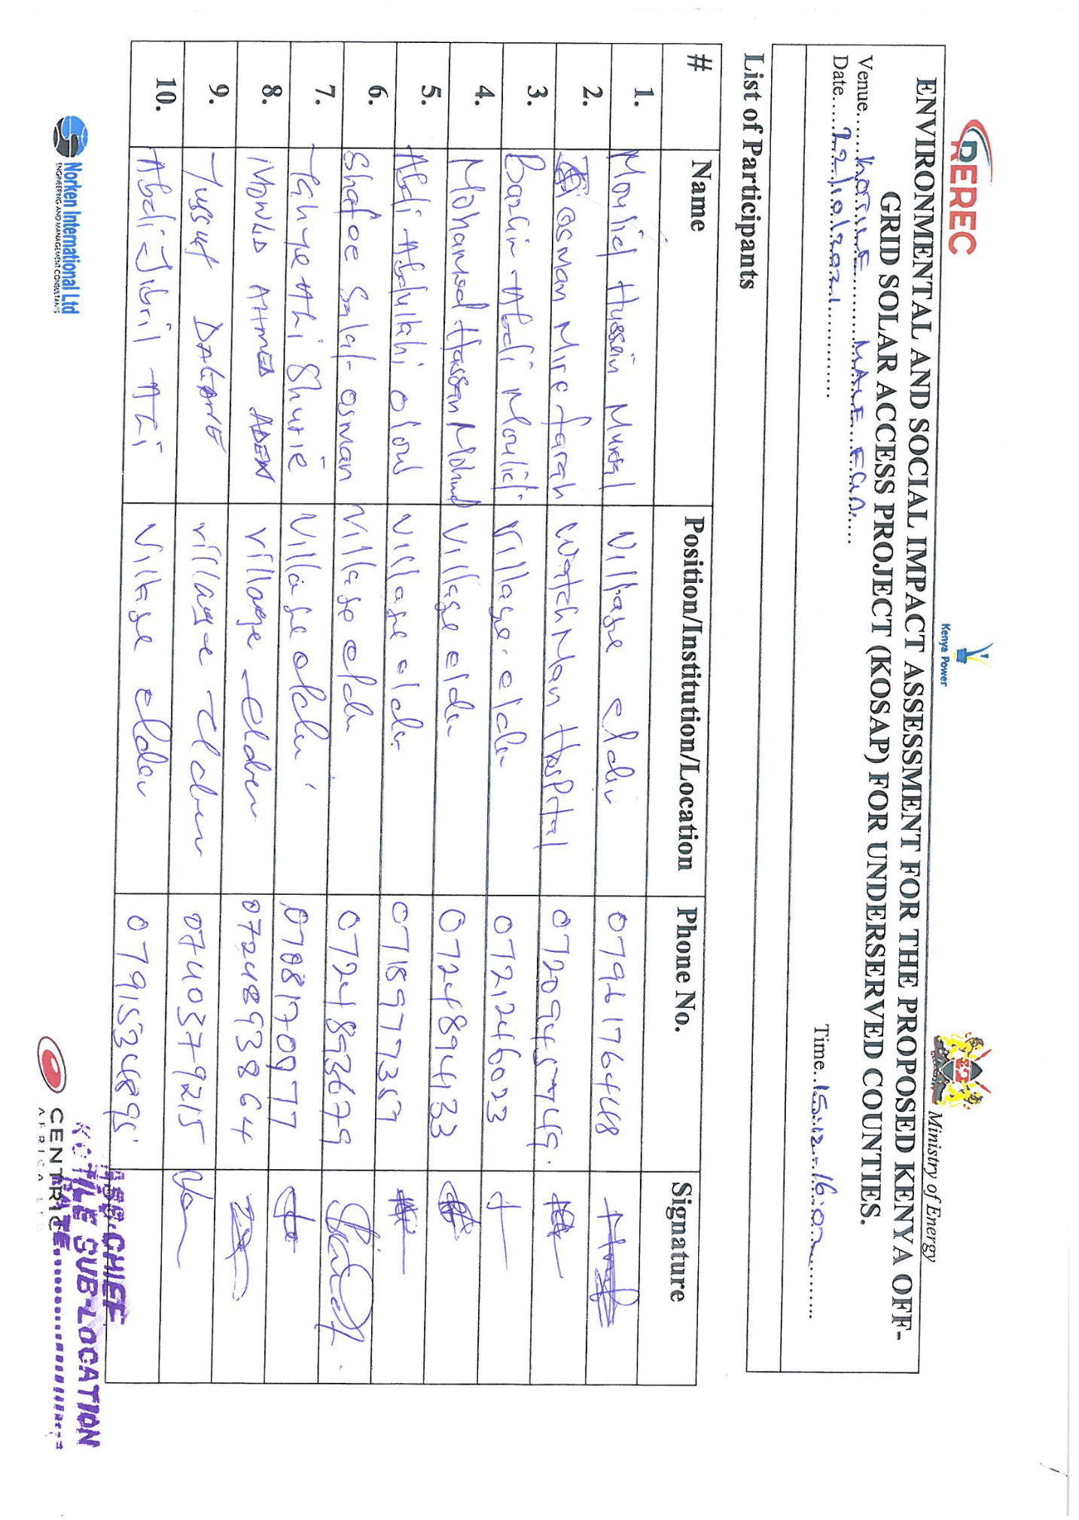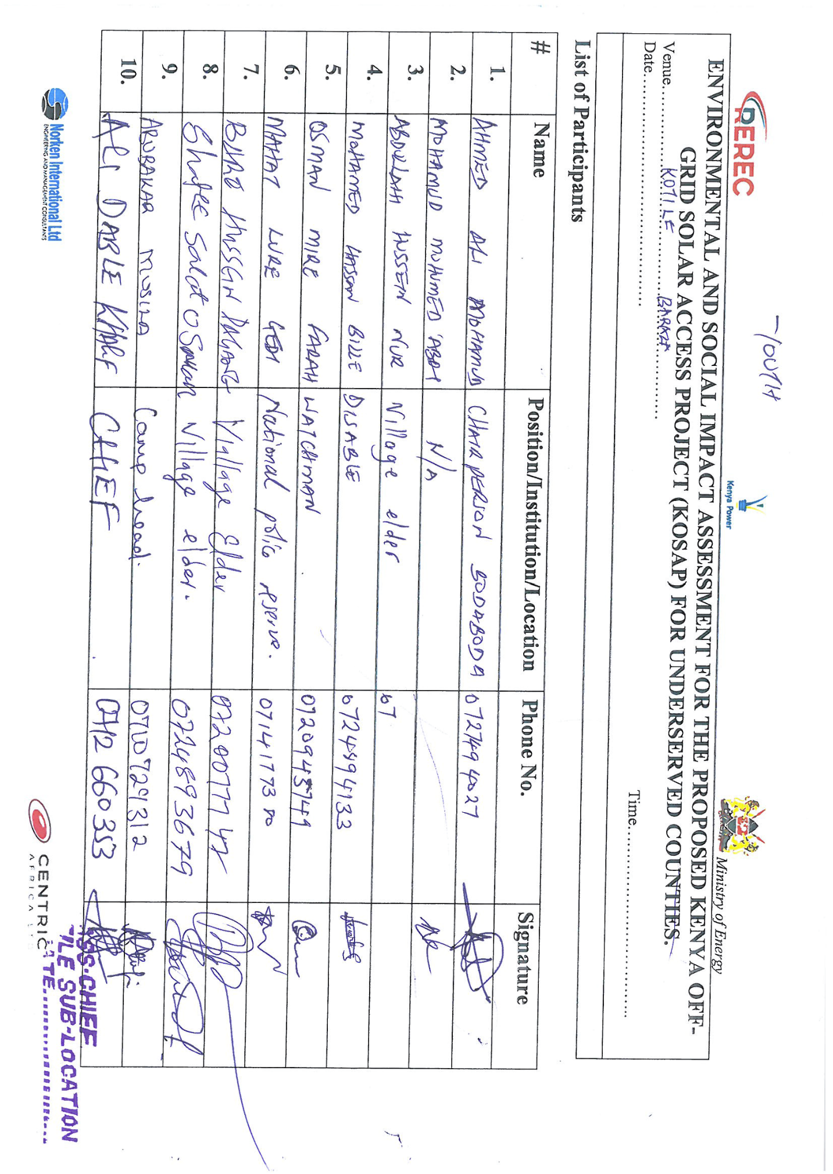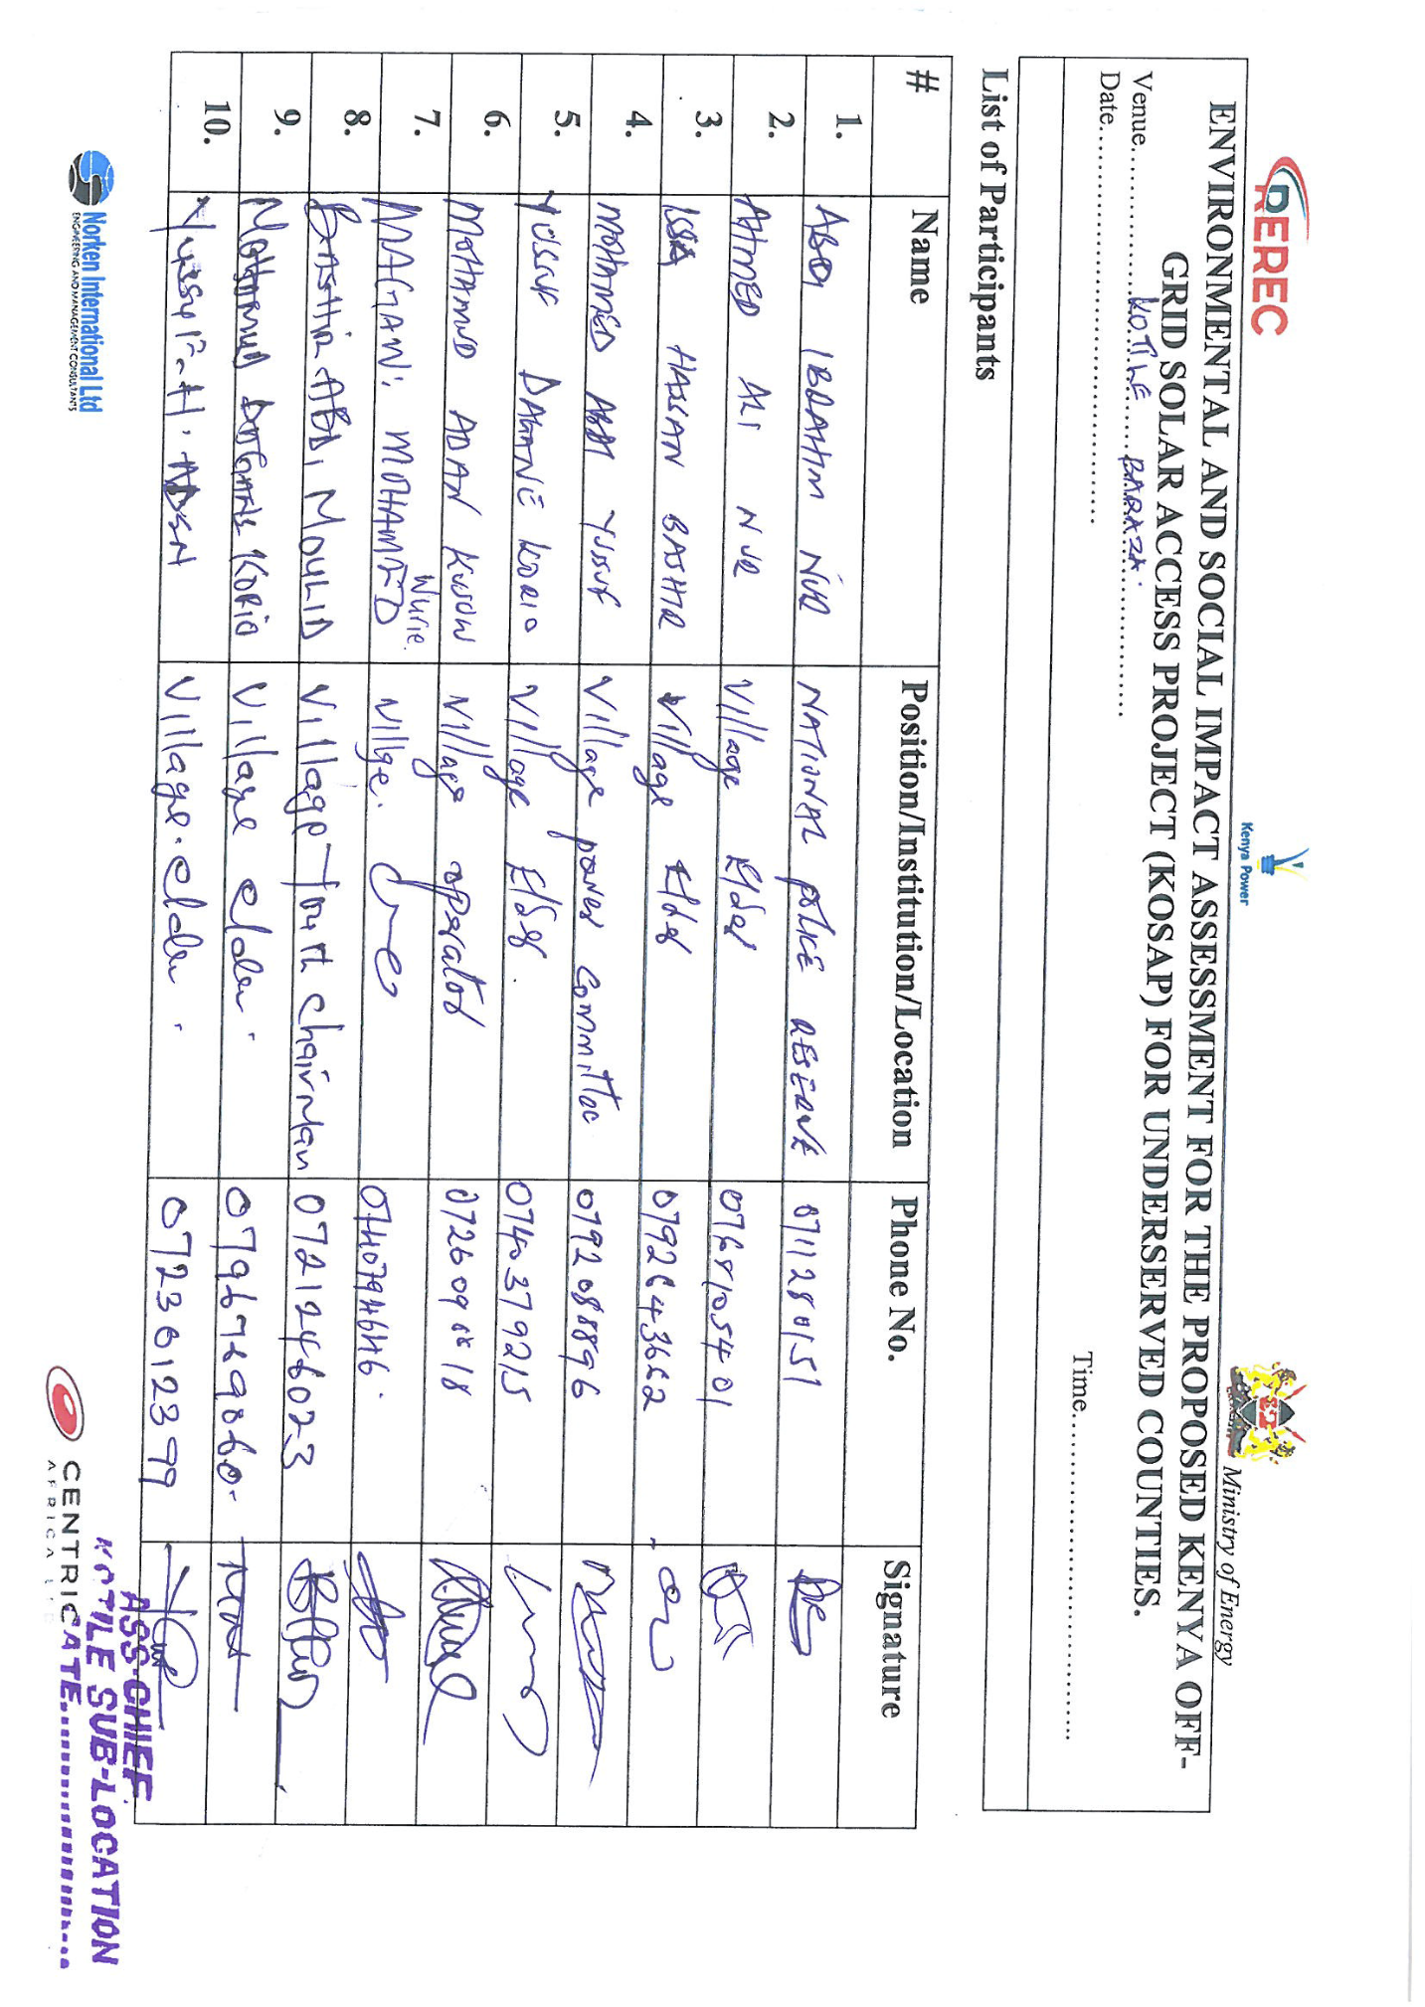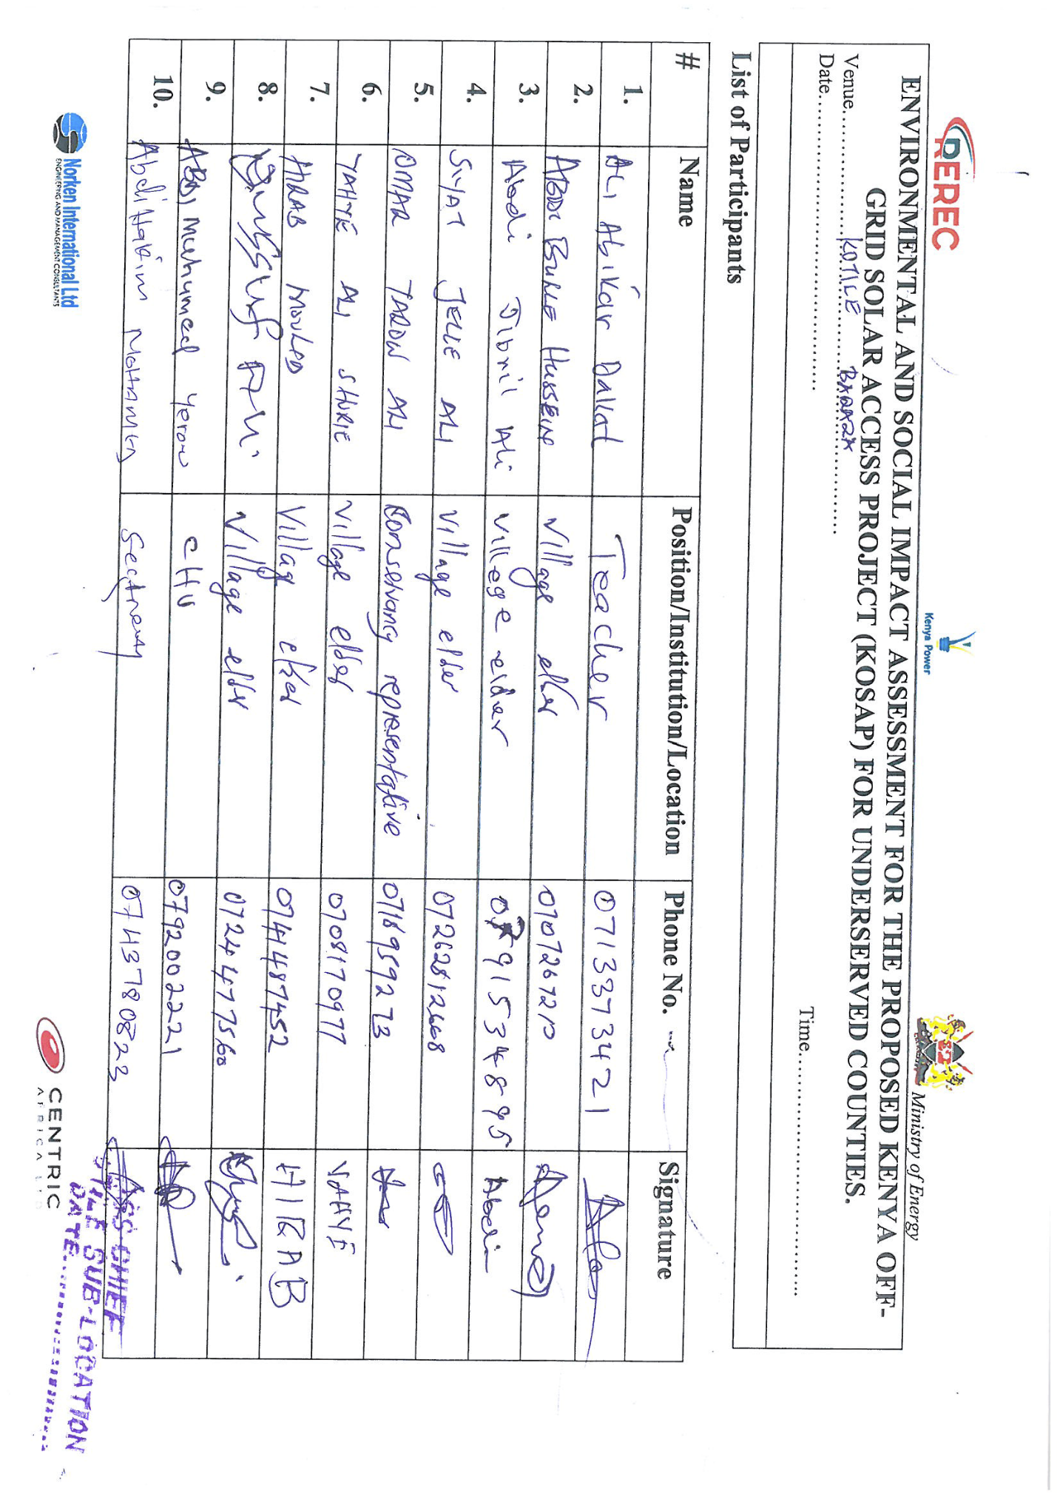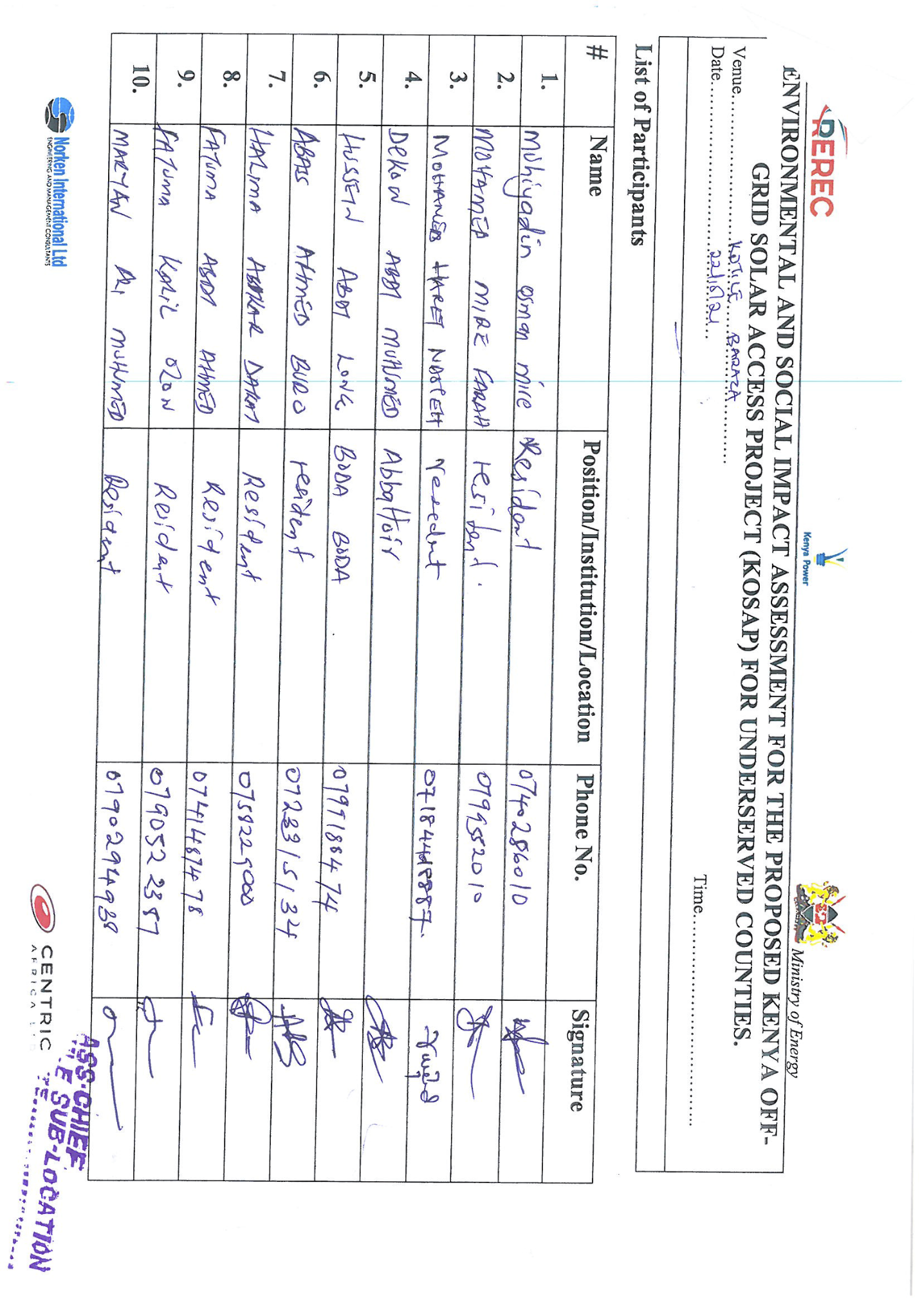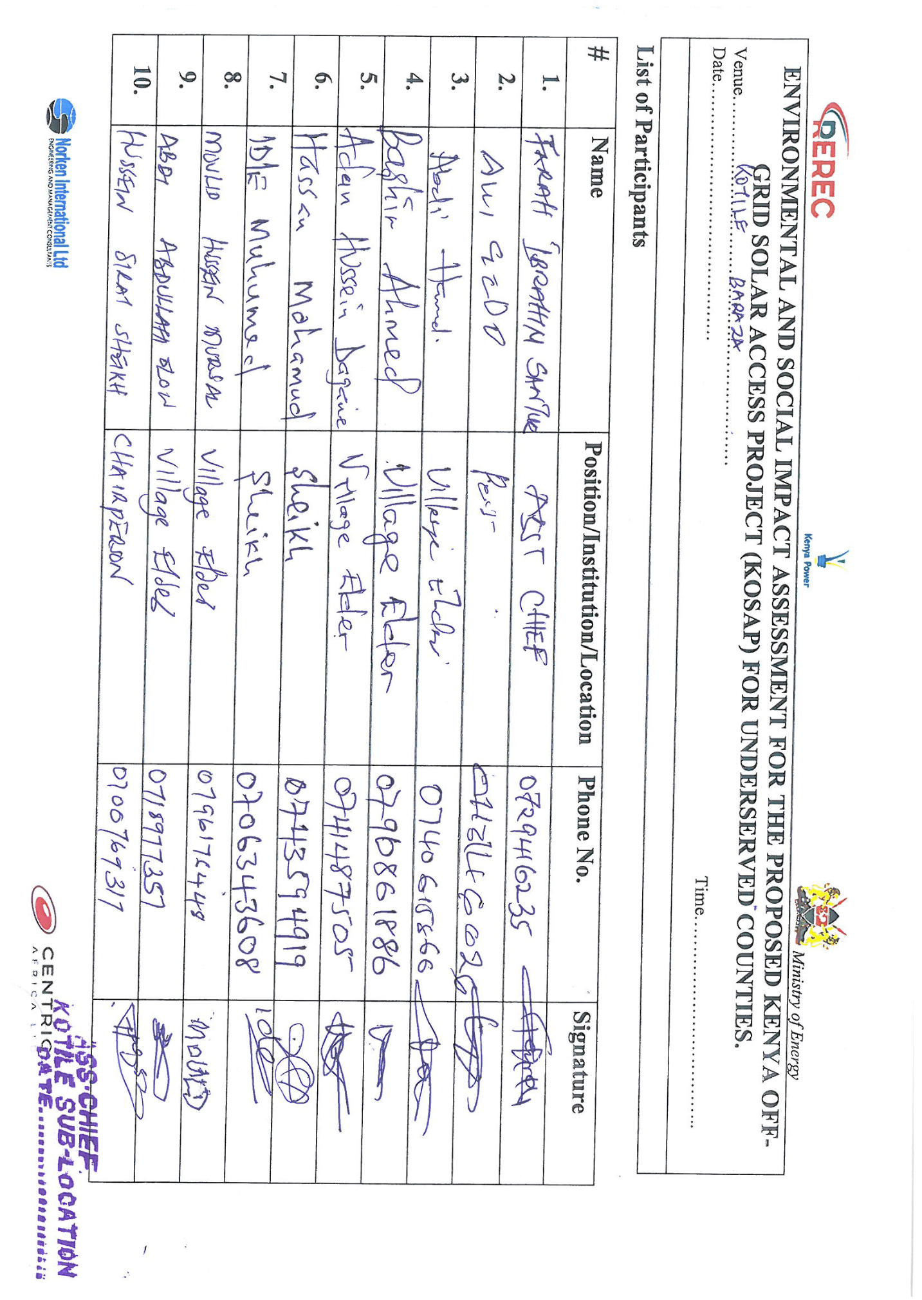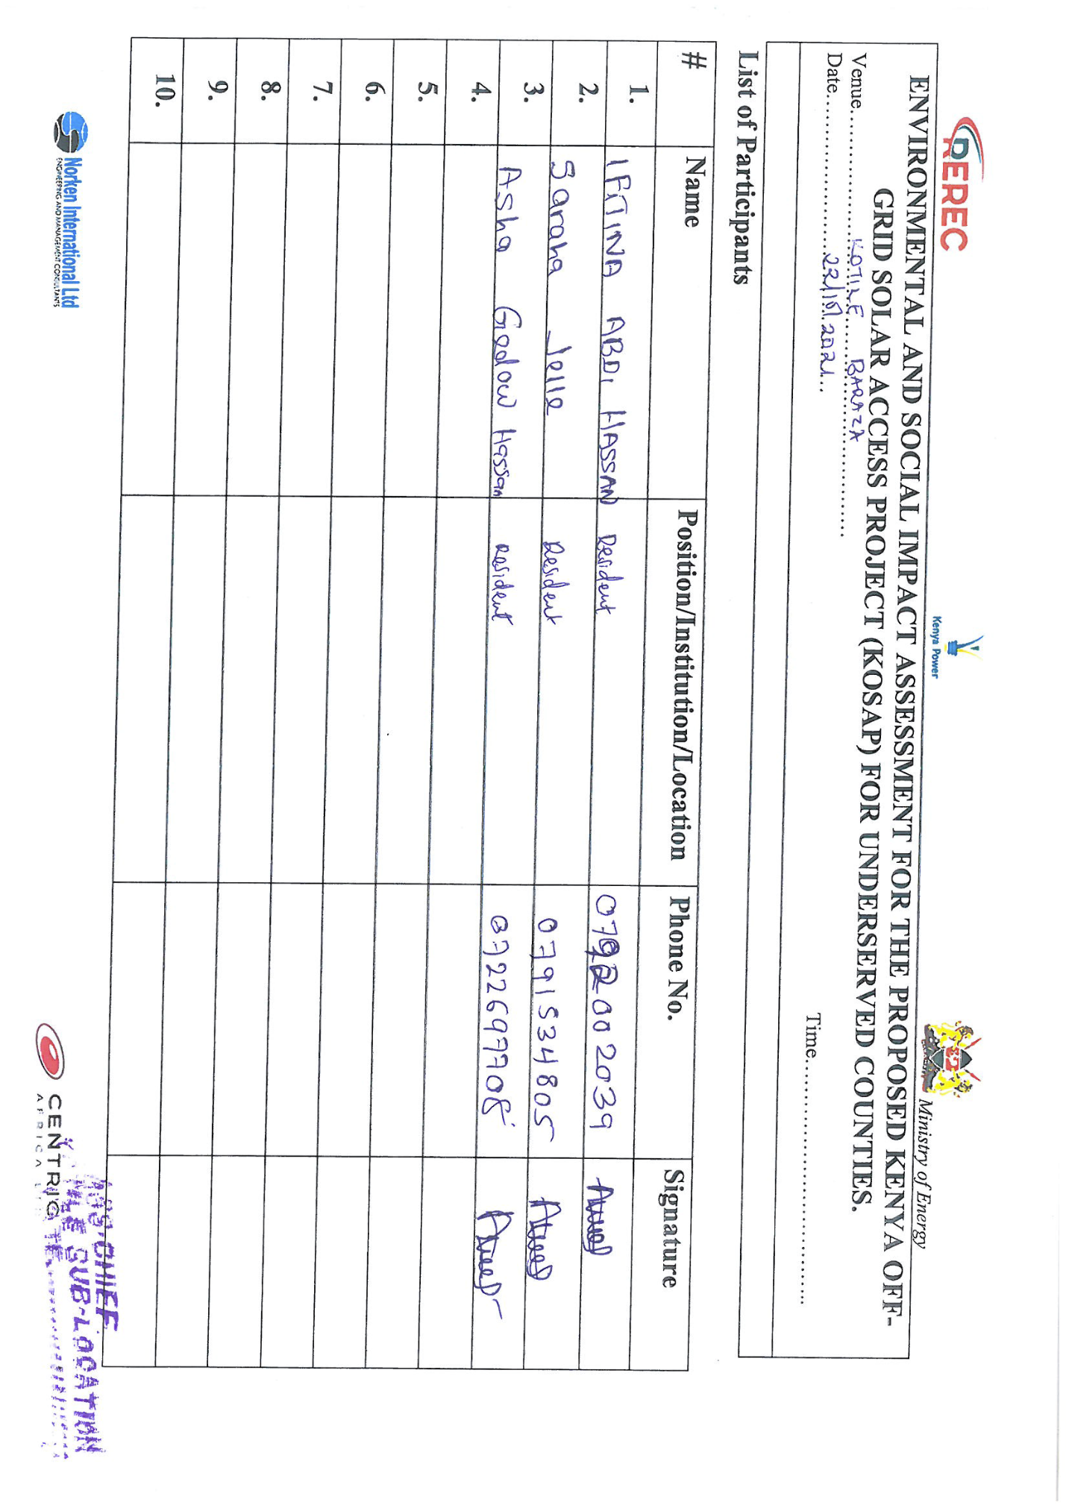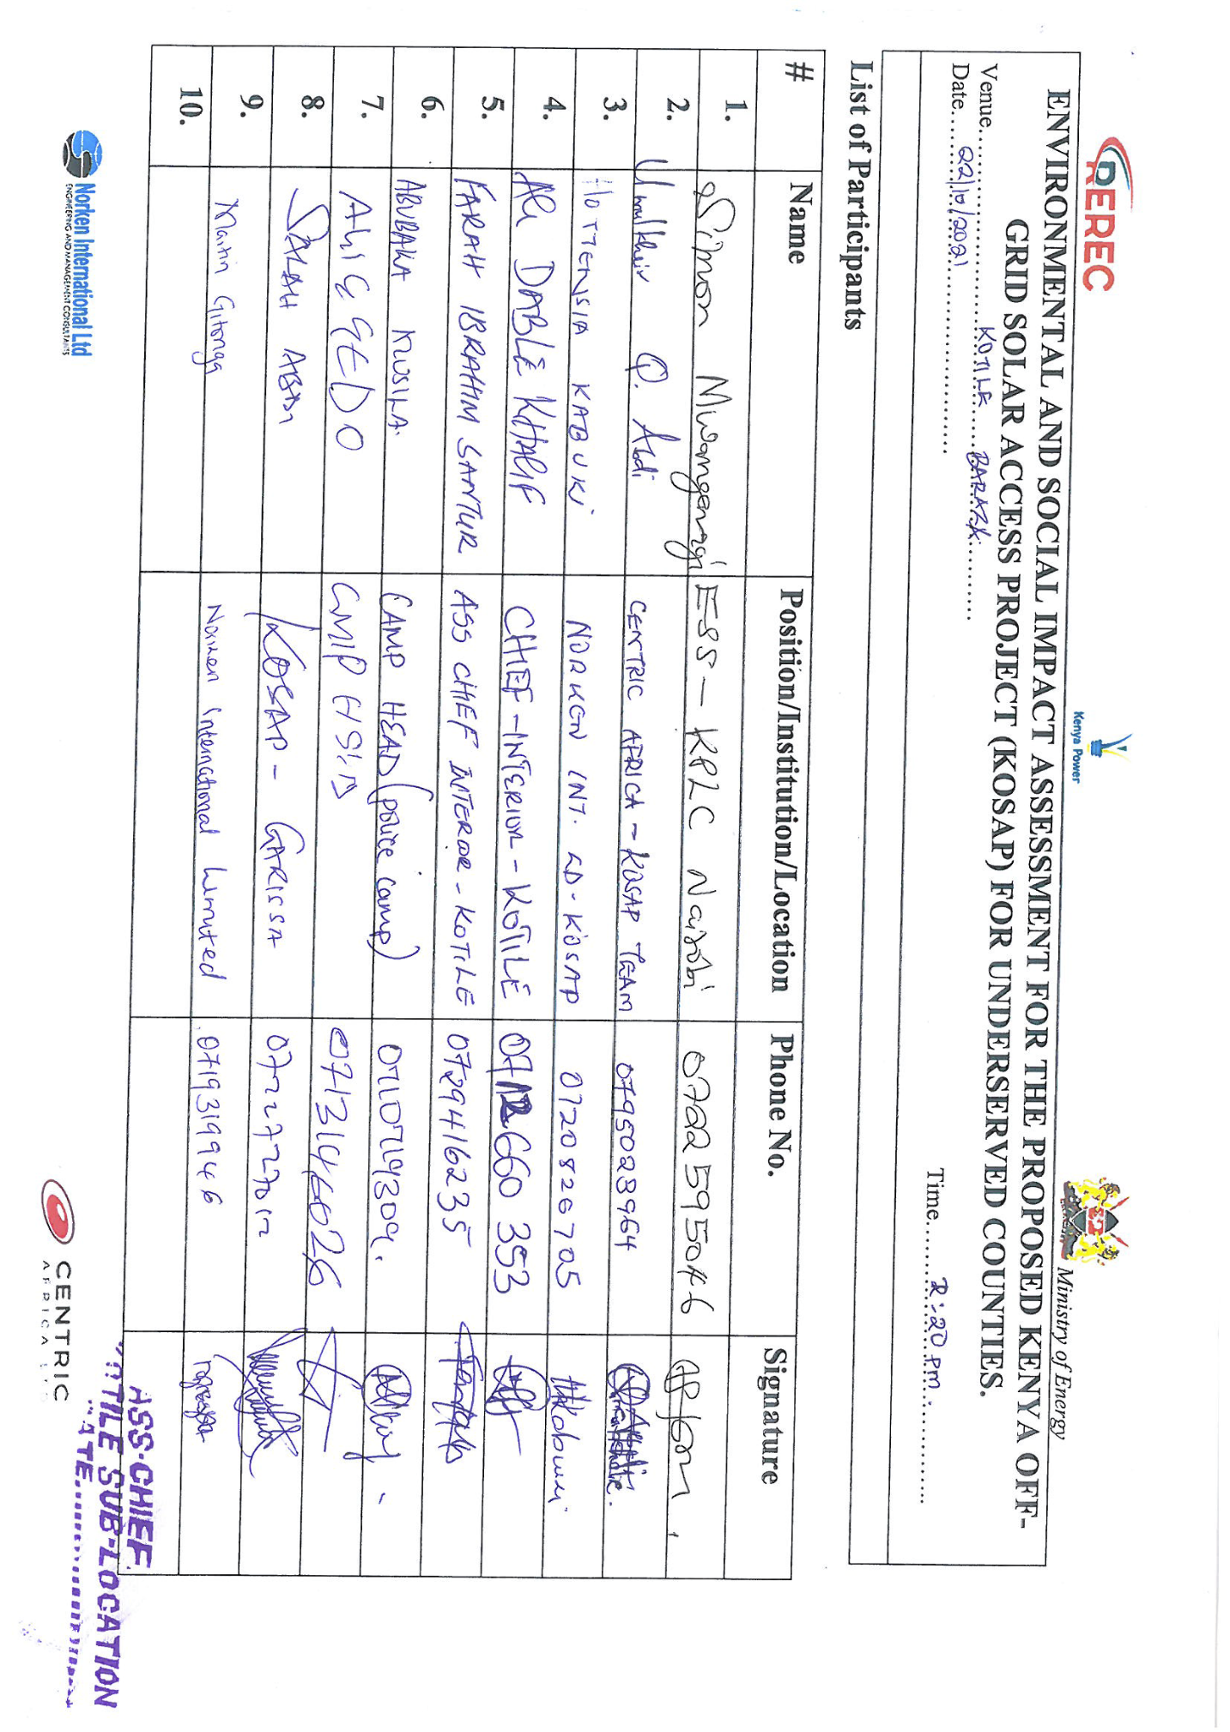

Youth Focus Group Discussion List of Attendance.
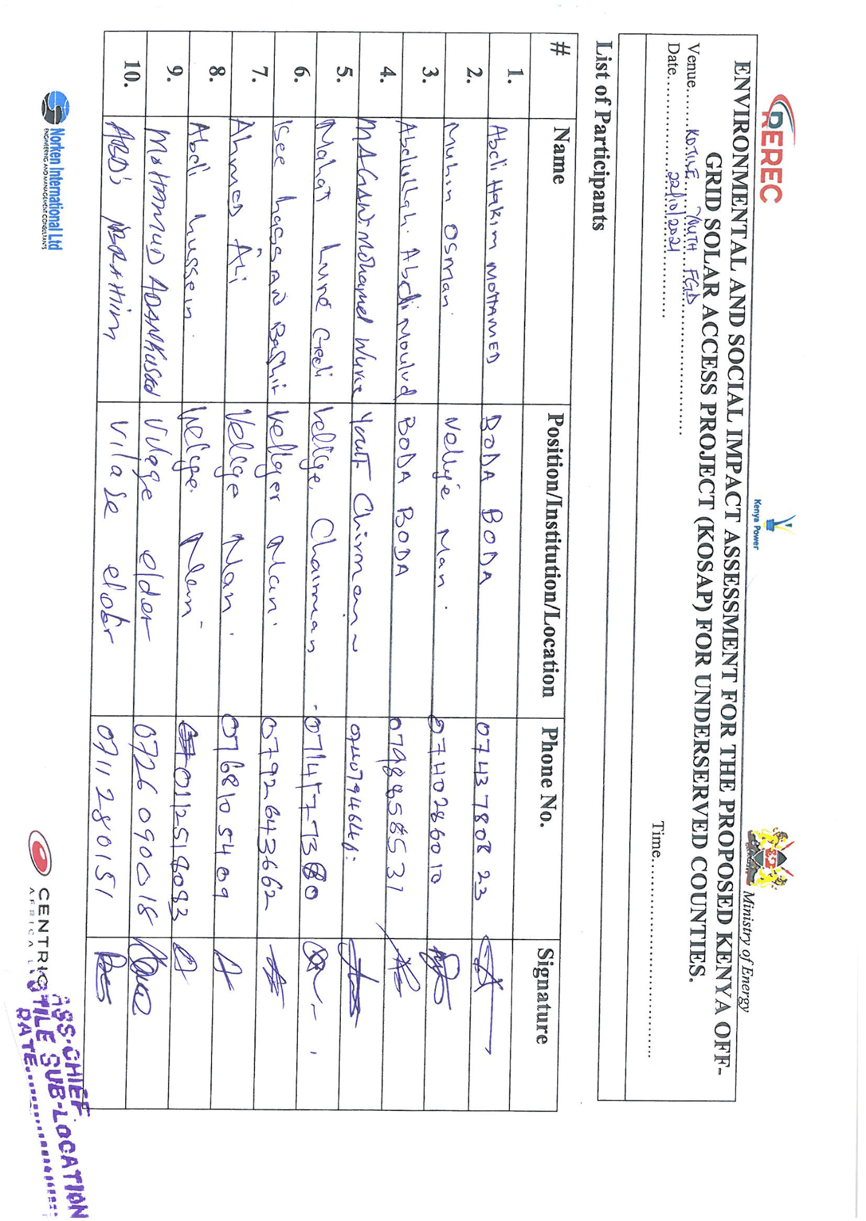

Women Focus Group Discussion List of Attendance.
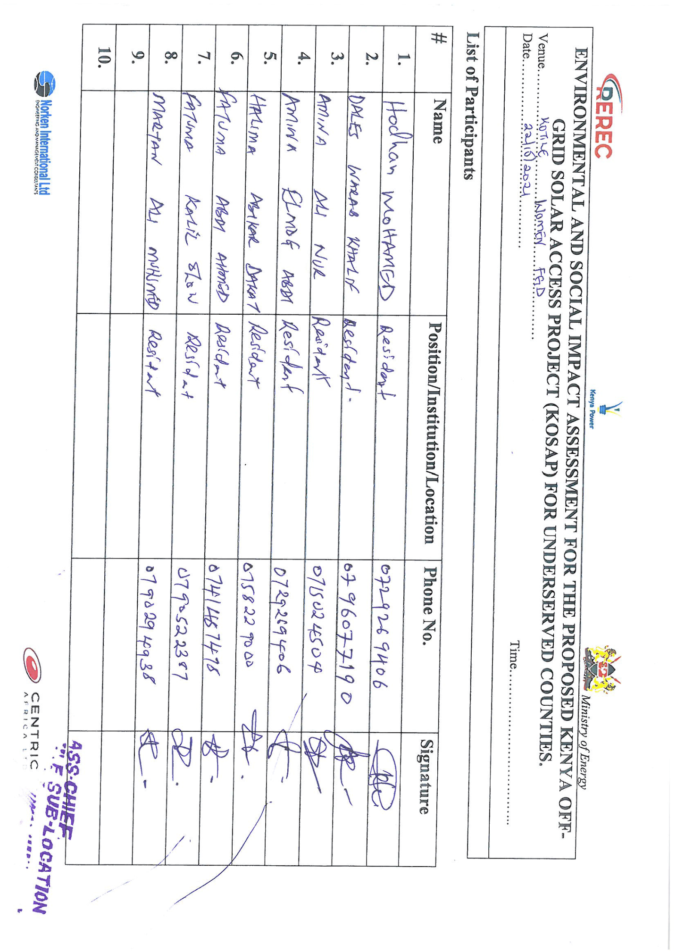

Men Focus Group Discussion List of Attendance.

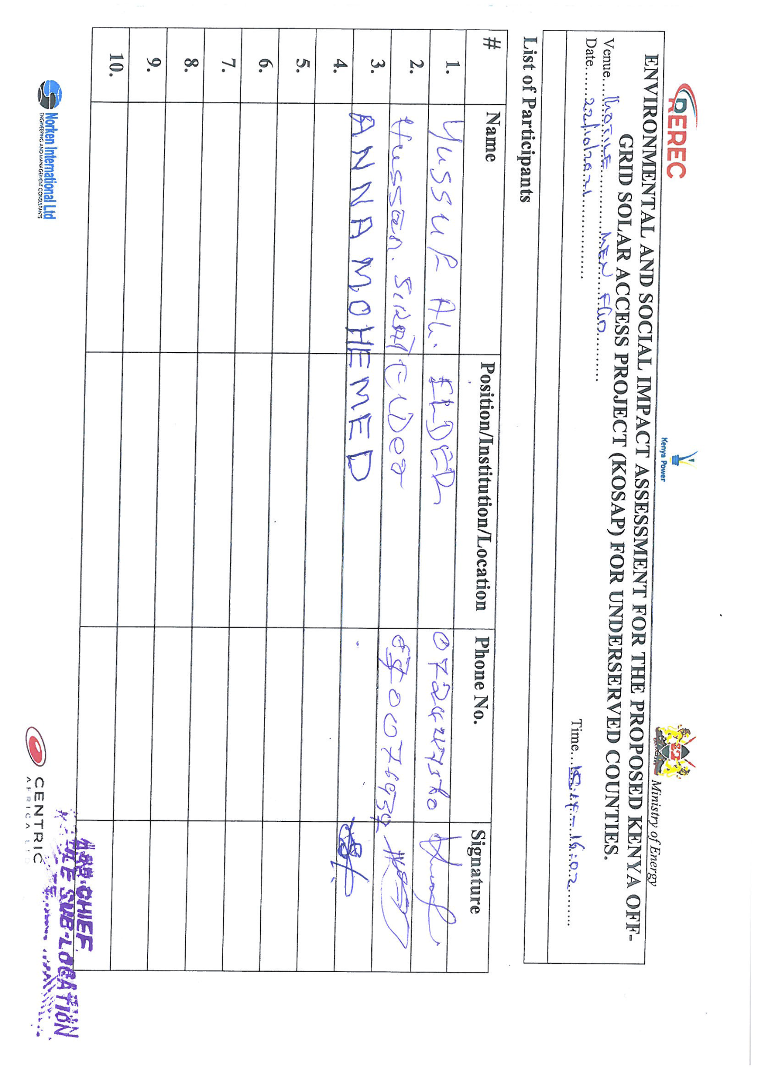

Minutes II: Minutes of the meeting leading to land identification and GRC Constitution and list of participants

Minutes of community consultation meeting leading to land identification and Grievance Redress Committee constitution
Project: Proposed Kotile Solar Mini-grid
Venue of meeting; Kotile village (identified site) in Kotile sub location in Kotile location, Garissa East Sub County of Garissa County
Date: 24/6/2021
AGENDAS
- Preliminaries
- Project description
- Technical aspects of the project
- Positive Impacts of the project –Solar Mini-grid
- Negative Impacts of the project and mitigations measures
- Need for land for the project
- Environmental and social screening of the site
- Grievance Redress Mechanism for the project
- Plenary session
- Focus Group discussions

Minute 1/KOSAP/2021: Preliminaries
The Chief of Kotile called meeting to order at 11:10a.m. The meeting began with a word of prayer. The Chief spoke in Kiswahili and community member translated by speaking in the local dialect to ensure all people understood the information. The chief welcomed all in attendance to the meeting. He asked the community members to participate in the stakeholder engagement exercise as it helps in information needed planning process.
The Chief welcomed the Director Environment from Garissa County to welcome the project team. The Director spoke in the local language as the Chief translated to Kiswahili for the sake of the project officers. He welcomed and thanked all for attending the meeting. He said that the County Government of Garissa is in support of the KOSAP project.

He invited Koech (KPLC) to introduce the other officers in the project team and proceed with the community engagements. Koech introduced the project team as shown in the table below.
KOSAP Project Team
S/No | Names | Position
1 | CEC Environment | County Government of Garissa
2 | Wilfred Koech | Environmental and Social specialist - KPLC
3 | Jamal | County Surveyor - Garissa
4 | Salah Abdi | County Renewable Energy Officer-Garissa County
5 | Irene Maina | KPLC
6 | John Kuria | Surveyor – KPLC
7 | Zadock K. Rotich | Engineer- KPLC
8 | Pius Nyaga Ngari | Environment & Social Specialist - KPLC

Minute 2/KOSAP/2021: Project Description
Koech explained that the national government is implementing KOSAP in partnership with County Government in 14 Counties in areas that are far away from the national grid. He said the proposed project is called KOSAP-(Kenya Off-grid Solar Access Project) is being implemented jointly by the Ministry of Energy, the Kenya Power and Lighting Company (KPLC) and the Rural Electrification and Renewable Energy Corporation (REREC) in partnership with the World Bank as a development partner, County Government as a partner and the communities in Off-grid areas being the PAPs. Off-grid areas are those places where the national electricity grid has not reached, and whose electricity access has been very low. The reason for choosing solar energy was because the area is far away from the national grid and the fact that the area is well endowed with natural sunlight with high temperatures.
He further expounded that the proposed Solar Mini-grid being implemented under KOSAP is part of the government’s effort towards universal access to power. He said the proposed Kotile solar Mini-grid is one of the thirty Solar Mini-grids to be funded through KOSAP in Garissa County. He told the community that the project was in the preliminary implementation stages which requires public participation of various stakeholders.

He further noted that the agenda of the visit was to undertake
- Undertake an environmental and social screening of the proposed sites to check suitability in terms of environmental, technical, social and health requirements.
- Undertake community engagement to sensitize the community on the project.
- Explain the land requirements for the project and sensitize the community on their rights in regard to land so that they can make an informed decision.
- Explain the need to set up Grievance Redress Mechanism for the project.
- Guide the community in electing Grievance Redress Mechanism committee members and sensitize the members of their work during project implementation
He invited (Engineer- Rotich) to explain to the community the technical aspects of the solar Mini-grid project.

Minute 3/KOSAP/2021: Technical aspects of the project
Zadock (KPLC) explained the technical aspects of the Mini grids which will entail; the installation of solar PV panels, usable battery, and thermal diesel backup unit (generator) to support solar and street lights. He explained to them that once constructed the Solar mini-grid will be operated by the implementing agency KPLC and the PAPs/those interested will be expected to pay for connection of electricity (one thousand shillings) and do wiring in their houses. He told them that connection of power will involve passing of electrical lines along the roads in order to reach their houses, business premises and public facilities and the route for passing the lines is called way leave. He noted that once the designs are done, the community will be notified of the exact routes during future consultations and that they will be required to give way leave consent (allowing the service lines to pass through their land in the extreme cases). He noted that the project will not compensate for way leaves due to budget constraints so that they can make an informed decision. He added that distribution or supply lines will be cover a radius of 1km from the mini-grid.

He told them that once connected, the PAPs will be expected to pay for electricity consumed and that the tariff employed will be the same as what other Kenya Power customers paying.
Minute 4/KOSAP/2021: Positive Impacts/Benefits of the Project
Koech explained that, every project has both positive impacts and negative impacts. Our assignment is to explain to you the impacts of the project so that you understand how the project will benefit you and the community at large and also explain to you the negative impacts of the project and the mitigation measures. The project benefit both direct and indirect are as follows:
- Better source of lighting- replacement of Kerosene lamp and small de-lite lamps with electricity lighting which is clean and has better lighting
- Benefits to education- provide source of lighting which enables pupils and students to take advantage of longer hours of preps/study in school and at homes. Electricity will be useful in availing power needed to enable use of radio and television sets. Once parents are able to buy these gadgets pupils can access electronic educational information
- Business opportunities-Power provides energy needed to power some gadgets that are difficult and expensive to power with generators. Access to electricity will therefore allow the community to take advantage of new business opportunities and enhance the existing ones e.g. Barber shops, salons, posho/maize mills, welding, photo copying, printing, fuel stations, milk coolers and fridges to preserve meat, milk among others. He asked the community to take advantage and set up some of these businesses
- Employment and wealth creation- community members will get opportunities to provide non-skilled and skilled labor during construction and operation phases of the project
- Local Material Supplies and other requirements- the proposed project provides opportunities to supply some materials available locally
- Up Scaling Electricity Access to the off-grid areas- this area is far away from the grid and so the proposed project helps to reach this area faster and in a cost effective manner as opposed to grid connections.
- Impact on HIV/AIDS-due to availability of power, communities can purchase communication equipment like radios and televisions which in turn provides access to information on various issues such as health topics on HIV/AIDs, nutrition and the current Covid-19 pandemic among other information
- Health benefits of the project- health benefits of the project are linked to replacement/elimination of use of kerosene lamps and candles, no need to use fuel generators which emits smoke causing respiratory diseases, the dispensary will also benefit from power that can be used to preserve drugs and vaccines alongside powering other medical equipment.
- Improved standard of living- Living standards of the community is bound to improve as they take advantage of small house hold appliances like e.g. TV, Fridges, radios, blenders, iron boxes e.t.c.
- Security- Enhanced security due to improvement in lighting up of the area through the street lights. Improved security also means more hours of business. The place will also be safe as lighting puts off opportunistic criminals who take advantage of darkness.
- Communications- improved communication due to availability of electricity to charge phones, opportunities to set up information communication and technology related business-like cyber cafes, access to E-government services among others.
- Presence of electricity will also attract other business investors to invest in the area

Minute 5/KOSAP/2021: Negative impacts of the project
Having discussed the benefits of the project, Koech explained that projects also have negative impacts. He noted that the most important thing is to be able to mitigate the negative impacts so that they do not affect the community adversely. He said ‘’the proposed solar Mini-grid will have the following negative impacts and he would present them alongside their mitigation measures.

 | Negative impact | Mitigation measures by contractor
1 | Vegetation clearance | - Clear only the areas that are needed to put up the mini-grid according to designs  - After construction, do landscaping with grass to areas that have no electrical installation as opposed to living areas bare  - Planting of trees
2 | Air pollution dust from construction activities | - Fence off construction site to suppress dust  - Use of masks for workers
3 | Air pollution dust from construction vehicles | - Limit vehicle speed to minimum possible when passing residential areas and the centre
4 | Air pollution from vehicle emissions | - Maintain and service vehicles  - No idling of vehicle’s engines
5 | Solid waste | - Clear all solid waste and dispose appropriately
6 | Land.  As you had been briefed before, the site identified should; -must not result in displacement of community members  - We must avoid land that is currently settled or which has squatters. | - The community has a right to allocate or not to allocate land for the project because there is no compensation for the land (the duty of acquiring land for the project rest with the implementing agency and the proponent (Ministry of Energy). The MOE is asking for partnership with the community –requesting community to identify land for setting up the mini-grid.
7 | Occupation safety and health hazards e.g. accidents, fall from heights, pricks by sharp objects | - Use of proper personal protective equipment like gloves, overalls, helmet, safety shoes  - Allocating work according to skills  - Toolbox talks to workers to identify hazards and risky activities and putting mitigation measures  - Close supervision of work
8 | Labor influx. The nature of the project will require technical skills that are not all available in this community. This will require movement of construction workers (labour influx) into this community. There are some risks that are involved with labor influx and we need to mitigate them as follows to avoid negative impacts on our community. | - We shall establishment and operationalize an effective Grievance Redress Mechanism accessible to community members where your grievances can be sorted  - Reduction of labor influx by tapping into the local workforce by the contractor
9 | Risk of social conflict due to competition for resources and opportunities | - Awareness-raising among local community and workers on the need to have a good /cordial working relation  - Consultations with and involvement of local communities in project planning  - Provision of cultural sensitization awareness for workers regarding engagement with local community.  - Recruitment of local workforce to the extent possible especially unskilled and semi-skilled jobs  - Contactor shall make provision to provide resources needed by the workers if the need for such resources may result to competition for resources e.g. water  - Working closely between contractor and the project grievance redress committee to address complains on time.
10 | Increased or illicit behavior and  crime (including prostitution, theft and substance abuse) | - Sensitization campaigns both for workers and local communities against such social evils  - Enforcement of sanctions (e.g., dismissal) for workers involved in criminal activities
11 | Communicable diseases (including STDs and HIV/AIDS) | - Education/awareness about transmission of diseases  - Awareness creation on STDs among the workers and local community on ethics, morals, general good behavior and the need for the project to co-exist with the neighbours during the community and worker engagement forums.  - Provide condoms to employees
12 | Gender-based violence including sexual exploitation and abuse of the community members by workers and sexual harassment among workers | - Information and awareness raising campaigns to you community members and specifically women and girls.  - Mandatory awareness creation for workers on required lawful conduct in the community and legal consequences for failure to comply with laws  - Report complaints on gender-based violence or harassment through the GRM or elders ensuring a survivor centered approach  - Working closely with chiefs and local law enforcement to act on community complaints on time  - Inclusion of GBV specific mitigation measures in the environmental and social management plan of contractor  - Requirement of contractor to have code of conduct for the workers and to implement them
13 | Child labour | - Ensuring that children and minors are not employed directly or indirectly on the project.  - Enforcement of Employment Act that requires contractor to adhere to minimum age  - Allowing your children to be employed is illegal and punishable by law because it interferes with the children’s right to education  - Report any case to the chief’s office
14 | Demand for Material/resources e.g water, sand, ballast | Contractor to consult with elders before using scarce resources in the community like the water to avoid conflicts.
15 | Oil Spill Hazards | - Contractor not to repair vehicles or equipment on site  - Maintain vehicles and equipment in good state
16 | Storm water and erosion | - Contractor to put measures to harvest rainwater and control erosion during construction
17 | Wastewater/ effluent | Contractor will provide sanitation facilities for workers
18 | Noise resulting from excavation machinery, vehicles and workers | - Contractor to work only during the day  - In case of blasting contractor to give notice to community through the village elders, grievance committee and chiefs office
19 | Visual and Aesthetic Landscape Impacts | - The visual negative impacts can be mitigated through putting up a wall round the facility to keep off/screen the project stacks, poles, panels by the contractor.  - Proper siting decisions can help to avoid aesthetic impacts to the landscape.
20 | Hazardous materials from damaged Panels- Photovoltaic panels may contain hazardous materials, and although they are sealed under normal operating conditions, there is the potential for environmental contamination if they were damaged or improperly disposed upon decommissioning. | - Proper planning and good maintenance practices can be used to minimize impacts from hazardous materials.  - Proper disposal of used or damaged solar batteries and panels using NEMA registered disposers for such wastes
21 | Fuel storage on site | - Contractor will undertake proper installation of the fuel storage tanks for the back-up generator.  - Have a budded wall 1.5 times the fuel stored to allow controlled collection in case of a spill.  - During operation implementing agency will ensure proper maintenance of the solar panels
22 | Public safety –potential risk of shocks and electrocution | As explained below in details

Public safety in regards to electricity
Koech educated the community by highlighting the importance of using electricity safely. He said electricity is good but failure to take safety precautions while interacting with power infrastructure can result in electric shocks, fires and even electrocution/death. He emphasized the following precaution/preventive measures to observe in order to prevent risk of electric shocks, fires and electrocutions.
- Engage a certified technician to do wiring in your premises
- Use quality materials while wiring
- Do not engage in individual illegal extensions of power lines to other houses
- Don’t touch sockets and switches with wet hands or wipe with wet cloths
- Do not tie your livestock on electric poles
- Do not cut earth wires that run along some electric poles
- Do not touch or go near any electric wire if you find it fallen on the ground
- Report any incident regarding electricity at the local office –staff in charge of operating the Mini-grid
- Vet all new people coming to the village by checking whether they registered their presence with the office of the chief especially those purporting to be technicians
- In case of a black out/no power supply do not open sockets or switches

Minute 6/KOSAP/2021: Land requirements for the project
Koech told the community that one of the agendas of the project team’s visit was to check the land/site that the community had or would identify for the project. The project team together with the community would undertake an environmental and social screening to determine whether it is appropriate for the proposed solar project. He then invited Irene (KPLC) to talk to the community on the issues to consider while identifying the land for the project.

She asked them about the ownership of the portion they had identified for the project. The community noted that the land they have identified is part of land which the community set aside for community project services.

The surveyor (Kuria-KPLC) explained to the community members that the surveyor will need to pick exact GPS points of the agreed area so that the process of land allocation may be progressed.

The community/PAPs of the project will pay Ksh 1000 for power connection and also pay for consumption of power to KPLC

Minute 7/KOSAP/2021: Plenary session
Koech then invited the community members to a plenary session for the community members to ask questions or seek clarifications on the information shared. The project officers were to write done the question and answer accordingly. The questions raised are presented in the table below.
 | Name | Questions/suggestions | Response | Response by agency on how feedback will be used or acted upon
1. | Mohammed Abdi Yussuf | Will the mini grid work during rainy seasons? | Yes the mini grid will work. There will be power through out | -
2. | Yussuf Omar | REREC were here two months ago and picked our names have you consulted with them? | No. but it will be done so as we can be on same page. | -
3. | Aden Omar | We have delights all over. Is the mini grid for each individual or is for all | We will have all the mini grid accessories assembled in one site then power will be distributed to those who will have paid Ksh. 1000 and done wiring into their houses or business. The mini grid is for the community
4. | Mohammed Hassan | How much will we be paying per month after connection to the mini grid? Or because sun is natural it will be free | The amount will differ depending on the amount of units you use. Someone with a fridge and a deep freezer will have to pay much more because they consume a lot of power. The monthly payments will be useful to the company and also for maintenance of the mini grid
5. | Mohammed Said | When will the project start? | We are in the preliminary stages once we finish with consultation, we will do an ESIA the we can start
6. | Farah Ibrahim | Where will we be buying tokens from? | Through your phones or registered token vendors

Photo of the community Meeting at Kotile

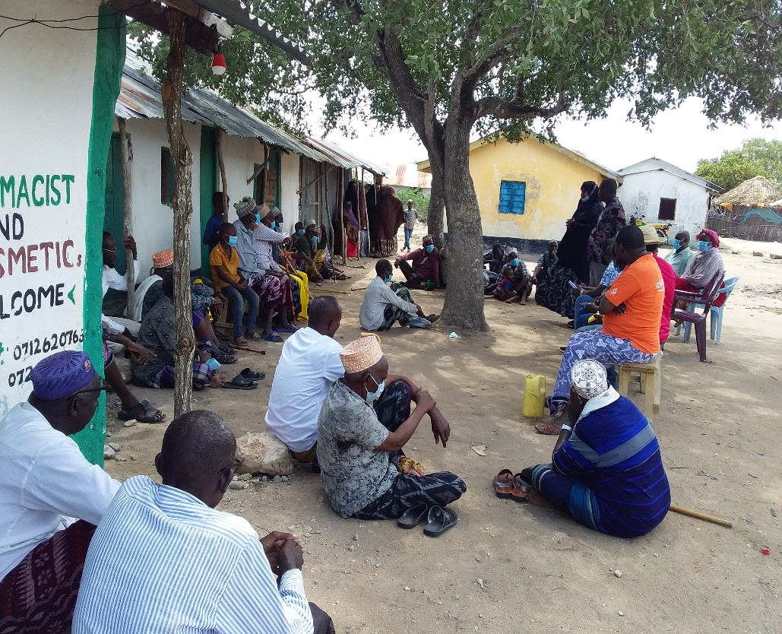

Minute 8/KOSAP/2021: Grievance Redress Mechanism
Koech explained that in a project, grievances may arise and it important to have a grievance redress mechanism that is known to all the community members and accessible with no costs to the community members. Before explaining how to set the GRM, he asked the community to explain how they deal with grievances/issues

Existing grievance redress mechanism in the village.
One of the elders reported that the elders in the community provide leadership and oversight to the community. These elders are resolve the conflicts or grievances or any issue in the village/centre. Any of the grievances that is difficult to resolve is referred to the office of the Chief

KOSAP Project GRM:
Koech explained to the community that it is important to put in place a project grievance redress mechanism (GRM). He noted that the GRM to be set should borrow heavily from the existing conflict resolution structures in the community. He added that the need for a GRM is to provide the community and other stakeholder’s opportunity to share project information and raise questions and grievances about the project. He told the community that they are free to raise any complain or request information about the project. He further explained that the project will have a three-tier grievance redress mechanism as follows.
- Locational grievance redress committee. This is the lowest level (forum) where the community will get project information and also ask questions. At this level you the community will choose project committee members who will also double as grievance redress committee. The membership will comprises; elders/men representatives, representatives from women, youth, special needs (persons with disability), and the office of the chief as Ex-officials. This will be the first stop for receiving information and raising grievances. The members to be chosen should possess leadership skills and it is hoped that most of the grievances will be resolved at this level.
- The second level of grievance redress will be the County Grievance Redress Committee comprising members of the County working group. This committee is at the county level and will resolve complains or issues that are unable to be resolved at the locational/project level. The chairman of the project grievance redress committee at the community will forward issues/ complains to the county grievance redress committee through CREO who will also be responsible for giving feed back to the local committee.
- The third level will be the National GRC comprising of KOSAP Project Implementation Unit at the Ministry of Energy and the implementing agencies. Matters that not resolved at the County level will be escalated to this National GRC by the CEC-Energy
- The last level of the GRM for the community or project affected persons will be arbitration or legal redress in a court of law once all the three levels have been exhausted.

He explained further that members of the project/ grievance redress committee will be chosen by the community members themselves. The committee chosen will be in charge of giving project information to the community and be a focal point for reporting project related issues of concern or grievances. He added that the composition of the committee should have representatives from all groups in the community including men, women, youth and persons with disability. The table below indicates the members of the GRC chosen by the community members
S/No | Name | Representative of | Contacts | ID No
1 | Mohammed Husein Salat | Youth | - | 29029433
2 | Moulid Hussein | M | 071369631 | 0539817
3 | Hussein Dakane | M | 0791989514 | 23427715
4 | Halima Yusuf | F | - | 20872753
5

Minute 9/KOSAP/2021: Focus Group Discussions
The community members were told of the need to have focus group discussions to discuss the project further and allow the people more opportunities to ask questions or give suggestions regarding the project. Therefore three separate meetings for men, women and youth were held. In these meetings the message on the project was echoed again especially on benefits and impacts (both positive and Negative) of the project to the community, rights of the community in regard to land and the need to have a grievance redress committee with representation from all groups in the community.

a) Focus Group Discussion with the women
Irene (KPLC) explained to the women that it was important to hold a separate discussion with them so that they have opportunity to freely express themselves. One focus group discussion was held with the women. She explained the agenda of the visit and a summary of the project in terms of its positive and negative impacts and their mitigation measures

Plenary Session
The women were allowed time to ask questions, give suggestions and or seek clarifications regarding the proposed project.
Table 1: Question, Suggestions, feedback and response for Focus group discussion with women
Name of Person making the contribution (e.g. comment or question) | Question, Comment, Suggestion | Feedback/Responses by project team | Response by agency on how feedback will be used or acted upon
No question was asked by the women | We are honored to host you and come again

Photo of the focus group discussion with the women
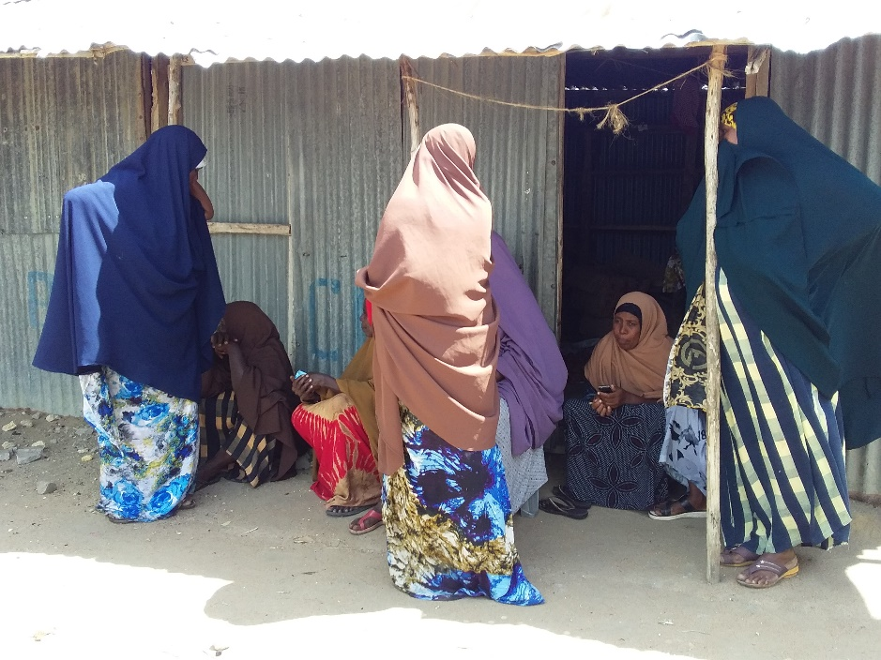

b) Focus group discussion with the youth
The youth were also invited to a separate discussion. Pius (KPLC) explained to the youth that they are also key to the decisions that are made in the community and so discussion with them was necessary so that they have opportunity to express themselves. .He gave a summary of the project in terms of its positive and negative impacts and their mitigation measures
Plenary Session
He asked the youth to feel free to air their opinions on the project. The youth said they support the project. The youth were then allowed to ask questions.
Name of Person making the contribution (e.g. comment or question) | Question, Comment, Suggestion | Feedback/Responses by project team | Response by agency on how feedback will be used or acted upon
Hassan Farah | Where will we be buying tokens from? | Through your phones or registered token vendors

c) Elders/men discussions
Koech explained to the men that it was important to hold separate discussion so that the community get enough opportunities to be informed of the project and be free to ask questions. He told the men that public participation in projects is crucial as it helps build consensus and enables people to make informed choices regarding projects. He repeated the agenda of the visit by the officers was to; undertake an environmental and social screening of the proposed site to check suitability in terms of environmental, technical, social and health requirements. The second objective was to undertake community engagement to sensitize the community on the project. The third objective was to explain the land requirements for the project, rights of the community in regard to the project and the need for a project grievance redress mechanism. Wilfred (KPLC) then gave a summary of the project in terms of its positive and negative impacts and their mitigation measures and the requirements for identifying land for the project. He also explained the need for the men to select representatives to the project committee who would represent their views/issues to the committee for redress.
The elders said they welcome the project and that they had already agreed on the portion of land where the project would be implemented i.e. part of the land which had already been set aside by the community for public utilities and one of the utilities under construction was a dispensary. The discussion was then opened up for questions.

Plenary Session
Question, Suggestions, feedback and response for focus group discussion with Men
Name of Person making the contribution (e.g. comment or question) | Question, Comment, Suggestion | Feedback/Responses by project team | Response by agency on how feedback will be used or acted upon
Hussein Dakane | We are very great full. We need this power like yesterday. The land is ready it you who are late.
Photo of the elders in the focus group discussion

Minute 10 /KOSAP/2021: Environmental and social screening of the site
The project team and the community members visited the identified site. The objective was to screen the site to check whether it was technically, environmentally and socially suitable for the project. The site was found to be appropriate for the project.
CONCLUSION
- The community welcomed the project and is in support of the project.
- Land identified belong to the community and is communally owned, representatives of the community signed the land forms as a sign of commitment
- No residential houses and no economic activity or business premises were on site during the site visit
- There will be no physical or economic displacement because the land was already set aside for community social projects by the community
- In terms of consultations one public meeting was held with the residents of Kotile. In addition, focus group discussions were held separately with the men, the women and the youth to enhance the stakeholder engagements. The engagements were fruitful and the community identified land for the proposed Mini-grid.
- The need for a grievance redress mechanism (GRM) was explained to the community including the need and roles of a grievance redress committee (GRC). A GRC was chosen with representatives from the men, women, youth and special needs group.
- The need for advance possession of the land as the process of survey and registration progresses was explained to the community and the community agreed to the same.
- It was explained to the community that it will be their responsibility to pay for connection to power , wiring of their premises and to pay for power consumed

The meeting ended at 1.27 p.m.

Recommendations
1. Environmental Social Impact Assessment to be progressed for the site

ANNEX
List of Attendance of the Community Engagements meetings
Main Meeting

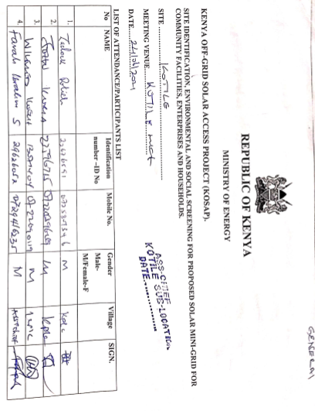
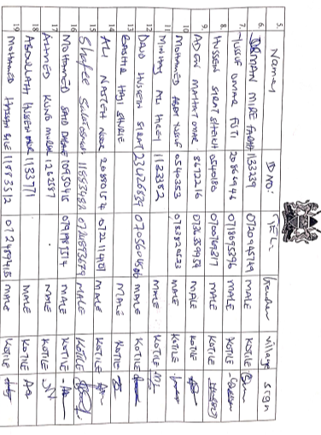
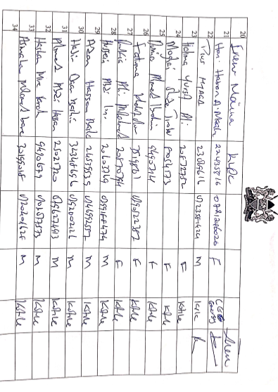
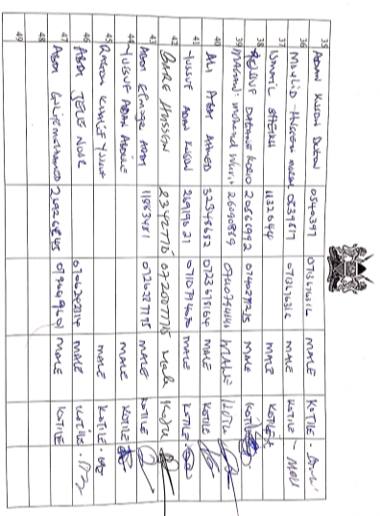

List of Attendance for the Men Focus Group Discussion
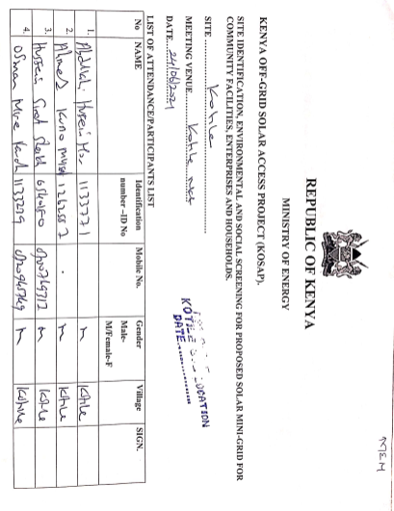

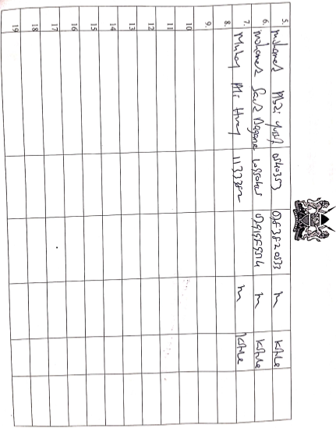
List of Attendance for the Women Focus Group Discussions

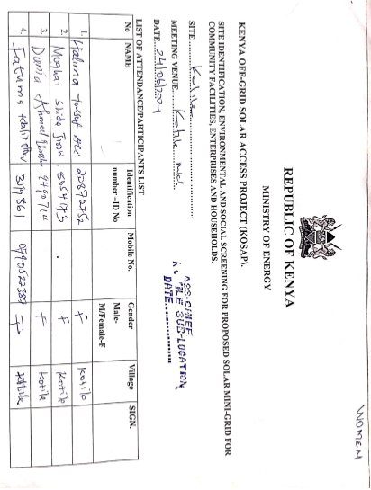
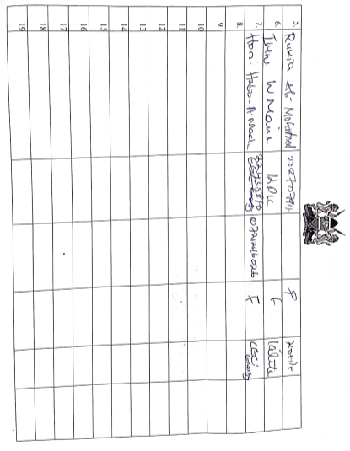
List of Attendance for the Youth Focus Group Discussion

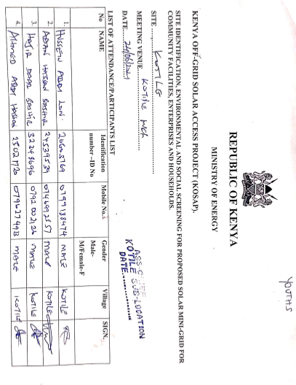

Lead Expert’s License
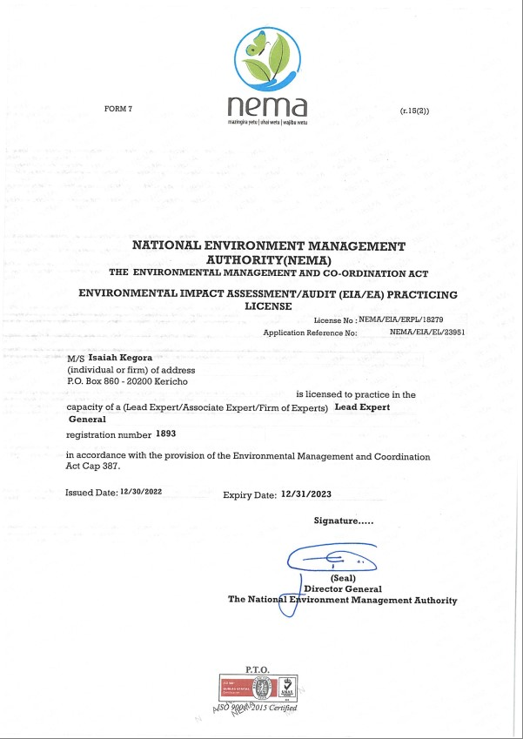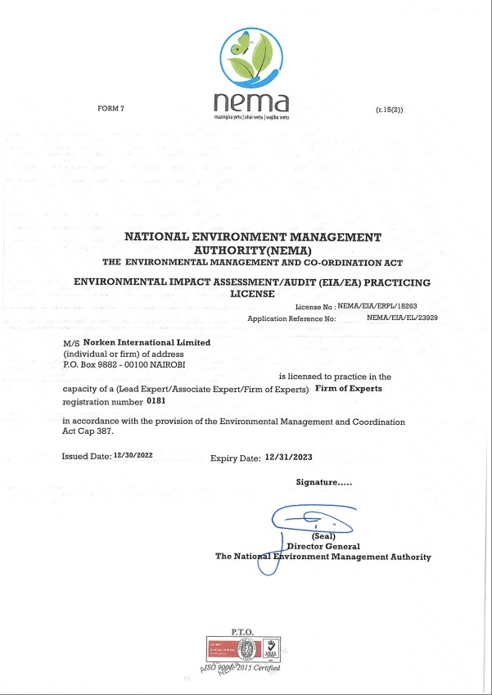

The Abbreviated Resettlement Action Plan- A-RAP

ABBREVIATED RESETTLEMENT ACTION PLAN
(A-RAP)

- Kotile Sub-project Site
The Kotile sub-project site is on unregistered community land and held in trust by the County Government of Garrisa on behalf of the community, in line with the Community Land Act 2016. The proposed site is uninhabited, has no structures, community facilities, or encumbrances. Consultations leading to the identification and selection of the sub-project site are captured in the Environmental and Social Screening report for Kotile site. Refer to Chapter 4 of the ESIA for the comprehensive socio-economic profile.

- Actual Census Survey of PAPs and Valuation of Affected Assets
The number of project-affected persons (PAPs) is 12000 (approximately 2100 households). The land acquisition-related impacts are loss of land and pasture. Mitigation measures include in-kind compensation for loss of land and pasture, and designing power distribution lines to avoid impacting trees, crops, structures, and community facilities. No physical displacement is anticipated; however, there is minimal loss of pasture occasioned by the acquisition of land utilized by the community for grazing. The 1.196 Hectares identified for the sub-project will be acquired compulsorily by the National Land Commission (NLC). The proposed site will be valued and compensated in line with the provisions of the Resettlement Policy Framework (RPF) prepared under KOSAP. Refer to section 2.2 of the ESIA for the sketch map of the site.

- Compensation Measures Agreed with the PAPs and other Resettlement Assistance to be Provided
The proponent requested the community identify three priority projects, whereby one out of the three would be provided as in-kind compensation for loss of land and pasture. The area has an existing two- and half-inch pipe that has served the community for 7 years. The community requested for upgrading of the pipe and also renovation of the water distribution kiosk. The value of the priority community project will be proportional to or higher than the value of land under acquisition. In addition, loss or damage to crops, trees, structures, and community facilities will be compensated in line with the provisions of the RPF, and as summarized in the entitlement matrix below.

3.1 Entitlement Matrix

Types of Impact | Person(s) Affected/Eligible for Compensation | Compensation/Entitlement/Benefits | Responsible organization
- Loss of Land
Loss of unregistered community land. | Community. | Compensation in-kind as prioritized by the community. | KPLC
Loss of land in unregistered group ranches. | Group ranch members. | Compensation in-kind as prioritized by the community.
Loss of land in registered group ranches. | Group ranch members. | Compensation in-kind as prioritized by the community.
Loss of land owned by the National Police, county governments and the Ministry of Interior | Government agencies. | No compensation for public land allocated to another government body.
Loss of land owned by the Kenya Forest Service (KFS) and Kenya Wildlife Service (KWS). | Government agencies. | No compensation for public land allocated to another government body. However, payment of conservation fees to KWS and KFS as stipulated under their respective regulations is foreseen.
- Loss of Use on Land
Loss of use on public land (e.g., grazing, farming etc.). | Communities utilizing public land. | Communities do not own public land; however, they utilize public land with consent from the relevant agencies. The project will implement the infrastructure project prioritized by the community as compensation for the loss of public land use. | KPLC
Loss of use on unregistered community land, unregistered group ranches and registered group ranches ( e.g., grazing, farming etc.). | Communities utilizing unregistered community land, unregistered group ranches, and registered group ranches. | Compensation in-kind as prioritized by the community.
- Loss of /Damage to Assets on Land
Trees | Community members on unregistered community land; community members utilizing public land; members of registered and unregistered group ranches and government entities. | During detailed design for power distribution lines and construction of the mini grid and community project, any crops, structures, trees, and community facilities shall be avoided to the extent possible. However, loss or damage to the above will be compensated/restored at full replacement cost, in line with the provisions of the RPF. | KPLC
Crops
Structures
Community facilities e.g., water sources (earth pans, boreholes etc.). | Community members on unregistered community land, community members utilizing public land, and members of registered and unregistered group ranches.

- Consultations with PAPs About Acceptable Compensation Options and Alternatives that have been Considered

Detailed consultations with PAPs on land acquisition and compensation, including the modalities of acquiring land and compensation options, were undertaken during the Environmental and Social Screening, Environmental and Social Impact Assessment, and the NLC land valuation process. The following sections provide a summary of the consultations.

4.1 Engagement of Project -Affected Persons (PAPs)
Local administration and County Renewable Energy Officers (CREOs) supported the proponent and implementing agency (IA) to mobilize community members and other stakeholders for public consultations and engagement activities. National and county government entities, community segments (men, women, youth, elders, persons with disability, vulnerable and marginalized groups, etc.), NGOs, and local leaders were engaged through key informant interviews, community meetings, and focus-group discussions. The proponent and IA implemented appropriate measures to ensure PAPs effectively participated in the consultations. Refer to Chapter 5 of the ESIA on public consultation and engagement.

Once the compensation award and Bill of Quantities (BoQs) are known, the Implementing Agency (IA) will engage the community and agree on the community project to be executed as in-kind compensation. During these consultations, the IA and the community will define the roles and responsibilities of the community in monitoring the implementation of in-kind compensation and maintenance once the IA hands it over to the community. Thus, the IA and the community will effect an agreement to be signed by the local leadership; representatives of the Grievance Redress Committees at the locational, county, and national levels; A-RAP Implementation Committee, and Implementing Agencies.

4.2 Identification of Community Representatives
The Kotile Locational Grievance Redress Committee (LGRC), constituting a chairperson, secretary, and three members, was formed through community consensus. The committee’s membership comprises men, women, youth, persons with disabilities, and ethnic minorities. The LGRC is responsible for engaging PAPs and resolving complaints. Refer to Chapter 6 of the ESIA on the Grievance Redress Committees. Further, the community will constitute the A-RAP Implementation Committee responsible for coordinating community engagements on the A-RAP and monitoring the implementation and closure of the A-RAP. The representation of the committee will consider gender, vulnerability, and intergenerational sensitivities.

4.3 Summary of Consultations on Land Acquisition and Compensation Options
Date | Objective | Implementing  Entities | Land Acquisition and Compensation Aspects  Discussed | Key Issues Raised | Responses  Given
24th June 2021 | Environmental and Social Screening.  Voluntary land donation (VLD).  Constitution of the Locational Grievance Redress Committee (GRC). | Ministry of Energy (MoE)  Kenya Power (KPLC)  Rural Electrification and Renewable Energy Corporation (REREC) | Site identification and land allocation for the sub-project.  Criteria for VLD.  Community entitlements (forms of compensation and implications for each). | none | none
October 22nd 2021 | Environmental and Social Impact Assessment. | Consultants  MoE  KPLC  REREC | Land acquisition through compulsory acquisition (not voluntary land donation).  Selection of three priority community projects, whereby one is to be implemented as in-kind compensation for land. | The area has an existing two- and half-inch pipe that has served the community for 7 years. The community requested for upgrading of the pipe and also renovation of the water distribution kiosk. | The proponent has set aside KES 1 million to implement the priority in-kind compensation project.  The value of the project will be proportional to or greater than the value of land.  NLC will determine the value of land.
May 2023 | Compulsory Land Acquisition. | NLC | Site inspection and inquiries.  Land valuation.  Award of compensation.

5. Institutional Responsibility for Implementation of the ARAP
Entity | Role
Ministry of Energy | - Coordinate A-RAP implementation and provide budget for in-kind compensation.
National Land Commission | - Implement the statutory process for compulsorily land acquisition, including site gazettement and inspections, inquiries, valuation, and award of compensation.
Kenya Power | - Monitor all land acquisition and compensation aspects (including A-RAP closure), complemented by a third-party monitor.  - Provide budgets for stakeholder engagement, grievance management, and monitoring, including the facilitation of the Land Acquisition and Compensation Implementation Committee, and the Grievance Redress Committee.
Mini-grid Contractor | - Implement in-kind compensation concurrently with the solar mini-grid project.
Supervising Consultant | - Monitor and report on implementation of in-kind compensation, and overall project compliance with social safeguards.
Grievance Redress Committees | - Formed at the locational, county, and national levels, and responsible for resolving complaints, including A-RAP related grievances.
A-RAP Implementation Committee | - Coordinate A-RAP engagements at the community level, monitoring A-RAP implementation and closure.
Affected Community | - Responsible for the operation and maintenance (O&M) of in-kind compensation project. An agreement stipulating the O&M roles and responsibilities of the community will be effected.

6. Procedures for Grievance Redress
The Project procedures for grievance redress were established through a public consultation process and informed by the existing conflict resolution structures in the community. The Grievance Redress Mechanism (GRM) comprises tiers at the project, county, and national levels. Refer to Chapter 6 of the ESIA for a detailed GRM.

7. Implementation Timetable and Budget for the ARAP Implementation

7.1 Timelines
The proponent will commission the community project by May 25th, 2025, before operationalizing the mini-grid. The mini-grid contractor will implement the mini-grid and the community project simultaneously. The Supervision Consultant and IAs will implement a commitment register to ensure the mini-grid contractor can achieve the agreed-upon milestones. The register will be complete with clear and practical timebound indicators, which can be monitored by all parties – the PAPs, IAs, the Ministry, third-party monitor, and the Bank.

7.2 Budget
The proponent has set aside KES 1 million for the community project (budget captured in the ESMP). The compensation award from NLC and the Bill of Quantities will inform the final cost of the community project. The costs for in-kind compensation, stakeholder engagement, grievance management (including the facilitation of the GRCs and the A-RAP Implementation Committee), and monitoring are covered under the project.

A cost basis that will yield compensation sufficient to replace assets, plus necessary transaction costs associated with asset replacement).

